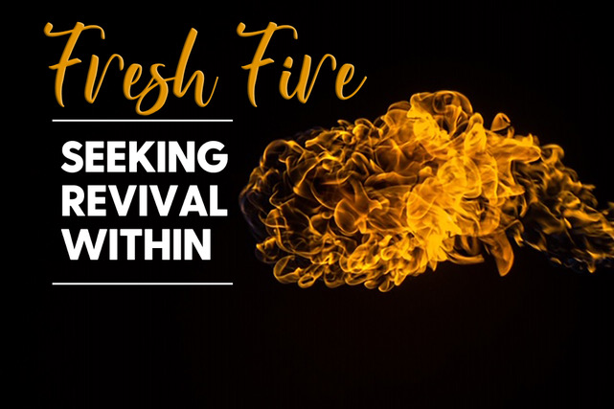

**“The Blessings of God’s Word”**

**Psalm 119:161-176**

* **The Word of God is Truth. – Read Psalm 119:161-164.** In this section, the psalmist speaks about the hatred that he feels towards falsehood. He contrasts his hatred for falsehood with his love from God’s Word (truth). What does **John 8:42-47** teach about lies? Do you know of any other passages in scripture that teach about lies and falsehood? What lies have you been tempted to believe lately?
* Why is it important for you to know that God’s Word is truth? How do you know that the Bible is true in what it teaches? What truth in scripture do you need to hold on to today?
* **The Word of God Provides Peace. – Read Psalm 119:165-168.** The psalmist states that those who love God’s Word have great peace. Peace comes when our hearts and minds are focused on God and His Word, not our circumstances. **Read Isaiah 26:3.** What does this verse in Isaiah promise us? Have you been seeking peace outside of God’s Word? Why is it not good to place our peace in circumstances? Have you been placing your peace in circumstances and not in God and His Word?
* **The Word of God Directs My Speech.** **– Read Psalm 119:169-172**. In this passage, the psalmist describes how he uses his lips and his tongue to worship God. Our mouths are the primary instrument we use to communicate the words that we say. Why is it important take seriously the words that we speak? What does the Bible teach about our words? **Read James 1:26; Colossians 4:6; Ephesians 4:29; Matthew 12:36.** What jumps out at you in these verses? How can you better use your words to encourage others this week?
* **The Word of God is The Voice of My Savior. – Read Psalm 119:173-176**. The psalmist refers to himself as a sheep that has gone astray. He then asks the Lord to seek him. This points to the fact that God is our Shepherd. **Read Isaiah 53:6; 1 Peter 2:25; John 10:11.** What do these verses say about us and what do they say about God? What does it mean that Jesus is our Shepherd? How does He shepherd you?

**Accountability:**

1. What is one practical thing that needs to change in the way you communicate with your mouth? What is one thing that you can do to live out the verses shared on the use of our words?
2. How often do you use your mouth to share the gospel with others? Is there someone who comes to mind right now?