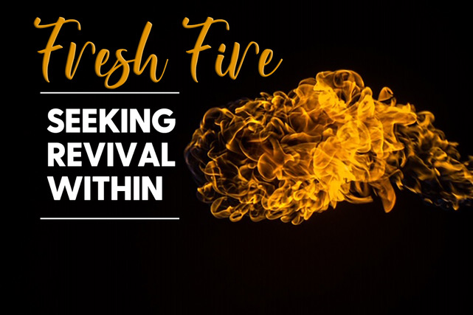

**“Who is Like Our God?”**

**Psalm 119:137-160**

* **Our God is Righteous. Read Psalm 137-144.** All throughout these verses, the psalmist repeatedly points out the fact that God is righteous. God’s actions are always right, and He Himself is the standard of what is right.
* Why is it important for you to know that God is righteous? Because his righteousness shows us His Holiness and His goodness
* What does this mean for you as a Christ follower? We can trust God with whatever outcome in our lives.
* What are some passages in scripture that speak about the righteousness of God? Ps 19:142 Your righteousness is righteous forever, and your law is true.

*but let him who boasts boast in this, that he understands and knows me, that I am the Lord who practices steadfast love, justice, and righteousness in the earth. For in these things I delight, declares the Lord.” -Jeremiah 9:24*

* **Verses 137-138** states that God’s Word is right and built upon righteousness. What does this mean and why is crucial for us to understand this truth about God’s Word?

**God’s word is righteous regardless of weather we believe it or not.**

* **Our God is Near to Us. Read Psalm 119:145-152.** In these verses, the psalmist speaks about how near his enemies are, but then he says that God is near as well. In trials, it can feel like God is far away. When was the last time that you felt like God was far away? What made you feel that way? Do you feel that way now?
* Sometimes when God is silent, it can feel like He is not close by. Pastor Jon stated, “*Silence does not equal distance*.” – What does scripture say about God’s proximity to His people? V.151 But you are near, O Lord
* **Read Deuteronomy 4:7, Psalm 34:18, and Psalm 23:1-4.** Pick one of these passages, and take a moment to pray its truth together as a group.
* **Our God Fights for Us. Read Psalm 119:153-155.** The psalmist asks God to both deliver him (fight for him) and defend him. Do you need God to fight for you and defend you today? If so, why? What battle are you in currently?
* **Read Psalm 35:1, Proverbs 18:10, and Romans 8:31.** How can we be encouraged by these passages today? What do you need to be reminded of by them?
* **Our God Revives Life. Read Psalm 119:156-160**. Twice the psalmist says to God, “give me life” or “revive me”. It is the idea that God has the power to give life to areas of our lives that appear dead and flat. Is there an area of your life that appears dead/flat at the moment (prayer life, broken relationship, time in the Word, etc)? What would revival in that area look like?

**Accountability:**

* Is there any area of your daily walk with Christ that is shallow with no depth at the moment? What challenges are you currently facing that hinder you from going deeper?
* What is the state of your heart today? How would you describe it currently? Hard and Callous? Or Soft and Tender?