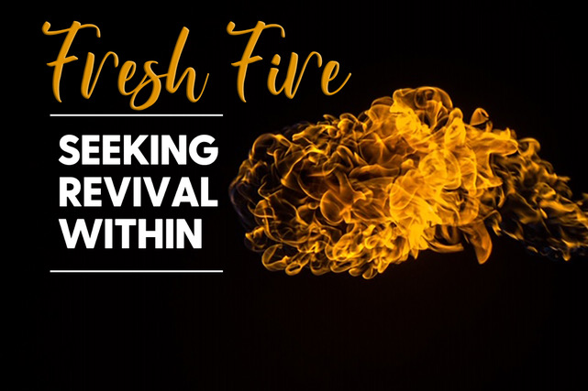

**“Why I love your Word”**

**Psalm 119:97-120**

* **Your Word makes me wise. Read v. 97-104.** On a scale of 1-10 how would you rate your love for God’s Word? Why? In the last year would that be growing or fading? What is the difference between knowledge and wisdom? Give an example of God’s wisdom that you are seeking to practice? How does God’s wisdom provide protection if practiced?
* **Your Word is a lamp unto my feet. Read v. 105-108.** What does light do to darkness? How does God’s Word reveal to us what we need to see? **Read Phil 4:8** and discuss what this reveals about when you have anxious thoughts? How does v 108 reveal how we are to approach God? What does that kind of praise look like?
* **Your Word is the joy of my heart Read v. 109-112.** How do you hold onto God’s Word when times are tough? In v 107 how does it work to be experiencing pain and affliction but still have joy? Describe any examples of that in your life. How does the words of God represent who He is? In verses 111 and 112 how does joy lead to obedience?
* **Your Word is my hope. Read 113-120**. What does the idea of double-minded mean as Matt 6:24 addresses? Why are no divided loyalties necessary for revival? What promises of God are sustaining you or holding you up right now? Read Ps 40:1-4 and discuss the truths of why we can find hope in God’s Word.

**Accountability:**

1. Pray together for the Lord to generate a greater super-natural love of His Word.
2. Is there any wisdom of God you are struggling to understand or obey?
3. What offerings of this world or in your flesh must you fight that seek your loyalty over God?
4. How can you fix your hope on God and His Word this week?