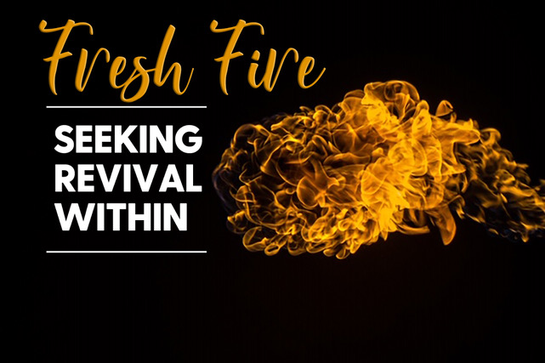

**“5 Prayer Requests for Inward Revival”**

**Psalm 119:17-32**

* **Lord, Open My Eyes. Read Psalm 119:17-19**. – In this section, the psalmist asks God to open his eyes so that he can see “*wonderous things*” in the Word of God. Why is it important for us to see God clearly? Why does the psalmist ask God to open his eyes?
* In verse 19, the psalmist refers to himself as a “sojourner” or “stranger” in this world. Why is this perspective important to have? What does this say about how the psalmist sees himself?
* **Lord, Keep Me from Being Distracted. Read Psalm 119:20-24**. – This passage states that “*even though*” he is in relational conflict, he still meditates on God’s Word. Do you allow outward circumstances to control your worship of Christ and your relationship with Him? What can we learn from Paul’s situation in Acts 17:23-26? Do you think it’s possible for you to live what he says in Philippians 4:11-13?
* **Lord, Give Me Understanding**. **Read Psalm 119:20-24.** – The psalmist asks for understanding in this passage. True spiritual understanding isn’t just knowing “*what*” God says, but “*why*” God says it. **Read Proverbs 3:5-6**. How have you leaned on God’s understanding lately? Are there times when you lean on your own understanding? If so, give an example.
* **Lord, Protect Me from Lies**. **Read Psalm 119:29-30.** – Pastor Jon stated, “S*atan doesn’t just lie to us; by getting us to believe his lies…..he actually teaches us to lie to ourselves…..because we repeat his lies*.” – What lies has Satan fed you? What lies are you repeating to yourself? – Why is God’s Word so crucial for overcoming lies and walking in truth?
* Satan loves to plant lies in areas that we have the deepest wounds. Do you see lies that have been planted by him in an area of your life that has deep wounds? What is the area? What is the lie? – Stop right now, rebuke the lie, and pray as a group for God’s grace and truth to invade that area. Pray for healing, victory, and the truth of God’s Word to rule there.
* **Lord, Set My Heart Free. Read Psalm 119:31-32 –** The phrase “*enlarge my heart*” or “*enlarge my understanding*” means to be “*free without restraint*”. The psalmist wants a heart that is not in bondage and is completely free to chase hard after God. Are there any areas of your heart that need to be set free? Is there something that your heart is in bondage to? Are there things that God has set you free from in your heart?

**Accountability:**

1. What verse did you memorize? Why did you choose this verse to memorize?
2. What is a different verse that you will memorize this week? Why that verse?
3. What has God most been convicting you about during this series? Why? What will you do about it?