**October 5 (Jer 8-12)**

Jeremiah 10.11 (“Thus shall you say to them: “The gods who did not make the heavens and the earth shall perish from the earth and from under the heavens”) was written in Aramaic, the language commonly spoken in the Near East in the 6th century and the only Aramaic in Jeremiah. It stands alone as a one-verse paragraph in the Masoretic Text of the OT. It has a chiastic structure:

“This passage is carefully structured and placed to contrast the LORD who is living and eternal (v. 10) and made the heavens and earth (v. 12) with the idols who did not and will disappear. It also has a very careful concentric structure in the original text where “the gods” is balanced by “these,” “heavens” is balance by “from under the heavens,” “the earth” is balanced by “from the earth,” and “did not make” is balanced and contrasted in the very center by “will disappear.” The structure is further reinforced by the sound play/wordplay between “did not make” (Aram לָא עֲבַדוּ [la’ ’avadu]) and “will disappear” (Aram יֵאבַדוּ [ye’vadu]). This is the rhetorical climax of Jeremiah’s sarcastic attack on the folly of idolatry.”(The NET Bible First Edition Notes (Biblical Studies Press, 2006), Jer. 10:11).

Leviticus 26:1 (ESV), “You shall not make idols for yourselves or erect an image or pillar, and you shall not set up a figured stone in your land to bow down to it…”

Idol: A man-made object that is venerated or worshipped for the deity, spirit or demon that it embodies or represents.

Characteristics of Near Eastern Idols:

Images of deities in the ancient Near East were conventionally anthropomorphic, i.e., having human form. Idols were most often carved in wood and stone, often adorned with precious metals like silver or gold.

The Ancient Near East believed that idols became vessels for divine presence through dedication rituals. These were believed to bring the god's spirit to the idol, allowing the deity to manifest its will through the image. Idols were where the deity became present in a special way, with some viewing the cult statue as becoming the god itself when the god showed its favor.

Rituals and offerings, such as those involving food and drink, were performed to please the deities and request their protection and power. Spells and incantations were performed before the idol to appeal to the deity.

Votive figures, typically made of stone, gypsum, or shell, were placed before the shrines representing worshipers, to remind the deities of their devotion.

Archaeology in the ancient Near East has confirmed the widespread nature of such religious practices. These include, among other finds:

• Ancient Near Eastern stone idols, such as standing position stone statues and Bactrian composite stone figurines.

• While less well-preserved due to the nature of the material, evidence of wooden cult figures exists, including the possibility that some were used in magical rituals or as offerings.

Representation of Deity:

Deities were frequently associated with specific symbols, such as the horned cap for Enlil, the eight-pointed star for Inanna/Ishtar, and various animals or natural elements. The characteristic anthropomorphism, representing the gods in wholly or partly human form, allowed for a more relatable connection for worshippers.

The specific deities and their representations varied across cultures and regions of the Near East, such as those worshiped in the Sumerian, Babylonian, and Assyrian traditions:

• Inanna/Ishtar, the goddess of love, fertility, and war, was often depicted with an eight-pointed star. A version of her was the “Queen of Heaven” mentioned several times in the book of Jeremiah.

• Enlil, the god of wind and storms, was associated with the horned cap, a symbol of divinity.

• Marduk, the chief god of Babylon, was represented in various forms, including statues.

• Shamash, the sun god, was often depicted with sun rays emanating from his shoulders.

Another wide-spread Assyrian stone idol was the massive, winged, human-headed bull or lion figures known as lamassu. These were symbols of protection and royal authority in ancient Assyria, mixing religion and politics. These monumental sculptures, frequently placed at palace entrances, were believed to ward off evil and convey the king's strength. They were typically placed in pairs at entrances to palaces and throne rooms. The lamassu embodied the power and divine favor of the Assyrian kings, showcasing their ability to control both the natural and supernatural realms.

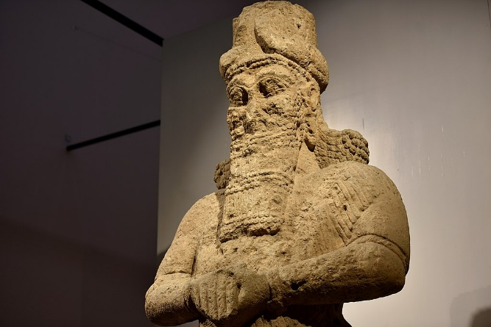Statue of the god Nabu (god of literacy, scribes, wisdom, and the rational arts), 8th C. BC., from Nimrud, Mesopotamia (Iraq), an ancient Assyrian city.

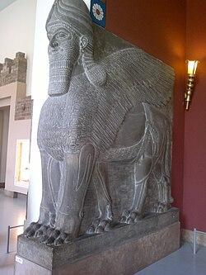

This is a cast from an original, one of a pair of five- legged lamassu with lion's feet.

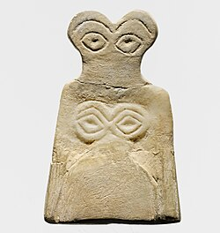

Tel Brak (Syria) Eye idol

Goddesses, Bactria, Afghanistan 2000-1800BC, composite idol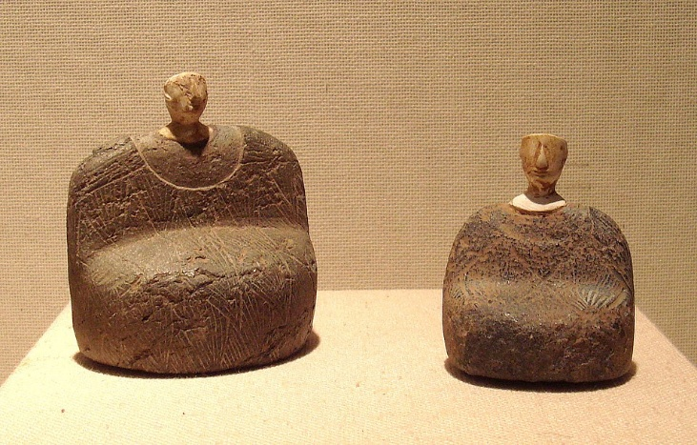

**Discussion Questions (Jer 8-12)**

1) Today’s reading is rich with various imagery patterns. Pick one or two images that Jeremiah uses to convey the Almighty’s communication and discuss why they are there and how they work.

2) Paul paraphrases Jeremiah 9:24 (“…but let him who boasts boast in this, that he understands and knows me, that I am the Lord who practices steadfast love, justice, and righteousness in the earth. For in these things I delight, declares the Lord.”) from either the Masoretic Version or the Septuagint in I Corinthians 1:31 and 2 Corinthians 10:17. How does his quotation help us better understand both Jeremiah’s and Paul’s words?

3) In Jer 11:18-23, Jeremiah’s calling affected his personal life directly. What does God’s response say about His attitude toward His prophets?

4) Jer 12 is a dialogue between Jeremiah and God. Does it compare in any way to those in the Book of Job? What does it reveal about Jeremiah’s character and his relationship with God?

5) How can you personally apply these verses?

6) Make up your own question and answer it.