**October 26 (Jer 23-27)**

**Solomon’s Temple**

Solomon's Temple was built on Mount Moriah in Jerusalem, where an angel of God had appeared to David (2 Chronicles 3:1). The site was originally a threshing floor David had purchased from Araunah the Jebusite (2 Samuel 24:18–25; 2 Chronicles 3:1).

Both archaeological and written evidence indicates that temples were built both inside Israel (Tel Motza near Jerusalem and Tel Arad west of the Dead Sea) and outside, such as at Elephantine and Heliopolis in Egypt even after the time of Hezekiah. However, from the time of the King of Judah, the Jerusalem Temple came to be the legitimate place of sacrificial worship to the God of Israel. Centralization of Israelite worship in the Jerusalem Temple was reemphasized under Josiah. The Jerusalem Temple itself was destroyed by the Babylonians in 586 BC. (Oxford Dictionary of the Jewish Religion, 1997, s.v. “Temple.”)

The biblical description of Solomon's Temple is technically a langbau building, a rectangular construction that is longer than it is wide. It is also categorized a tripartite building, with three units: the ulam (porch), the heikal (sanctuary), and the debir (the Holy of Holies). It is also classified as a straight-axis temple; there is a straight line from the entrance to the innermost shrine. The ulam, or porch, featured two bronze pillars Jachin and Boaz. The porch led to the heikal, main chamber, the sanctuary. It measured 40 cubits in length, 20 cubits in width, and 30 cubits in height with a candelabrum, a table and a gold-covered offering altar. At the far end of the sanctuary was a wooden door that led to the Holy of Holies. The Holy of Holies, also called the "Inner House", was 20 cubits in length, breadth, and height, probably with an elevated floor. There was a two-leaved door between it and the Holy Place overlaid with gold. It had no windows.

**Medes and Persians**

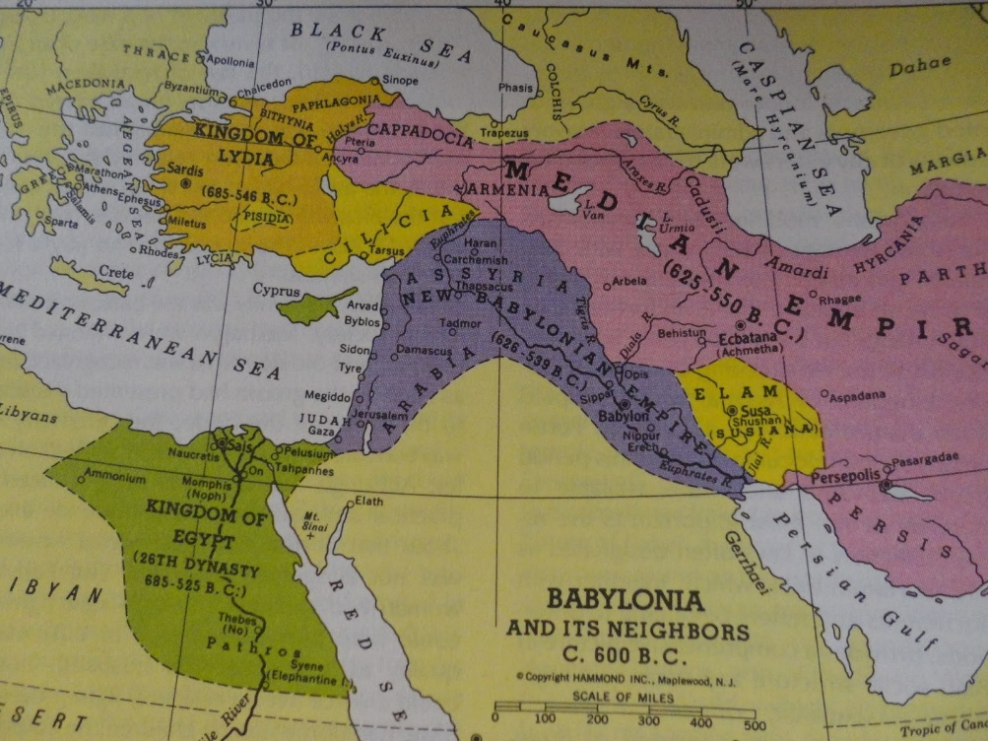Media as a political state was arranged around its capital, Ecbatana, in eastern central Mesopotamia and existed from the 7th century BC until the mid-6th century BC. It controlled a large part of the Iranian plateau. By 612 BC, the Medes became strong enough to overthrow the declining Assyrian empire with their allies the Babylonians. In 550 BC Ecbatana was conquered by the Persian king Cyrus II, with the Medes becoming part of the Persian empire.

**Persia**

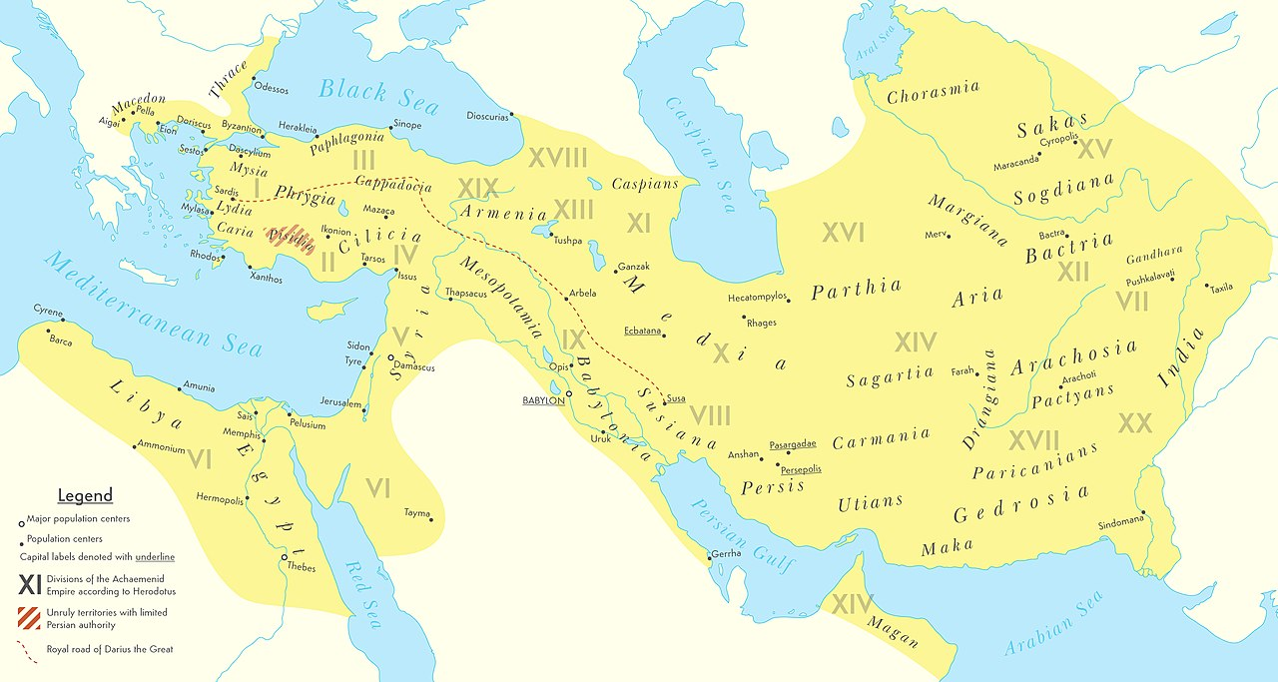 The First Persian Empire was founded by Cyrus the Great of the Achaemenid dynasty in 550 BC. Around the 7th century BC, the area of Persis on the Iranian plateau was settled by the Persians. From Persis, Cyrus defeated the Median Empire, Lydia and the Neo-Babylonian Empire. Persia lasted until 330 BC, when Alexander the Great conquered it.

**Discussion Questions (Jer 23-27)**

1) Jer 23:1-8 speaks generally and then specifically about a renewal of righteous rule for the Israelites by God. How does its precise wording convey to the people God’s intentions beyond their immediate political situation to a future fulfillment? Compare this with Isaiah 4:2 and 11:1.

2) The prophet in Jer 25 uses the (wine)cup of wrath metaphor to carry God’s message of anger across the Near East, from Egypt to the Persians (Media). How does this poetical device work and what is Jeremiah saying about “all the kingdoms of the world” (25:26)? Why do you think God is extending His anger to the rest of the nations as well as Judah? Why in Jer 25:26 is Babylon hidden by a code name?

3) What is the significance of Jeremiah being personally involved with the effects of his prophecies in Jer 26? What’s the importance of God ordering the prophet to speak prophecy in the Temple court in Jerusalem? What are the parallels with and differences from Jesus’s presence in Jerusalem and how do they illuminate the ministry of both?

4) Contrast the earthly political wisdom that made Zedekiah oppose Nebuchadnezzar with God’s desire that the people of Judah submit to Babylon’s rule in Jer 27?

5) How can you personally apply these verses?

6) Make up your own question and answer it.