**October 19 (Jer 18-22)**

**Ancient Levantine Trade Routes, Ca. 1300 BC**

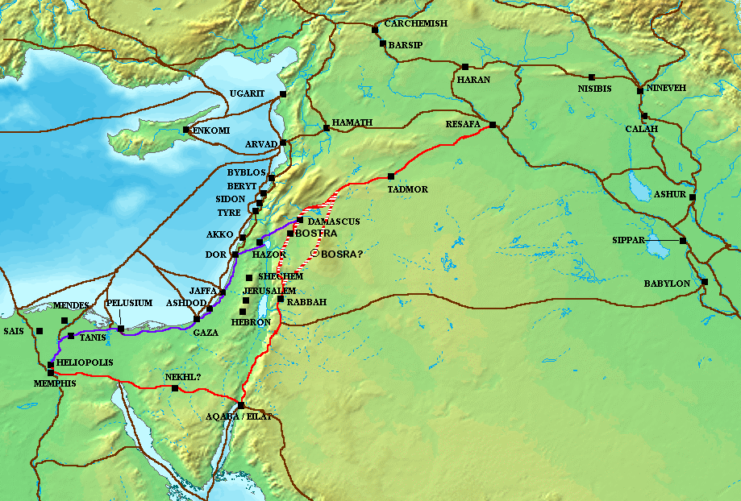The Via Maris (Way of the Sea) is in purple. The King’s Highway (Via Regia) is in red; it connected Africa with Mesopotamia (Egypt to the Euphrates River). Other routes are in black.

Many ancient kingdoms depended greatly on the King’s Highway for trade access, including Edom, Moab and Ammon.

The Via Maris was the other major trade route connecting Egypt and the Levant (the region bordering the Eastern Mediterranean Sea) with Anatolia and Mesopotamia. Crossed by the other routes, trade could go from Africa to Europe, Asia to Africa. It followed the Canaanite coast, then turned east through Megiddo and the Jezreel Valley to Tiberias on the Sea of Galilee. It then turned north through Migdal, Capernaum and Hazor, before crossing the Jordan River to Damascus.

**Jeremiah in the Masoretic and Septuagint Versions**

The LXX and MT texts of Jeremiah differ considerably from each other. The LXX is about an eighth shorter and the order of some of the text is different. This is much more substantial than most discrepancies between the two versions in the other books.

The Masoretic Text (MT) defines the Jewish canon , with its vocalization and accentuation known as the masora. Masora specifically means the diacritic markings of the text of the Jewish scriptures and the concise marginal notes which note textual details. It was primarily copied, edited, and distributed by a Jewish group, the Masoretes, from the 7th to the 10th centuries A.D. The oldest known complete copy is the Leningrad Codex, dating to 1009 A.D. They were based primarily in Jewish centers such as Tiberias, Jerusalem, and Sura and Nehardea in Mesopotamia.

The Septuagint (LXX) is the earliest Greek translation of the Hebrew Bible from the Hebrew. The first five books of the Hebrew Bible were translated into Koine Greek by Jews living in Ptolemaic Egypt in the large Jewish community in Alexandria, in the early or middle part of the 3rd century BC., with the remaining books being translated in the 2nd century BC.

There are two ways in which the LXX and the MT can differ: A) The Hebrew text that the LXX translators were translating from was very different from the MT; or B) The LXX translators translated loosely. In the Book of Jeremiah, the evidence points to the former, because in the Dead Sea Scrolls the fragments of Hebrew texts of Jeremiah agree with the LXX and not the MT.

**Jeremiah 33:15**

“In those days and at that time I will cause a righteous Branch to spring up for David, and he shall execute justice and righteousness in the land.”

**Zechariah 3:8 (see also 6:12)**

“Hear now, O Joshua the high priest, you and your friends who sit before you, for they are men who are a sign: behold, I will bring my servant the Branch.”

**Discussion Questions (Jer 18-22)**

--The pottery theme is carried from 18:1-7, 11, into Chapter 19, now applied to Jerusalem itself. What is the significance of this application?

--The opposition of the Israelites now comes to Jeremiah directly in Jer 20. Why, by whom and with what implications immediate and cosmic? What are God’s and Jeremiah’s responses?

--The “way of life and the way of death” (Jer 21:8) are offered to the people of Jerusalem and by implication all Judah/Israel. How are each represented in this chapter?

--Jer 22:11-19 provides contrasting views of kingship, with Jeremiah criticizing King Jehoiakim, who was placed on the throne by Pharaoh Necho II, who had also killed Josiah in battle and deposed Jehoiakim’s brother Jehoahaz in the space of three months. What are the contrasts? How do they vary? Is there a change when the focus shifts in vv. 20-23?

-- How can you personally apply these verses?

-- Make up your own question and answer it.