**October 12 (Jer 13-17)**

**Babylon**

The founding of the Neo-Assyrian Empire (911–605 BC) saw Babylon once again under the control of the Assyrian state for the next three centuries.

Babylonia fell to the Chaldeans in 780 BC, while there was civil war in Assyria. The Chaldean tribe had a century earlier settled in a small region in the far southeastern corner of Mesopotamia, by the Persian Gulf and southwestern Elam. At this time in Babylonia, the north was controlled by Assyria, its throne occupied by foreign Chaldeans, and civil unrest prominent throughout the land. The Babylonian king Nabonassar overthrew the Chaldean usurpers in 748 BC, and successfully stabilized Babylonia.

With the accession of the Assyrian king Tiglath-Pileser III (745–727 BC) Babylonia came under renewed attack. Babylon was invaded and sacked. In 729 BC the Assyrian king decided to rule Babylon directly as its king instead of allowing Babylonian kings to remain as Assyrian vassals. It was during this period that Mesopotamian Aramaic slowly began to overlap then supplant Akkadian as the spoken language of the general populace of both Assyria and Babylonia.

Soon after, Assyria underwent a series of civil wars which were to cause its downfall. Babylonia took advantage of constant unremitting civil war in the Assyrian heartland and rebelled under Nabopolassar, a previously unknown tribal chief of the Chaldeans, who had settled in southeastern Mesopotamia by c. 850 BC.

**Neo-Babylonian Empire (Chaldean Empire)**

[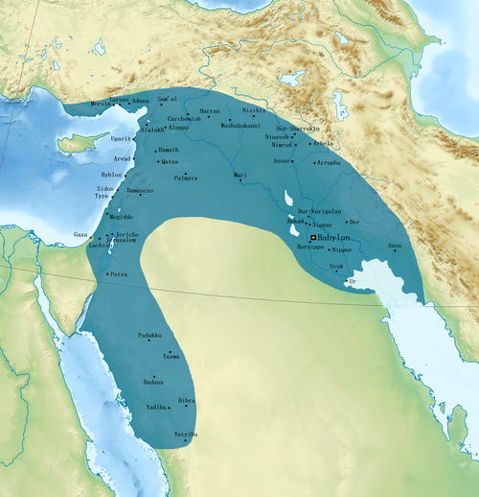](https://en.wikipedia.org/wiki/File:Neo-Babylonian_Empire_under_Nabonidus_map.png)In 620 BC Nabopolassar seized control over much of Babylonia with popular support; only the city of Nippur and some northern regions showing loyalty to the Assyrian king. In 615 BC, Nabopolassar allied the Babylonians and Chaldeans with Cyaxares, and king of the Iranian peoples, the Medes, Persians, Sagartians, Parthians, Scythians and Cimmerians and the regional Aramean tribes.

This alliance started a combined attack in 614 BC, and after five years of fierce fighting Nineveh was sacked in late 612 BC after a prolonged siege, but house to house fighting continued. The king of Assyria managed to successfully fight his way out of Nineveh and to the northern Assyrian city of Harran in Upper Mesopotamia which he made his new capital. The Assyrian king held out against the alliance until 607 BC, when he was eventually ejected by the Medes, Babylonians, Scythians and their allies.

The Egyptian Pharaoh Necho II, whose dynasty had been installed as subject to Assyria in 671 BC, tried to help the Assyrians. The Assyrians fought on with Egyptian aid until what was considered a final and decisive victory was achieved against them at Carchemish in northwestern Assyria in 605 BC. The seat of empire was thus transferred to Babylonia for the first time since Hammurabi over a thousand years before.

Nabopolassar was succeeded by his son Nebuchadnezzar II (605–562 BC), whose reign gave Babylon once more control of much of the civilized world, taking over portions of the former Assyrian Empire, with the eastern and northeastern portion being taken by the Medes and the far north by the Scythians.

Nebuchadnezzar II campaigned against the Egyptians and drove them back from control of the Sinai. A subsequent attempt to take Egypt itself failed, mainly due to a series of rebellions from the kingdom of Judah and the former kingdom of Ephraim, the Phoenicians of Caanan and the Arameans of the Levant. The Babylonian king crushed these rebellions, deposed Jehoiakim, the king of Judah, and deported a sizeable part of the population to Babylonia. Cities like Tyre, Sidon and Damascus were also subjugated.

**Baal and Marduk**

The name Baʻal was particularly associated with the storm and fertility god Hadad and his local manifestations. The Hebrew Bible includes use of the term in reference to various Levantine deities, often with application towards Hadad, who was decried as a false god. Baʿal Zebub (Hebrew: בעל זבוב, lit. "Fly Lord") occurs in the first chapter of II Kings as the name of the Philistine god of Ekron. Regardless of their original relationship, by the 1st millennium BC, the two were distinct: Hadad was worshiped by the Aramaeans and Baʿal by the Phoenicians and other Canaanites.

Early Semitic records see him as a weather god, with particular power over lightning, wind, rain and fertility.

The dry summers of the area were explained as Baʿal's time in the underworld, and his return in autumn was said to have caused the storms that revived the land. Thus, the worship of Baʿal in Canaan was connected to the region's dependence on rainfall for its agriculture. Anxiety about water availability for crops and trees increased the importance of his cult, which focused attention on his role as a rain god. He was also called upon during battle. The Lebanese city of Baalbeck was named after Baal.

**Marduk**

He was a god in ancient Mesopotamia and patron deity of Babylon from the 1st millennium BC. In the city of Babylon, Marduk was worshipped in the main city temple. He was a prominent figure in Babylonian cosmology, especially in the Babylonian Enuma Elish creation myth.

Nabonassar claimed that Marduk proclaimed him lordship and had ordered him to plunder Assyria, which only ruled Babylonia due to divine anger. He claimed that he killed the Assyrian king and laid waste to his lands by the command of Marduk and Nabu and with the weapons of Erra, who were the main trio of the First Millennium Babylonian ideology.

In royal inscriptions of the Neo-Babylonian kings, Marduk is exalted as the king of the gods and as the source of their authority. In a Late Babylonian god list, all the gods on the list were identified with Marduk.

**Discussion Questions (Jer 13-17)**

1) Jer 13 and 16 have significant symbolic actions and divine enigmatic sayings, as well as metaphoric language. How does God use these in this chapter and why?

2) Is the drought in Palestine at the time of Chapter 14 only a physical punishment of Israel and Judah by the Lord? Why or Why not?

3) Chapter 15 and 17 include some of Jeremiah’s personal responses to the spiritual situation of the Israelites. What do we learn about him the man and his prophetic mission?

4) Today’s study passage ends in 17:19-27 with God focusing on the Sabbath, the evil present practices of the people of Jerusalem and a prophetic future when it will have been kept holy. Why was it important that they hear about this?

5) How can you personally apply these verses?

6) Make up your own question and answer it.