**December 7 (Jer 48-51)**

**Battle of Carchemish**

The Battle of Carchemish was a battle fought ca. 605 BC between Pharaoh Necho II’s Egyptian armies, combined with military remnants of the Neo-Assyrian Empire, against the Babylonian armies led by Nebuchadnezzar II. The Assyrians were there after their last capital, Harran, had been captured by the Babylonians four years earlier. Babylon and the Medes fought the battle to gain control over the region of Syria. Carchemish was a strategic Euphrates River crossing and trade city in what is modern-day Syria. The battle would be a major defeat for the Egyptian and Assyrian forces and resulted in expanded Babylonian territory. The defeat ended Egyptian influence in the Levant and led to Babylon expanding its domain to the borders of Egypt.

While marching northward from Egypt, Pharaoh Necho II would face the army of King Josiah of Judah at Megiddo. Josiah was an ally of the Babylonians; they aimed to keep the Egyptians from joining the Assyrians to ensure a Babylonian victory.The Judean army was defeated at the Battle of Megiddo, and Josiah would be killed in 609 BC.Necho then placed a new king on the throne of Judah, Jehoiakim, as an Egyptian vassal.

**Countries Surrounding Judah**

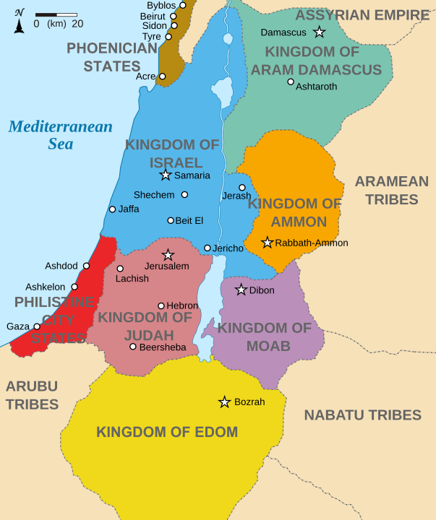**Moab** - This was an ancient Levantine kingdom whose territory is today located in southern Jordan. Its mountainous land lies alongside the eastern shore of the Dead Sea. The Moabite capital was Dibon. Their chief god was Chemosh: they were the "people of Chemosh" (Num 21:29; Jer 48:46). In times of trouble, human sacrifices were offered to Chemosh; for example, King Mesha sacrificed his son and heir to him (2 Kings 3:27).

**Ammon –** TheAmmonites were a Semitic-speaking kingdom laying to the east of the Jordan River, between the Arnon and Jabbok Valleys, in present-day Jordan. The chief city of the country was Rabbah site of the modern city of Amman, Jordan's capital. It had a productive agricultural sector and occupied a vital place along the King's Highway, the ancient trade route connecting Egypt with Mesopotamia, Syria, and Asia Minor.] As with the Edomites and Moabites, trade along this route gave them considerable revenue. Milcom, Molech and the moon god were the gods of Ammon.

**Edom –** This was a kingdom that stretched across portions in the south of present-day Jordan and Israel. The Edomites' original country stretched from the Sinai Peninsula as far as Kadesh Barnea. It reached as far south as Eilat, the seaport of Edom. On the north of Edom was the territory of Moab.The ancient capital of Edom was Bozrah, now Busaira, Jordan.Mount Seir appears to have been strongly identified with them as a site of worship.

In King Solomon’s time Edom became subject to Israel, with Israelite governors. In the divided kingdom Edom became a dependent state of Judah. Edom revolted against Jehoram and elected a king of its own (2 Kings 8:20–22; 2 Chronicles 21:8). Amaziah then attacked and defeated the Edomites, seizing Selah, but the Israelites never subdued Edom completely.

**Damascus** – Now in present-day Syria, Damascus was built in a strategic site at a crossroads between trade routes: the north–south route connecting Egypt with Asia Minor, and the east–west cross-desert route connecting Lebanon with the Euphrates river valley.

By the start of the first millennium BC, several Aramaic kingdoms had formed, as Aramaeans abandoned nomadic life and merged into associated tribes. One of these was Aram-Damascus, founded in 965 BC and centered on Damascus. As this nation expanded southward, it blocked the Kingdom of Israel from spreading north and the two kingdoms soon clashed.

After Assyria went on a wide-scale campaign of quelling revolts throughout Syria, Damascus became subject to them. One effect of this was civil stability and economic benefits from the Arabian spice and incense trade. Assyrian authority diminished by 609–605 BC, and Syria came under the control of Pharaoh Necho II. By 572 BC, Nebuchadnezzar II of the Babylonians had conquered all of Syria.

**Kedar** **and Hazor** – Kedar was an Arab tribe often mentioned in the Old Testament. It was centered on a location in the north of Hejaz, an area on the Arabian Peninsula that included most of western Saudi Arabia. It is bordered on the west by the Red Sea, on the north by Jordan and on the south by Yemen. Hazor, otherwise unidentified, may refer to various Arab settlements in the region.

**Elam** - This was an ancient civilization centered in the far west and southwest of Iran, long in decay by the time of Jeremiah. The Elamites often allied with the Babylonians and the Medes against the Assyrian Empire. In Jeremiah’s time, it was divided into smaller kingdoms due to Assyria destroying its unity. These were apparently controlled by the Medes at the time.

**Discussion Questions (Jer 48-51)**

1) Jer 48 deals with God’s judgment of Moab. Who are the multiple voices in the chapter and how do they function to convey His meaning? In vs. 7, what is the significance of the god Chemosh going into exile with his priests and officials? What is vs. 10 doing in Jer 48?

2) Jer 49 deals with God’s judgment on the Ammonites, Edom, Damascus, Kedar, Hazor, and Elam. Compare and contrast God’s words against each of these nations. In vss. 8 and 10-11, what is the significance of Jeremiah’s references to Esau?

3) In Jer 50, how are the Jews characterized? Do we learn anything new bout their moral state and situation than in previous chapters? What was prophesied as to their future?

4) How does Jeremiah’s sending of Seraiah ben Neriah (Baruch’s brother) to Babylon in Jer 51 compare and contrast with earlier prophecies on Jeremiah’s part? Compare Jer 36:1-8. What is the significance of the shift of prophetic focus from Jerusalem to Babylon?

5) How can you personally apply these verses?

6) Make up your own question and answer it.