January Newsletter 2026

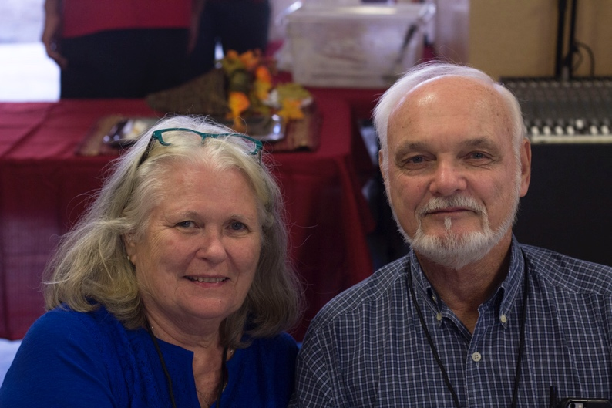
In 1981 The Lord spoke to Dennis and told him that we were to move to Panama City, Panama. He told him to minister to the American military, to work in the National Leper colony and to be active in a Spanish church. After attending Rhema Bible college for two years, we packed up our four children ages 8 through 12 and moved to Panama. We did not know one person in Panama. As you can see Dennis was wild and crazy for God.
It was miraculous how all the details fell in line. In one month, we were pastoring a small church outside of the American military base. It was a small Spanish/ English church for the enlisted members of the American military community. It was a 5 mile walk to the only leper colony in Panama.
After two years the lord told us to move deeper into the jungles of Panama. A Spanish pastor asked Dennis to go with him and check it out. So, he did and he came back on fire for the Embera Indians.
An older gentleman said they had been praying for years for someone to come and live there to teach them about God. At that time, they did not have the Bible translated into their language.
We moved our family there and Dennis began teaching them about the character of God. This was life changing because their pagan Gods were never satisfied with their lives no matter how hard they tried. After two years Dennis established our first church in the village of Los Mono’s. Dennis was given the right to start churches in all the Indian villages. He was known as a man of high integrity.
He not only was trusted by the Head chiefs but also the police force in the Darien jungles. The head of the police and the ambassador of Panama would visit him and ask his counsel about the things in the Darien.
We felt like we were the richest people in the world. We loved the call of God on our lives.

Children Reaching Children

This program is mostly funded by the children in our supporting Churches. We also have adults that support It that have a heart for this next generation.
It funds all our outreaches for the children in the villages that we have established churches in.
It also helps pay for the supplies needed to go to school when needed. If you or your church 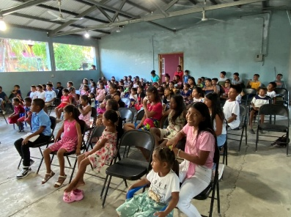 would like to be a part of this program, please designate your giving to Children Reaching Children’s ministry.

Prayer Request

1.Please pray for me as I transition in this new season without Dennis by my side. It has been difficult for me. Loneliness is my greatest enemy. I know that it is Gods will that I continue the work here.

2. Please pray for someone to come and help me. They will need to be financially responsible for themselves and their expenses.

Ministry Needs

I will be visiting churches this year. If you would like me to come and share about what is happening in the ministry here, please contact me via email. Jeanne.vidamin@gmail.com

Group opportunities

March 4-9-----------Children’s Conference
June 5-15 ----------Construction Group
July 2-7---------------Men’s conference
September 26-----Ladies conference

I can work with you on the dates if these are not compatible for you.

