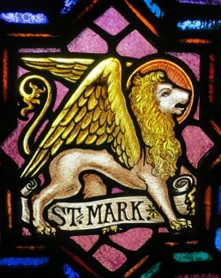
St Mark’s Newsletter November 2026
Our Mission: To Proclaim the Gospel, To Make Disciples, To Embody Christ’s Love

Newsletter Changes
After much consideration and study of the financial impact of sending the newsletter to people who may not be interested in receiving it, the December newsletter will be the last one sent in a bulk mail.
A newsletter will be available online or sent in an email or a copy can be mailed to those who request it. Over the next few weeks, we will be securing information about how you would like to receive your newsletter.
A signup sheet will be available at church for members and friends to designate distribution preference. You may also send an email to
SECRETARY@SMARKLC.ORG
and request to be added to the email list. You may also contact the church office at 828.459.2161 with questions and/or to let us know your preferred method of receiving the newsletter after December. If you do not request a preferred method of receiving the newsletter by December 13th, you may risk not receiving future newsletters.
St Mark’s Veteran’s
Recognizing our Veteran’s and thanking them
for their service.

Nolan Hedrick by Judy Craig
George Setzer, Jr. by Tina Simmons
Larry Arndt (Army) by Denise Arndt
Rick Arndt (Marines) by Denise Arndt
Michael E Smyre (Army)
Pamela L Smyre (Army)
Rudy Little (Army)
Norman Morrow (Army)
Trent Wright (Navy)
Kermit Nash (Army)
Johnny Kisler (Army)
Jimmy Smith (Army) by Patty Little
Larry Isenhour (Air Force) by Patty Little
Andrew Hefner (Army) by Patty Little
David Wilfong (Army) by Patty Little

"Pay to all what is owed to them . . . respect to whom respect is owed, honor to whom honor is owed." Romans 13:7

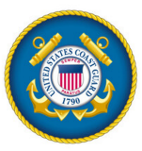

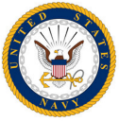

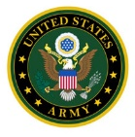



‘Gifts from the Heart’
Christmas Shopping Day
Saturday, November 21st 9am - 3pm
Our third annual Christmas Shopping day is fast approaching and we need everyone's help with this Inspirational Ministry Opportunity. There are over 125 shoppers registered already and we need volunteers and items to make this year as successful as the past two have been. Below is a partial list of items needed. New items are requested. Also, volunteers are needed for various task: assisting shoppers, serving the meal, gift bagging, table monitoring and registration. Please sign up on the table in the sanctuary if you are able to help.
Items Needed for the Christmas Shopping Day on November 21st Mens Small Tool Kits, Flashlights, Car Care Items, Grilling Items, Keychains, Head lamps Womens Bath/body, Lotions, Mesh Scrubs, Keychains, Umbrellas, Comb/Brush
Children Crayons, Games, Coloring Books, Small Toys, Small Stuffed Animals Kitchen Cookie Mix Packets, Cooking Utensils, Dish Clothes, Christmas Mugs Other Christmas Socks, Toboggans, Hats, Gloves, Toiletry Items
Food Desserts, Sugar Free items, Soft Candies, Hot Chocolate Packets
WE DO NOT NEED . . . Jewelry, Pictures, Wall Art, Candles, Toy Guns
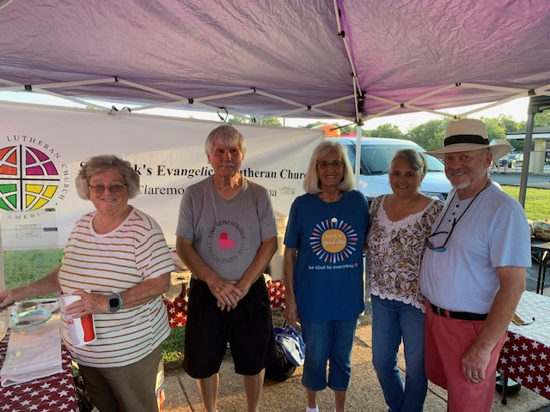
Claremont Daze 2026
Thank you to all who volunteered to made our Outreach Ministry a success at Claremont Daze. Fun and Fellowship was had by all as they greeted visitors with a smile, a kind word and fresh popcorn. Baked goods were also available for purchase with the proceeds going to our Blessing Box. Thanks to Nicky Setzer for coordinating and the following for volunteering: Evelyn Setzer, Nobia & Ken Summer, Patty Little, Judy Craig, Tim & Judy Carpenter, Mona Sigmon, Carol Schaefer, Donna Evans and Pastor Quentin & Raye Surace.

St Mark’s Preschool
The preschool is in full swing preparing for the Fall and enjoying the beautiful weather.

A recent field trip to the Farm in Dobson, NC created tons of smiles, laughter and memories as the children and some family members enjoyed the trip.


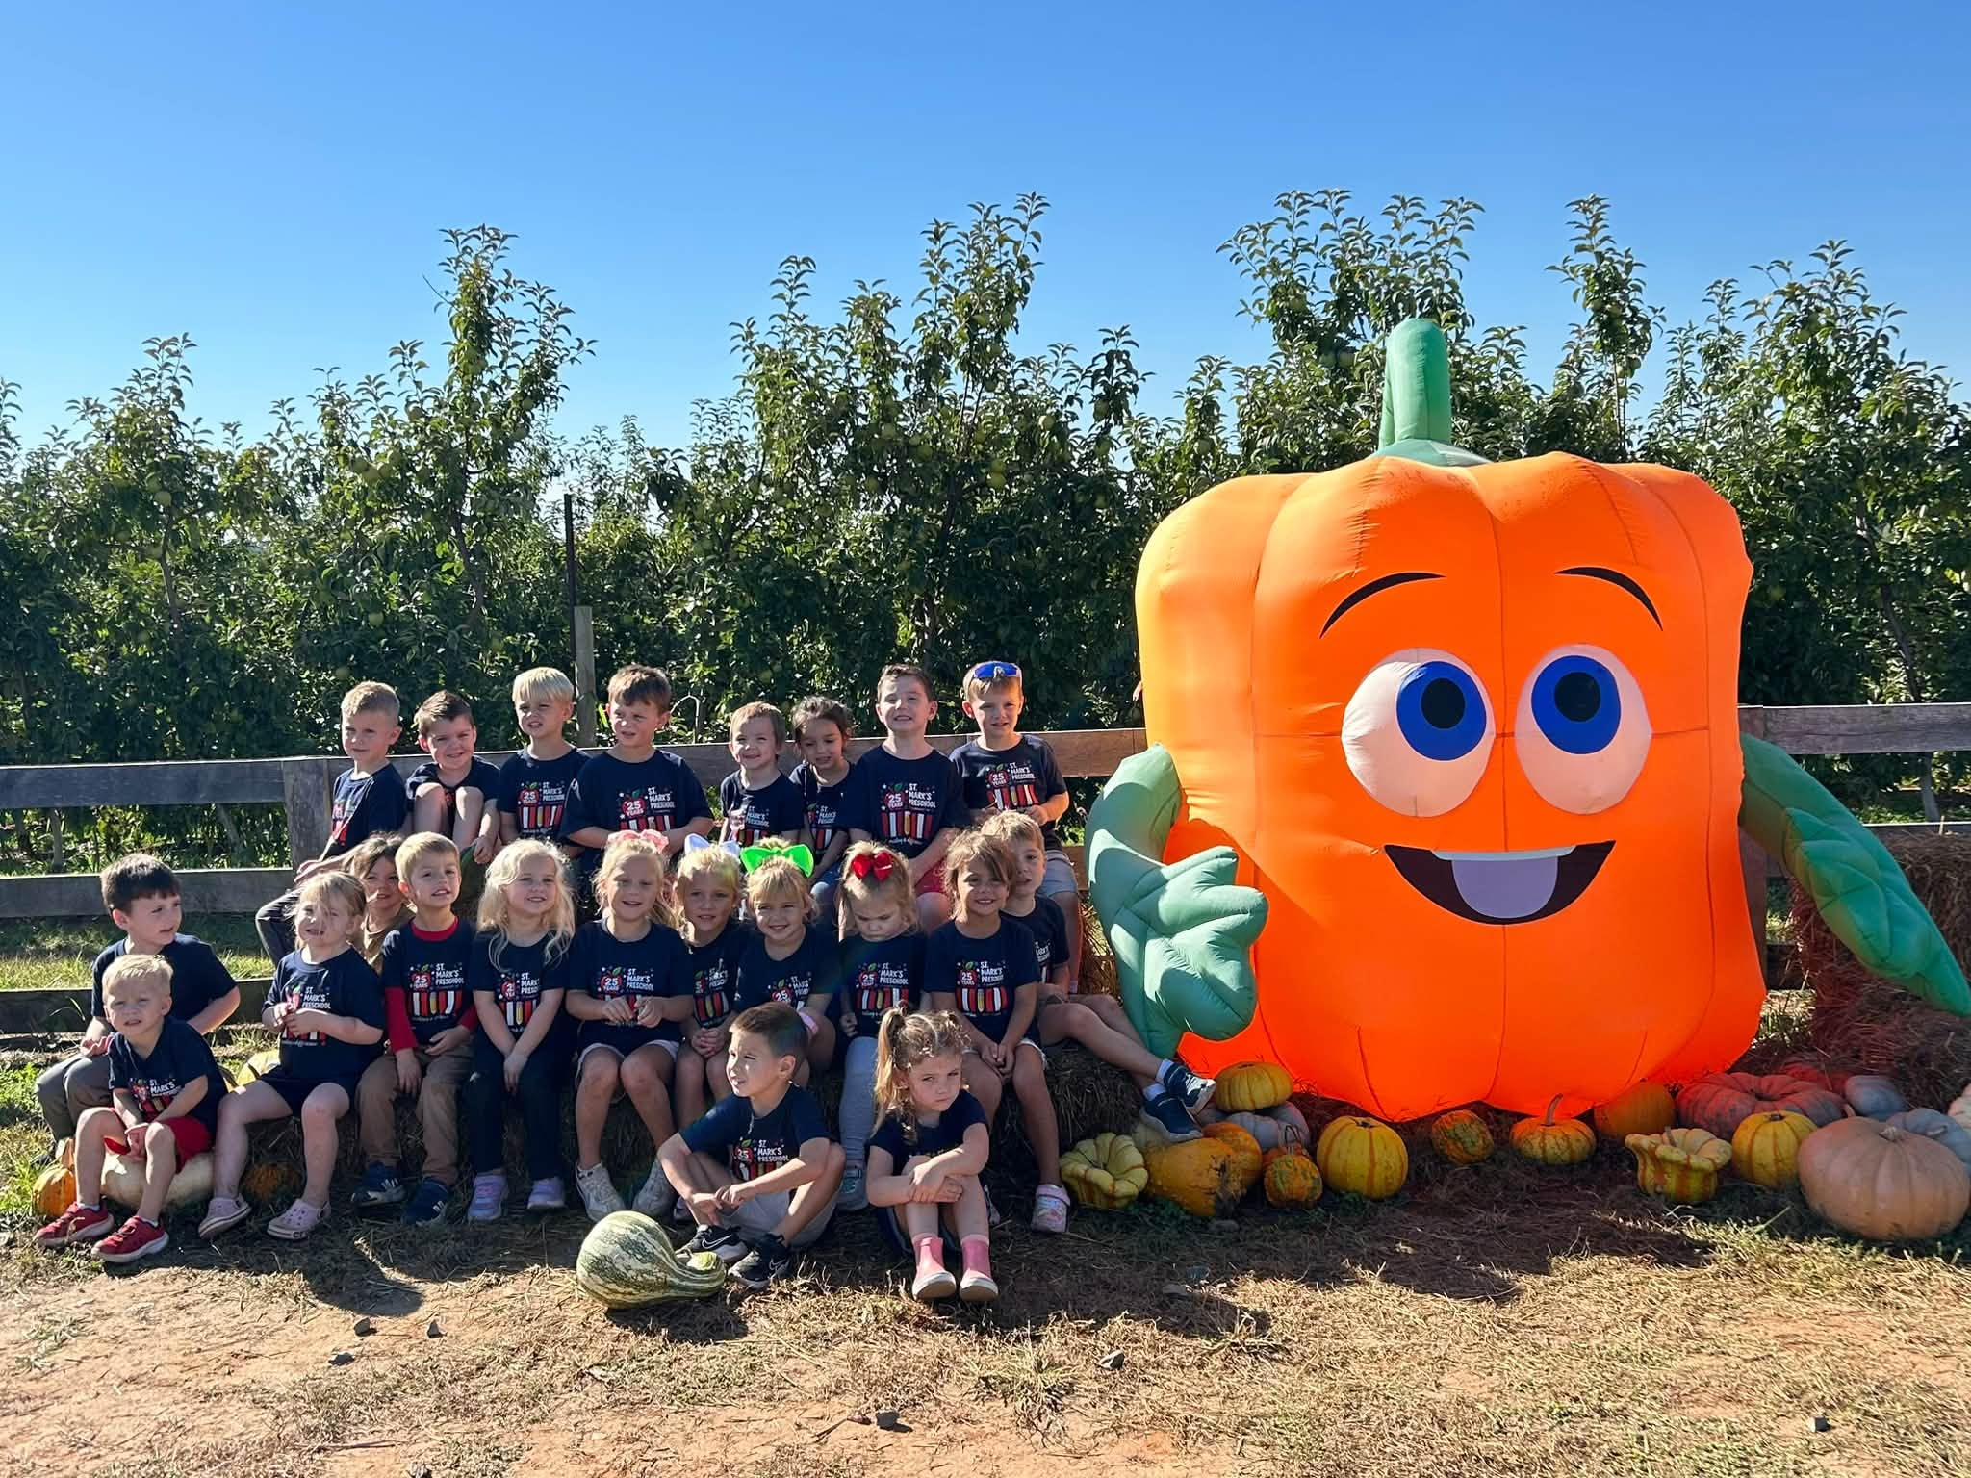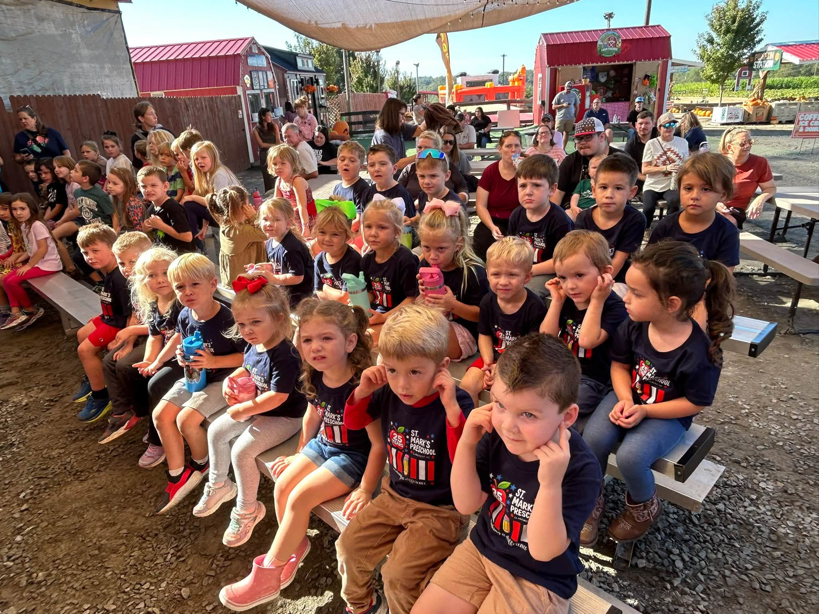

Happy
Anniversary!
Happy Birthday!

2nd – Blake Sigmon
7th - Pennie George
10th – Judah Theisen
11th – Tim Sherrill
12th – Tim Bumgarner
13th – Richard Schroeder
20th – Gary Carpenter
20th – Jan Carpenter
20th – Tim Carpenter
21st – Jim Stewart
22nd – Lisa Widener
25th – Boyce Hollar, Jr
25th – Ted Sigmon
26th – Kathy Whisnant
5th – Zach & Mally Gardner
10th – Morgan & Gus Loza
20th – Chuck & Debbie Watson

Mark Your
Calendars

Nov 1 – All Saint’s Sunday
Nov 8 – Veteran’s Day luncheon
Nov 15 – Congregational Meeting
Nov 21 – Gifts from the Heart
Nov 29 – 1st Sunday in Advent

Dec 5 – Christmas Parade
Dec 6 – 2nd Sunday in Advent
Dec 13 – 3rd Sunday in Advent
Children’s Christmas Program
Congregational Lunch
Dec 17 – Preschool Christmas Prog.
Dec 20 - 4th Sunday in Advent
Dec 24 – Christmas Eve Service
Dec 27-Lessons and Carols Service


Memorials
A memorial was recently given in memory of Johnny Sigmon by Roger Boger. Johnny’s legacy continues to live on through this memorial
to be used for the
ministries at St Mark’s.



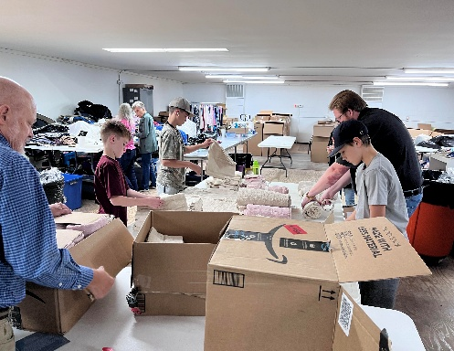

Family & Friends:
Zane Albert
Heather Killian Forbes
Rusty Hastings
Jack & Luke (Per Cathy S)
Fran Little
Bill Mataya
Mark Sepulvador
Loretta Stephenson
Phil Williams
Active Military:
Davis Tucker

Keeping Our Brothers and Sisters in Christ in Our Prayers

WELCA Activities
Get Involved

Nov 2 (Mon) - Bible Study 11 AM in lounge.
Nov 10 (Tues) - ‘Safety First’ presentation by Claremont Chief of Police, John Thomas. TBA
September/October 2026 Worship Attendance
September 27 | Present  66 | YouTube  4
October 4 | 71 | 8
October 11 | 51 | 12
October 18 | 65 | 9

Members:
Libby Brown Gail Carpenter
Gary & Susan Carpenter Alanna Dotson
Bill Dotson Kathy Gibson Rachel Hall
Donald & Debbie Herman
Linda & Willie Hewitt
Tammie Hoyle
Benny & Linda Lytton

Gaye Morrison
Kelly Morrison
Norman Morrow
Betty Powell
Carolyn Sherrill
Larry & Judy Smyre
The Family of
Jo Marilyn Hewitt

Youth Service Project
Our youth recently spent an afternoon lending their folding and sorting skills to Highways and Hedges. After folding over 150 towel sets and sorting bins of shoes, the group enjoyed ice cream at Udderly Delicious. Thanks to Noah, Jon and Silas for your hard work.
St Mark’s Ministry Financial Analysis
September 2026
General Fund Offerings
Month - $16,660.74 Year - $337,748.93
Expenses
Month - $25,724.44 Year - $234,164.57
Balance
Month – ($9,063.70) Year - $103,584.36
Noisy Offering
October Noisey Offering for Safe Harbor the totaled $154.00 Here is a list of the remaining 2026 monthly Noisy Offering recipients:
November - Rising Hope Farm
December - Christmas meals for needy families

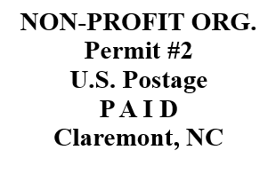

St. Mark’s Lutheran Church
P.O. Box 550
3216 W Main Street
Claremont, NC 28610

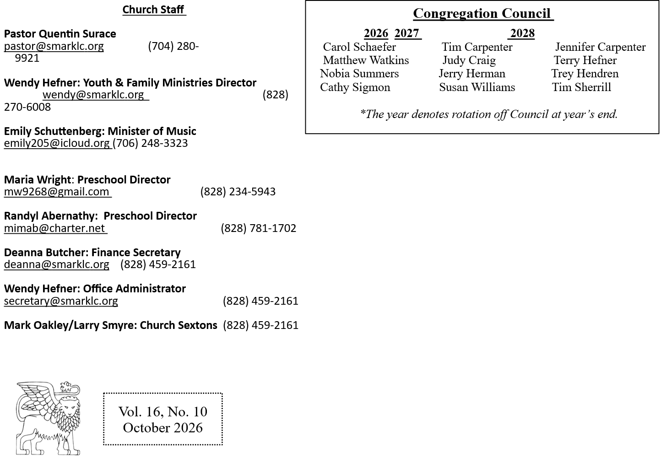

Vol. 16, No. 11
November
Congregation Council meets on November 16th at 6:30 pm.

Item for the December newsletter due by November 18th.

Church Office Hours
Monday – Thursday, 9:00am – 2:00pm
Newsletter Changes
The December newsletter will be the last one sent in a bulk mail.
Newsletters will be available online, through email or a copy can be mailed to those who request it.
See information inside to designate your distribution preference. If you do not request a preferred
method of receiving the newsletter by December 13th, you may risk not receiving future newsletters.
Follow Us Online

Facebook: St Mark’s Lutheran Church, Claremont, NC

Website: www.smarklc.org

Youtube: St. Mark’s Lutheran Church, Claremont NC
http://www.youtube.com/@st.markslutheranchurchclar6483

