St. Mark’s Evangelical Lutheran Church

All Saints day 10:00 am November 1, 2026
*Please stand as able P: Pastor; A: Assisting Minister; C: Congregation
SETTING 2 PG 116
GATHERING
GATHERING MUSIC (9:45AM)
WELCOME AND ANNOUNCEMENTS (9:55AM)
PRELUDE AND LIGHTING OF CANDLES BY ACOLYTE

CONFESSION AND FORGIVENESS

P: Blessed be the holy Trinity, ☩ one God, our dwelling place for all generations, whose compassion never slumbers.
P: Let us confess our sin in the presence of God and of one another.
Silence is kept for reflection

P: Holy God,
C: we confess that we have trusted in our preparation instead of your invitation. We prioritize our piety over care for
your beloved. We trust the voice of our shame and fear, which keeps us from entering fully into relationship with you
and others. We are not awake to the coming of your reign. Rouse us and rescue us, that we may enter into your joy.
Amen.
P: Inherit the riches of God’s grace. ☩ Jesus, the good shepherd, feeds you with his mercy. You are forgiven.
Blessed are you. C: Amen

* OPENING HYMN “For All Your Saints, O Lord ” Vs. 1, 2 ,4, 5 ELW # 427

* APOSTOLIC GREETING

* KYRIE P. 120 ELW

*PRAYER OF THE DAY
Almighty God, you have knit your people together in one communion in the mystical body of your Son, Jesus Christ our Lord. Grant us grace to follow your blessed saints in lives of faith and commitment, and to know the inexpressible joys you have prepared for those who love you, through Jesus Christ, our Savior and Lord, who lives and reigns with you and the Holy Spirit, one God, now and forever. C: Amen
Word

LessonS Revelations 7:9-17; 1 John 3:1-3

*GOSPEL ACCLAMATION “Alleluia Lord …” P. 124 ELW

GOSPEL READING Pastor Quentin Surace

P: The Holy Gospel according to John C: Glory to you, O Lord

P: The Gospel of the Lord. C: Praise to you, O Christ.

CHILDREN’S SERMON Matthew 5:1-12 Pastor Quentin Surace

Sermon Pastor Quentin Surace
*HYMN OF THE DAY “For All the Saints ” Vs. 1, 2 ,6, 7 ELW #422

*apostles’ CREED ELW P. 127

*PRAYERS BY ASSISTING MINISTER
A: United with the great cloud of witnesses . . . C: Hear Our Prayer.

*SHARING OF CHRIST’S PEACE
MEAL
THE OFFERIng HYMN “Shall We Gather at the River” ELW # 423
OFFERING PRESENTATION/RESPONSE “Praise God, from Whom all Blessings Flow”
Praise God, from whom all blessing flow; praise God, all creatures here below; praise God above, ye heav’nly
host; praise Father, Son, and Holy Ghost. Amen.

OFFERING PRAYER
Eternal God, our time, talents, and treasures are gifts from you. Receive what we offer, and all that you entrust to us, until hungry no more, all the world is fed, through Jesus Christ, our Savior and Lord. C: Amen

*GREAT THANKSGIVING
P: The Lord be with you. C: And also with you
P: Lift up your hearts. C: We lift them to the Lord
P: Let us give thanks to the Lord our God C: It Is right to give our thanks and praise

*PROPER PREFACE FOR SUNDAY

*HOLY, HOLY, HOLY (sung) ELW P. 130
Holy, holy, holy Lord, God of pow’r and might, heav’n and earth are full of your glory. Hosanna in the highest.
Blessed is he who comes in the name of the Lord. Hosanna in the highest. Hosanna in the highest.

*WORDS OF INSTITUTION FOR HOLY COMMUNION

*THE LORD’S PRAYER P: Lord, teach us to pray . . .

DISTRIBUTION
We welcome all who believe Jesus is Lord to receive the sacrament of Holy Communion. An usher will guide
you to the center aisle to receive communion. You may return to your seat by the outer aisle. If you are not
able to come forward, please notify an usher by raising your hand and communion will be brought to you.

INVITATION

AGNUS DEI (LAMB OF GOD) ELW P. 135
Lamb of God, you take away the sin of the world; have mercy on us. Lamb of God, you take away the sin
of the world; have mercy on us. Lamb of God, you take away the sin of the world; grant us peace.

DISTRIBUTION HYMN “Spirit of God, Descend Upon My Heart ” ELW # 800

*PRAYER AFTER COMMUNION
P: Holy God, we have received your never-ending mercy in this meal. You continuously seek the lost, bind the injured, and feed your people abundantly. Now send us out, awake to your presence, now and forever. C: AMEN

SENDING
*BLESSING
P: The holy Trinity, Father, ☩ Son, and Holy Spirit, bless you with wisdom to welcome the reign of God, today and always. C: Amen.

P: Together let us proclaim our mission:
C: To proclaim the Gospel. To make disciples. To embody God’s love. Amen

*SENDING HYMN “Oh, When the Saints Go Marching In ” On Screen

*Dismissal: P: Go out in joy. Be led forth in peace. C: Thanks be to God !

POSTLUDE

C: Amen
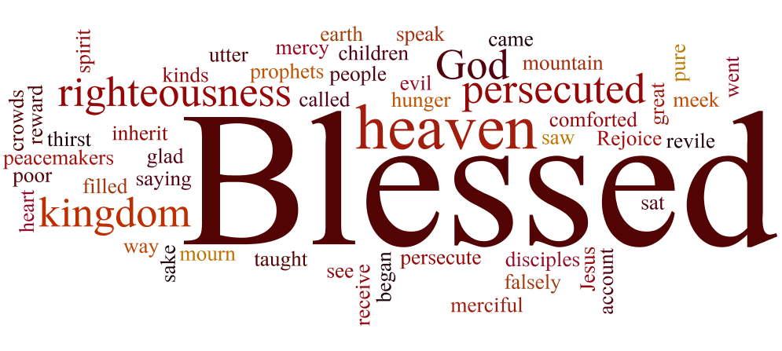
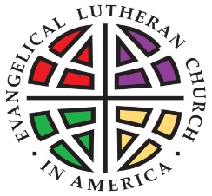

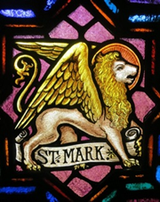
ST. MARK’S EVANGELICAL
LUTHERAN CHURCH

Novemeber 1, 2026

all saints day

Sunday morning learning 9:00am

Sunday WORSHIP SERVICE 10:00am

YOUTUBE live stream 10:00 AM

http:// www.youtube.com@st.markslutheranchurchclar6483

First Reading: Revelation 7:9-17

⁹ After this I looked, and there was a great multitude that no one could count, from every nation, from all tribes and peoples and languages, standing before the throne and before the Lamb, robed in white, with palm branches in their hands. ¹⁰ They cried out in a loud voice, saying, “Salvation belongs to our God who is seated on the throne and to the Lamb!” ¹¹ And all the angels stood around the throne and around the elders and the four living creatures, and they fell on their faces before the throne and worshiped God, ¹² singing, “Amen! Blessing and glory and wisdom and thanksgiving and honor and power and might be to our God forever and ever! Amen.”
¹³ Then one of the elders addressed me, saying, “Who are these, robed in white, and where have they come from?” ¹⁴ I said to him, “Sir, you are the one who knows.” Then he said to me, “These are they who have come out of the great ordeal; they have washed their robes and made them white in the blood of the Lamb. ¹⁵ For this reason they are before the throne of God and worship him day and night within his temple, and the one who is seated on the throne will shelter them. ¹⁶ They will hunger no more and thirst no more; the sun will not strike them, nor any scorching heat, ¹⁷ for the Lamb at the center of the throne will be their shepherd, and he will guide them to springs of the water of life, and God will wipe away every tear from their eyes.”

Second Reading: 1 John 3:1-3
¹ See what love the Father has given us, that we should be called children of God, and that is what we are. The reason the world does not know us is that it did not know him. ² Beloved, we are God’s children now; what we will be has not yet been revealed. What we do know is this: when he is revealed, we will be like him, for we will see him as he is. ³ And all who have this hope in him purify themselves, just as he is pure.

Gospel: Matthew 5:1-12
¹ When Jesus saw the crowds, he went up the mountain, and after he sat down, his disciples came to him. ² And he began to speak and taught them, saying:
³ “Blessed are the poor in spirit, for theirs is the kingdom of heaven.
⁴ “Blessed are those who mourn, for they will be comforted.
⁵ “Blessed are the meek, for they will inherit the earth.
⁶ “Blessed are those who hunger and thirst for righteousness, for they will be filled.
⁷ “Blessed are the merciful, for they will receive mercy.
⁸ “Blessed are the pure in heart, for they will see God.
⁹ “Blessed are the peacemakers, for they will be called children of God.
¹⁰ “Blessed are those who are persecuted for the sake of righteousness, for theirs is the kingdom of heaven.
¹¹ “Blessed are you when people revile you and persecute you and utter all kinds of evil against you falsely on my account. ¹² Rejoice and be glad, for your reward is great in heaven, for in the same way they persecuted the prophets who were before you.”

Church Staff
Pastor: Pastor Quentin Surace Custodian: Larry Smyre / Mark Oakley
Music Director: Emily Schuttenberg Office Administrator: Wendy Hefner
Family Ministries Director: Wendy Hefner Preschool Co-Director: Randyl Abernathy
Finance Secretary: Deanna Butcher Preschool Co-Director: Maria Wright
2026 Church Council President: Terry Hefner

Introduction
All Saints celebrates the baptized people of God, living and dead, who are the body of Christ. As November heralds the dying of the landscape in many northern regions, the readings and liturgy call us to remember all who have died in Christ and whose baptism is complete. At the Lord’s table we gather with the faithful of every time and place, trusting that the promises of God will be fulfilled and that all tears will be wiped away in the new Jerusalem.

Our Mission:

To Proclaim the Gospel

To Make Disciples

To Embody God’s Love
Assisting in Worship Today
Preaching: Pastor Quentin Surace Ushers:
Organist: Emily Schuttenberg Assisting Minister: Kermit Nash
Greeters: Judy Craig, Janice Sigmon Lay Reader: Kermit Nash
Communion Asst.: Acolyte:
Crucifer:
Council Duties: Judy Craig. Jerry Herman
Attendance last Sunday 73 (includes YouTube Live viewers)

