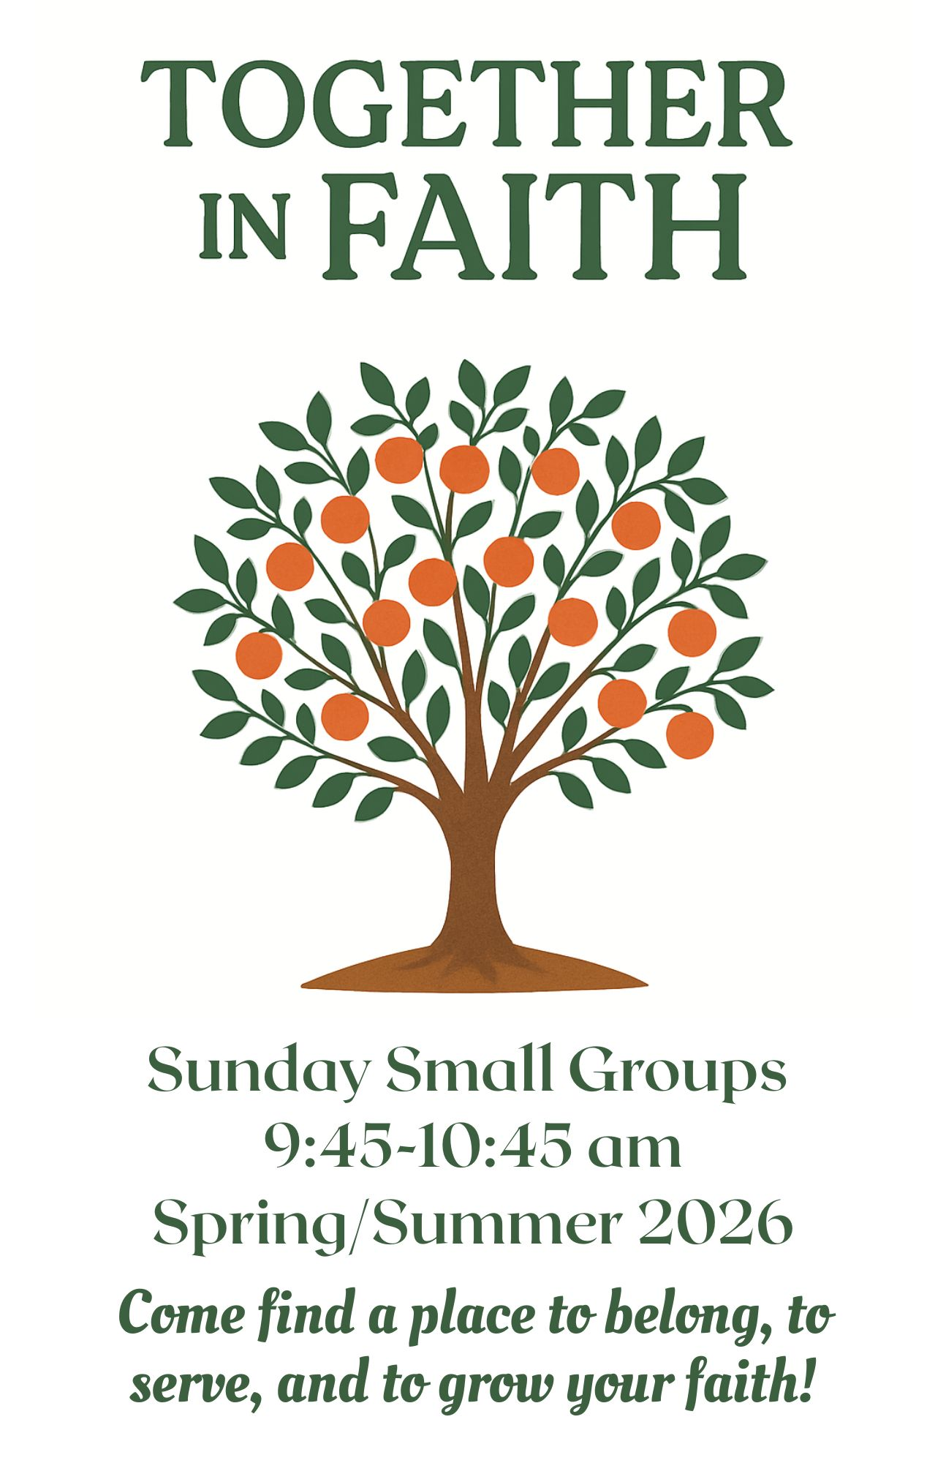

Find Your Place at Sierra Vista
At Sierra Vista, we believe faith grows best in community. Sunday Small Groups (Sunday School) are places to belong, to ask questions, and to share life with others on the journey of faith. You’re welcome to try out different groups until you find the one that feels like home. Whether you’re looking to deepen your faith, build new friendships, or discover ways to serve, there’s a place for you here. Come, grow and live the Jesus way—together.

Sunday Small Groups
9:45-10:45am

Children (Kinder -5th grade)
Room: LC105

Middle School Youth (6th-8th grade)
Room: LC101

High School Youth (9th-12th grade)
Room: LC211

The Bridge

Description: We are currently in our 30s-40s, bridging the gap between age groups. This fall we will

be studying Words of Life: Jesus and the Promise of the 10 Commandments Today, which corresponds with the fall sermon series. We also discuss highs and lows hoping to bridge the lows life can bring with the highs of God’s promises. Join us!

Room: LC202 (Located in the Life Center, 2nd floor)

Special Projects: Our mission is to change the light bulbs in the church as a way to actively contribute to

the needs of our church family.

Outside Fun: Playing pickleball or other active pursuits with kids/teens in tow.

Contact: Rebecca Webb (325) 650-8646

College Age / Young Adult
Description: 18-20+ year olds meet for this class to discuss faith, the Bible, and life in an informal,
relaxed environment. Anyone is invited to attend.
Room: LC206 (Located in the Life Center, 2nd floor)
Special Projects: Help with church functions, when available.
Contact Person: Joy Allen (325) 374-3314
Tracy McIver (325) 234-2985

Covenant
Description: Variety of ages gather for this class to
study topics based on the 12-Steps using Christian material.
Room: FH4 (Located next to the Fellowship Hall)
Special Projects: As the class sees a need.
Contact Person: Coral Jean Warren (325) 656-4787

Friends
Description: This class is made up of couples in their
50’s, 60’s and 70’s. They study a variety of topics and authors.
Room: LC209 (Located in the Life Center, 2nd floor)
Special Projects: Helping Hands; State School Christmas Project; Bunk & A Prayer; Texas Ramp Project;
and Church sponsored projects.
Contact Person: Frank Tipton (320) 374-3107

The Light
Description: This class provides a Bible study for all ages and walks of life, using the curriculum
Genesis to Revelation. “The Light” is not only what the individuals in this class try to
follow, but it is also who they seek to be.
Room: LC204 ( Life Center, 2nd floor)
Special Projects: Local Missions
Contact Person: Rick Mantooth at rick@mantoothfamily.com

Mary-Martha Class
Description: Mature, older adults gather for this class to study and discuss The Adult Bible Study
Series. Members contribute as they are able and care for one another like family.
Room: S-4 (Located off the Sanctuary Narthex)
Special Projects: Harvest Festival – Bake Sale; Meals for
the Elderly; Christmas/ Easter/ Thanksgiving Baskets; Bus Fund.
Contact Person: Laura Bloebaum (325) 944-1453

New Beginnings
Description: This class is composed of couples and
singles, retirement age and up.
Members love informal discussions. Lessons
range from Cokesbury Curriculum DVD-
based studies to individually prepared lessons. New ideas are welcome, and questions abound as members explore the intersection of faith, scripture, & life in today's world. ~ Lesson leading rotates among those who love to do so!
Room: FH1 (Adjacent to Fellowship Hall)
Special Projects: The primary mission support of the class is
for food-need ministries such as SV Food Ministry, Project Dignidad baskets and Kids Eat Free.
Contact Person: Sue Holdren, Class Coordinator phone (325) 245-7848; email goldenlyre62@gmail.com

Good Neighbors
Description: This class is composed of couples and
singles who desire to grow in their faith and connect with others. We use video based bible and topical studies, with input from the group as to what we want to study.
Room: LC208 (Life Center, 2nd floor)
Contact Person: Lauren Webster (512) 517-8624

The Penguins
Description: Couples and singles (ages 60+) gather for fellowship and peer-led Biblical discussion. They utilize the Cokesbury Adult Studies, as well as topical studies with DVDs.
Room: LC207 (Life Center, 2nd floor)
Special Projects: House of Faith; Children’s Bed Project; Salvation Army; Harvest Festival; Kid’s Eat Free
summer lunches, Mosaic Campus Ministry
Contact Person: Dean McIntyre (325) 234-7711
Suzette McIntyre (325) 234-1111

Seekers of New Life
Description: Adult seniors (ages 60 and up) gather to meet for adult Bible Study and discussion, using lectionary- based lessons. All ages are welcome.
Room: S-1 (Near the Sanctuary)
Special Projects: House of Faith; Concho Valley Home for Girls; Soup Kitchen; Exodus; KICK; and TLC.
Contact Person: Beverly Nevins (325) 949-6805
Mary McClure (325) 944-7733

Serendipity
Description: Multi-age (30-60’s), couples and singles — some with young and some with grown
children — gather in this class for discussion of a variety of topics and curriculum decided by the group and/or based on suggestions from the group. The class studies a variety of Bible-based lessons for faith-building with a relaxed, friendly atmosphere.
Room: LC210 (Located in the Life Center, 2nd Floor)
Special Projects: Texas Ramp Project; Goodfellow
AFB Exodus; Harvest Festival; SVUMC Food Ministry; and many more.
Contact: Melinda Springer at (325) 656-0365

TBD “To Be Disciples”
Description: Join us in TBD (To Be Disciples), a Sunday School class designed for couples in their 30s and 40s with young and school-age kids.
Fall Study Each week, we dig into practical topics like building a Christ-centered home, strengthening your marriage, raising kids with biblical values, finding peace in the chaos, and living out your faith in everyday life.
Room: LC202 (Life Center, 2nd floor)
Special Projects: Harvest Festival; SVUMC Food Ministry
Contact: David White 325-226-0463

“For where two or three
are gathered in my name, there am I among them.” – Jesus
Matthew 18:20

Our mission…
to grow a community that reflects Christ through
love, faith, and service.
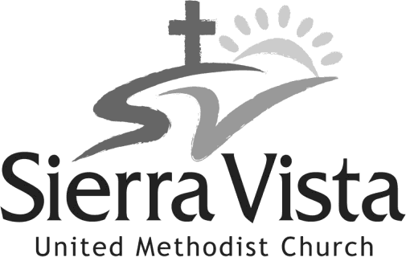

4522 College Hills Blvd.
San Angelo, Texas 76904
Church: (325) 944-4041
Email: office@sierravista.org Website: www.sierravista.org

