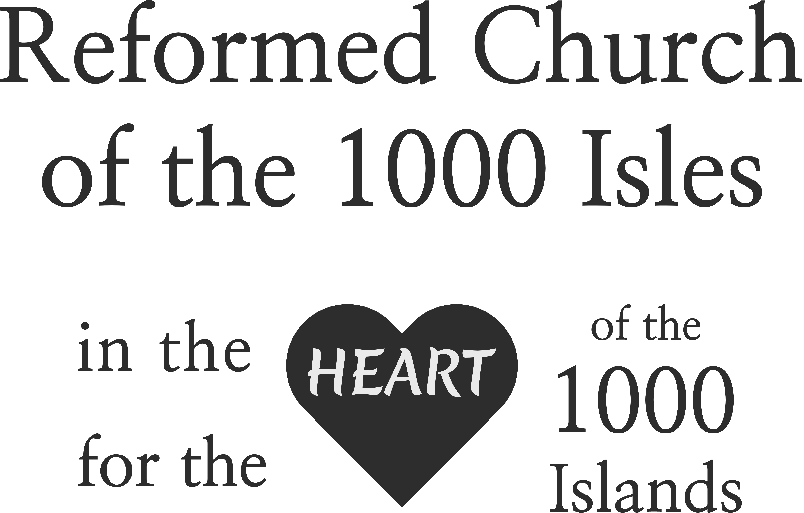

Worship 10:30 am
November 23, 2025

54 Church Street
Alexandria Bay, NY 13607

Email: church@reformed1000.org

315-629-9575

www.reformed1000.org
The Reformed Church
of the Thousand Isles

Please silence your cell phone
*Stand If You Are Able
Prelude
*Introit #562 “Rejoice Ye Pure In Heart”
Welcome

*Call to Worship (adapted from Psalm 118 )

Give thanks to the Lord, for God is good;
God’s love endures forever
Blessed is the one who comes in the name of the Lord.
From the house of the Lord we bless you.
You are my God, and I will praise you;
You are my God, and I will exalt you.
Give thanks to the Lord, for God is good;
God’s love endures forever

Songs of Praise

*We Believe
Great Are You Lord
*Living Hope

Apostles Creed
I believe in God, the Father almighty,
creator of heaven and earth.
I believe in Jesus Christ, his only Son, our Lord,
who was conceived by the Holy Spirit
and born of the virgin Mary.
He suffered under Pontius Pilate,
was crucified, died, and was buried;
he descended to hell.
The third day he rose again from the dead.
He ascended to heaven
and is seated at the right hand
of God the Father almighty.
From there he will come to judge
the living and the dead.
I believe in the Holy Spirit,
the holy catholic* church,
the communion of saints,
the forgiveness of sins,
the resurrection of the body,
and the life everlasting. Amen.

*When used with a lowercase “c”, the word catholic simply
means worldwide or universal.

Time With The Younger Church
Offertory Hymn #561 “We Gather Together”

Doxology
Prayer of Illumination
Scripture Hebrews 13:15-25
Sermon Jesus > Everything Week #28

The Celebration of the Sacrament of the Lord’s Supper

*Closing Song “The Blessing”

*Benediction
*We Leave to Serve
*Postlude

Nursery Available Downstairs during Sunday worship.
Live Stream Viewing and Online Giving
Available at www.reformed1000.org

Give Online – You can give electronically by going to www.reformed1000.org and select “Giving” tab.
You can also use the QR code to the right.



Worship Service Archive is available online on the church website.
Wednesday Morning Bible Study meets at 9 a.m. at church in Anchor Cafe. Everyone is welcome to attend. We are studying the Gospel of John. Our schedule of texts is as follows:
November 26th – No Meeting This Week
December 3rd – John 16:1-15
December 10th - John 16:16-33
December 17th – John 17:1-25
December 24th and 31st - No Meeting

RCTI Daily Bible Reading Plan is on Week #62.
Sign up to receive daily devotional email reminders by emailing church@reformed1000.org to request being added to the list.
Additional resources available on designated page on website.

ACTS Thrift Store and Food Pantry: Food Pantry open Thursdays. 42601 State Route 12 Phone: 315-686-3008 www.alexandriathriftstore.org

2025 Church Nursery Schedule

November
2nd - Cierra Trickey
9th- Lauren Buttgen
16th- Kristy Umstead
23rd - Barb McAloon
30th – Evelyn Lai

December
7th Alysa Huizenga
14th Heidi Sourwine
21st Karissa Hagar
28th Cierra Trickey

*Please be in the nursery at least 15 minutes before service begins.
If you are interested in serving in the nursery ministry in 2026 please reach out to Cierra Trickey - cierra_daily@yahoo.com

Sunday School - Children and Youth downstairs at 9:30 a.m.

Sunday Adult Bible Study at 9:30 a.m. in Jubilee Hall led by Charles and Pam Dougherty. Come each week and study the texts in the Bible reading plan.

Pastor Jeff loves to connect to offer pastoral care, discipleship and spiritual direction. The best way to connect with Pastor Jeff is just to ask him and he will eagerly find a time. Feel free to leave a message at 315-629-9575 / jmcilrath@icloud.com.
Pastor Jeff is “off” on Fridays so please manage your expectations for contact accordingly unless in the case of emergency.

5 PROJECT - $200K CAPITAL CAMPAIGN UPDATE
We have raised $163,731 which is 81% of our $200,000 goal. Help us reach our goal by the end of 2025 with a special gift to the Joshua Project / PTL Fund. $36,260 left to finish!

Activ8Her Women’s Ministry – We meet the 2nd and 4th Monday of each month at 6 p.m. No second meeting in November (11/24). Contact Jodi Cullen or Heather McIlrath for more info.

Men’s Ministry meets every 2nd and 4th Monday at 6 p.m. (same nights and time as Activ8Her) Next Meeting is November 24th and we meet downstairs in Room 1 /2.

Ministry Team at RCTI

Rev. Jeff McIlrath- Lead Pastor
Philip Lai- Director of Worship Arts
church@reformed1000.org
www.reformed1000.org
315-629-9575

Treasurer – Carol Ward - abaywards4@aol.com
Financial Team Coordinator – MemRee Byers - memreebyers@gmail.com
Hospitality Coordinators – Jody Beerman - rickbeer54@msn.com
Mary Gaffney - gaffneymary45@yahoo.com
Nursery Coordinator – Cierra Trickey sierra_daily@yahoo.com
Youth Ministry (PIER) – Pastor Jeff – jmcilrath@icloud.com

Elders: *Dan Byers – danielbyers72@gmail.com
Charles Dougherty - cdougherty1000@gmail.com
Mark Evans – cheesebox48@gmail.com
Gayle Hunneyman – g.hunneyman@yahoo.com

Deacons: Scott Adamowski – scott.adamowski@ghd.com
William Stowe - wstowe1210@yahoo.com
Debbie Hagan Homoki –deborahhagan0@gmail.com
**Mary Ellen Lingenfelter – mlink6@msn.com

*denotes consistory vice president ** denotes chair of deacons

No Spaghetti Dinner This Week
Due to Thanksgiving Holiday


Please Remember that Wednesday Night Ministry follows the Alexandria Central School schedule when it comes to closures for
holidays or weather.

Advent Begins
Sunday November 30, 2025
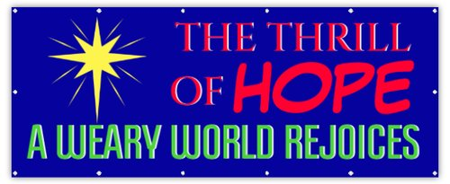

Angel TREE MINISTRY
Help us serve local families in need this Christmas by selecting a tag from the tree in Anchor Café and returning the unwrapped gift by December 7th – you are also invited to participate in our campaign to purchase 100 - $20 Walmart Cards by 12/7. Please remember to register any tags you take on the sign-up sheets next to the tree.

