Life Church at Wayside
Springfield, Oregon

Church Profile
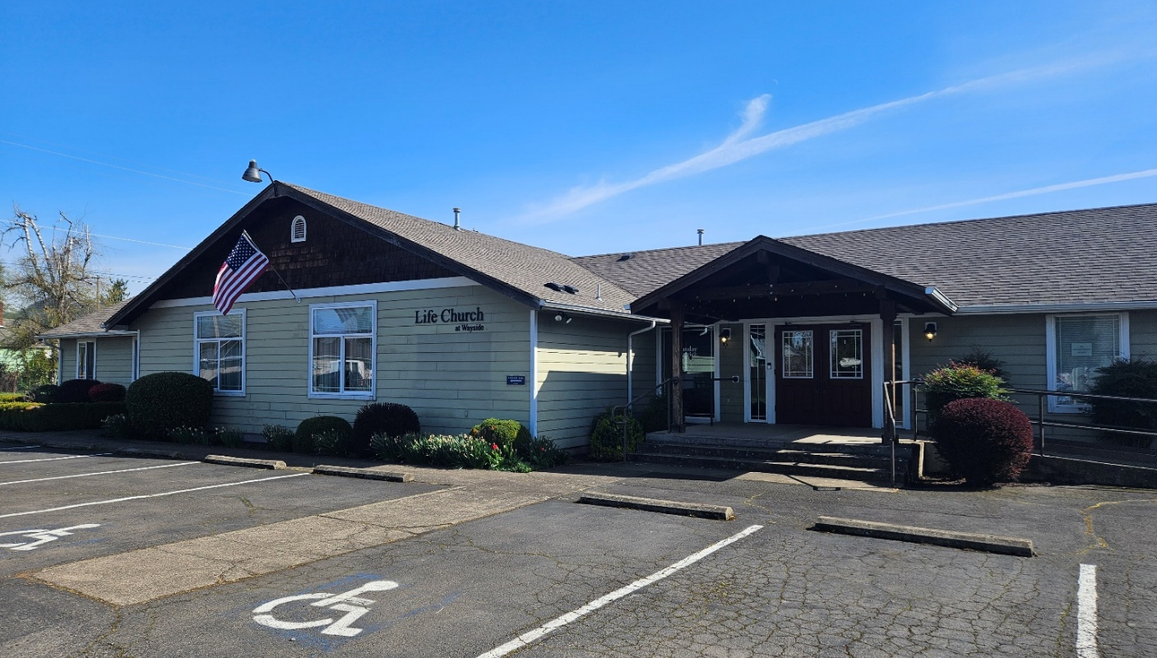

Mission Statement:
Following Jesus, Impacting the World

Community
Life Church at Wayside is located in Springfield, Oregon in the heart of Willamette Valley. Immediately adjacent to Eugene, the local area includes approximately 260,000 residents. The church is in a local neighborhood two blocks from Riverbend Elementary School.

The city of Springfield is within an hour of the beach and national forests. Two rivers flow through the area and offer great fishing or rafting opportunities. The Valley is full of attractions and activities including outdoor adventures, vineyards and wineries, skiing, and cultural attractions as well as historic landmarks.

Church
Life Church at Wayside was established in 1954 as Wayside Open Bible Chapel. Responding to the call of God and the urging of a local missionary, the church became a thriving outreach to the local community, especially to the children. Over the years the church has been a lighthouse to the city of Springfield. Typical attendance is 35 to 40 each Sunday.

With two decades of training and equipping children and their families to follow the Lord, Life Church at Wayside continued to grow and proclaim the gospel. The church supports a kingdom approach to ministry which includes serving the community, cooperation and collaboration with other area churches and ministries, and teaching, training, and equipping the body of Christ. This is a loving family committed to caring for and serving one another.

Life Church at Wayside is known as a place of prayer and worship where Jesus is exalted and proclaimed as the head of the church and the Son of God, because He is worthy. As a commitment to prayer, there is an ongoing two-hour worship and prayer night each week. They also partnered with about fifty other churches to pray together for the community and the church. They have hosted healing rooms and prayer summits.

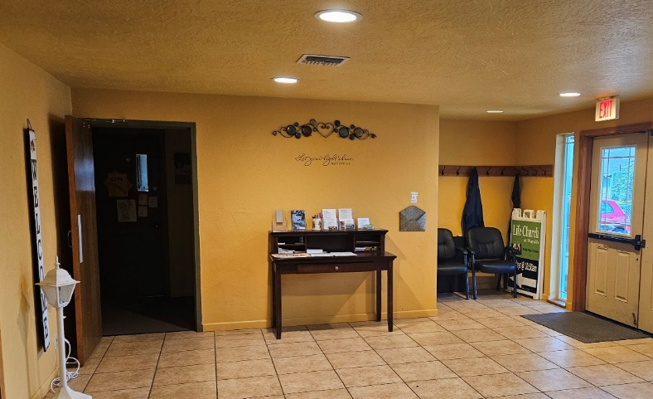
Facilities, Ministries, and Staff
The facility and property include a multi-purpose building that has a sanctuary that seats 75 to 80. The back doors of the sanctuary can be opened to accommodate larger crowds. There are three classrooms, a kitchen and dining area, and a nursery. The church owns a house next door along with a large piece of property with a play structure and van storage area. There is also an overflow parking lot. Sunday morning worship services are livestreamed on You Tube and have a new digital sound board and a good sound system in place.

The church has a Sunday morning worship service and a weekly Thursday night prayer and worship service. There are two weekly women’s bible studies and one men’s study. Partnering with the greater body of Christ, the church hosts another men’s Bible study each week, Christian Evangelism Fellowship meetings, and various livestream conferences and webinars as well as periodic worship nights.

Currently the staff includes an office administrator/associate pastor, a nursery worker, a children’s church worker, and a lead Pastor. All the positions receive a stipend each month.

Finances
Presently the church is debt free apart from the house adjacent to the church which is rented to cover the mortgage. The church is unable to meet its monthly obligations through tithing but has a substantial savings account to bridge the gap.

The church actively supports Open Bible through the 5% plan, MVP giving, and giving to missionaries.

At present the Lead Pastor role should be seen as a tent making role that, with growth, the church would fully support the Pastor.

Pastoral Candidate
Life Church at Wayside is seeking a Lead Pastor with the following qualities:

• Prioritizes their relationship with Jesus and models a vibrant spiritual life.
• Gifted communicator and preacher.
• Spirit-filled, able to listen and follow the prompting of the Holy Spirit.
• Models, godly character, and lifestyle
• Humble Servant Leader considering the needs of others and the Church.
• Able to acknowledge the gifting of others and empower them to grow.
• Has a Kingdom approach to ministry and body life.
• Has and encourages a positive attitude that overcomes difficulty.
• Lifelong Learner seeking to grow and develop as a leader, pastor, and follower of Christ.

To Respond
Those wishing to be considered for the position should send a resume with photo to the Regional and District Director by DATE.

Chris Hansler, Regional Director Chuck Gustafson
Pacific Region of Open Bible Oregon District Director
2320 Warren Street 433 SW 5th
Eugene, OR 97405 Redmond, OR 97756
Chris@pacificopenbible.com Chuck@desertsong.org

