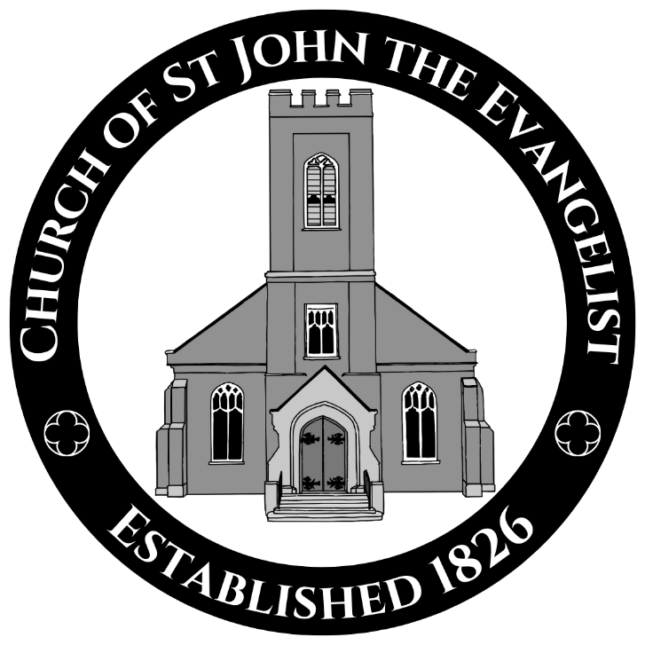
Peterborough’s Oldest Church—Established 1826
99 Brock Street, Peterborough Ontario K9H 2P2
705-745-7624 www.stjohnspeterborough.ca
The Twenty-First Sunday after Pentecost
October 18th, 2026—10:00 a.m.

Welcome.

This church is a place of prayer and encounter with God. The stones of these walls have sheltered people seeking the presence of the Holy One for two centuries. This place of worship has been made hallowed by the prayers of generations and you are welcome to join your heart and voice to theirs.

St John’s is an inclusive community of faith in the Anglican tradition: we welcome saints and sinners, people of faith and of no faith, people who are sure they know everything and those who are full of questions. All persons may share equally in the life and leadership of our church and we worship with and serve people of different ethnicities, politics, gender identities and sexual orientations, economic circumstances, and abilities. This church belongs to God, so all of God’s children are welcome here.
The Gathering of the Community

We gather in this place in person and virtually and we acknowledge that we are in Nogojiwanong, the traditional territory of the Mississauga Anishinaabe, the Original inhabitants and stewards of this part of the Creation, on whose land and by whose waters we gather by the Williams Treaty to worship, listen, learn, share, and heal together in the name of our Creator, the Holy One of Blessing.

Prelude Two Preludes on “Adore Te” C.V. Stanford; Barrie Cabena
“Adore Te” arr. Jason W. Krug, Cantabile Ringers

The Congregation stands as the hymn begins.

Hymn 328—Lo, God Is Here! Let Us Adore St Catherine (St. Finbar)

The Greeting
Presider The grace of our Lord Jesus Christ,
and the love of God,
and the fellowship of the Holy Spirit,
be with you all.
People And also with you.

Collect for Purity
Presider Almighty God,
All to you all hearts are open,
all desires known
and from you no secrets are hidden,
Cleanse the thoughts of our hearts
by the inspiration of your Holy Spirit,
that we may perfectly love you,
and worthily magnify your holy name;
through Christ our Lord. Amen.

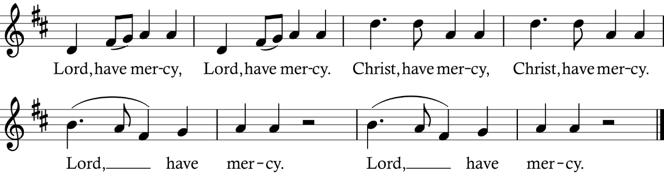
Kyrie Eleison

Collect of the Day
Presider O God, whose image we bear and whose name we carry, yours is the world and all it contains. Recall us to our true allegiance, so that above the powers and rulers of this world you alone may claim our loyalty and love. We make our prayer through our Lord Jesus Christ, your Son, who lives and reigns with you in the unity of the Holy Spirit, God for ever and ever.
All Amen.

The Congregation sits.

The Proclamation of the Word

First Reading Exodus 33:12-23
Reader A reading from the Book of Exodus.

Moses said to the Lord, "See, you have said to me, 'Bring up this people'; but you have not let me know whom you will send with me. Yet you have said, 'I know you by name, and you have also found favour in my sight.' Now if I have found favour in your sight, show me your ways, so that I may know you and find favour in your sight. Consider too that this nation is your people." He said, "My presence will go with you, and I will give you rest." And he said to him, "If your presence will not go, do not carry us up from here. For how shall it be known that I have found favour in your sight, I and your people, unless you go with us? In this way, we shall be distinct, I and your people, from every people on the face of the earth." The Lord said to Moses, "I will do the very thing that you have asked; for you have found favour in my sight, and I know you by name." Moses said, "Show me your glory, I pray." And he said, "I will make all my goodness pass before you, and will proclaim before you the name, 'The Lord'; and I will be gracious to whom I will be gracious, and will show mercy on whom I will show mercy. But," he said, "you cannot see my face; for no one shall see me and live." And the Lord continued, "See, there is a place by me where you shall stand on the rock; and while my glory passes by I will put you in a cleft of the rock, and I will cover you with my hand until I have passed by; then I will take away my hand, and you shall see my back; but my face shall not be seen."
Hear what the Spirit is saying to the Church.
People Thanks be to God.

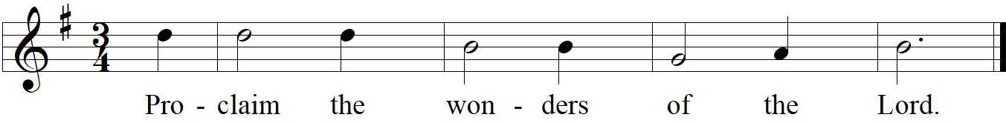
Psalm 99
The Cantor sings the verses; the Congregation joins in the Refrain (R).
The Lord is King; let the people tremble; he is enthroned upon the cherubim; let the earth shake. R.
The Lord is great in Zion; he is high above all peoples. Let them confess his Name, which is great and awesome; he is the Holy One. R.
"O mighty King, lover of justice, you have established equity; you have executed justice and righteousness in Jacob." Proclaim the greatness of the Lord our God and fall down before his footstool; he is the Holy One. R.
Moses and Aaron among his priests, and Samuel among those who call upon his Name, they called upon the Lord, and he answered them. He spoke to them out of the pillar of cloud; they kept his testimonies and the decree that he gave them. R.
"O Lord our God, you answered them indeed; you were a God who forgave them, yet punished them for their evil deeds." Proclaim the greatness of the Lord our God and worship him upon his holy hill; for the Lord our God is the Holy One. R.

Second Reading 1 Thessalonians 1:1-10
Reader A reading from the Letter of Paul to the Thessalonians.
Paul, Silvanus, and Timothy, To the church of the Thessalonians in God the Father and the Lord Jesus Christ: Grace to you and peace. We always give thanks to God for all of you and mention you in our prayers, constantly remembering before our God and Father your work of faith and labour of love and steadfastness of hope in our Lord Jesus Christ. For we know, brothers and sisters beloved by God, that he has chosen you, because our message of the gospel came to you not in word only, but also in power and in the Holy Spirit and with full conviction; just as you know what kind of persons we proved to be among you for your sake. And you became imitators of us and of the Lord, for in spite of persecution you received the word with joy inspired by the Holy Spirit, so that you became an example to all the believers in Macedonia and in Achaia. For the word of the Lord has sounded forth from you not only in Macedonia and Achaia, but in every place your faith in God has become known, so that we have no need to speak about it. For the people of those regions report about us what kind of welcome we had among you, and how you turned to God from idols, to serve a living and true God, and to wait for his Son from heaven, whom he raised from the dead Jesus, who rescues us from the wrath that is coming.
Hear what the Spirit is saying to the Church.
People Thanks be to God.
The Congregation stands.

Hymn 505—Be Thou My Vision Slane

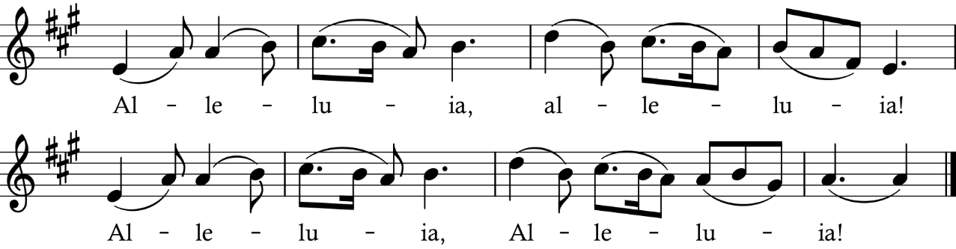
Gospel Acclamation (sung before and after the Gospel)

Gospel Matthew 22:15-22
Gospeller May God be with you.
People And also with you.

Gospeller The Holy Gospel of our Saviour Jesus Christ according to Matthew.
People Glory to you, Jesus the Christ.

Gospeller Then the Pharisees went and plotted to entrap Jesus in what he said. So they sent their disciples to him, along with the Herodians, saying, "Teacher, we know that you are sincere, and teach the way of God in accordance with truth, and show deference to no one; for you do not regard people with partiality. Tell us, then, what you think. Is it lawful to pay taxes to the emperor, or not?" But Jesus, aware of their malice, said, "Why are you putting me to the test, you hypocrites? Show me the coin used for the tax." And they brought him a denarius. Then he said to them, "Whose head is this, and whose title?" They answered, "The emperor's." Then he said to them, "Give therefore to the emperor the things that are the emperor's, and to God the things that are God's." When they heard this, they were amazed; and they left him and went away.

The Gospel of Christ.
People Praise to you, Jesus the Christ.

The Congregation sits.

Sermon

A silence for reflection follows the sermon.

The Congregation stands at the invitation of the Presider.
Affirmation of Faith and the Baptismal Covenant
Presider Let us affirm our faith and renew our baptismal covenant.
All I believe in God,
the Father almighty,
creator of heaven and earth.
I believe in Jesus Christ,
his only Son, our Lord.
He was conceived by the power of the Holy Spirit
and born of the Virgin Mary.
He suffered under Pontius Pilate,
was crucified, died, and was buried.
He descended to the dead.
On the third day he rose again.
He ascended into heaven,
and is seated at the right hand of the Father.
He will come again to judge the living and the dead.
I believe in God the Holy Spirit,
the holy catholic Church,
the communion of saints,
the forgiveness of sins,
the resurrection of the body,
and the life everlasting.
I will continue in the apostles’ teaching and fellowship,
in the breaking of bread, and in the prayers.
I will persevere in resisting evil and,
whenever I fall into sin, repent and return to the Lord.
I will proclaim by word and example
the good news of God in Christ.
I will seek and serve Christ in all persons,
loving my neighbours as myself.
I will strive for justice and peace among all people,
and respect the dignity of every human being.
I will strive to safeguard the integrity of God’s creation,
and respect, sustain, and renew the life of the Earth. Amen.

The Prayers of the People

Confession and Absolution
Presider Dear friends in Christ, God is steadfast in love and infinite in mercy; welcoming sinners and inviting them to the table. Let us confess our sins, confident in God’s forgiveness.
Silence
Most merciful God,
All we confess that we have sinned against you
in thought, word, and deed,
by what we have done,
and by what we have left undone.
We have not loved you with our whole heart;
we have not loved our neighbours as ourselves.
We are truly sorry and we humbly repent.
For the sake of your Son Jesus Christ,
have mercy on us and forgive us,
that we may delight in your will,
and walk in your ways,
to the glory of your name. Amen.

The Peace
Presider The peace of Christ be always with you.
All And also with you.

Please turn to the people around you and exchange a sign of God’s peace.

Celebration of the Eucharist

At the Offertory, gifts of bread and wine, signs of the fruit of human labour, are brought to the altar to be transformed into the Body and Blood of Jesus Christ, signs of God’s love for the world. The money offering, a sign of our gratitude for God’s blessing of our lives, collected before the liturgy, is blessed.

Hymn 381—Praise, My Soul Praise, My Soul

Prayer over the Gifts
Presider Beloved God, you spread before us a table of plenty, and give us the cup of new life to drink. Receive all we offer this day with our grateful thanks and praise, in the name of Jesus Christ our Saviour.
All Amen.
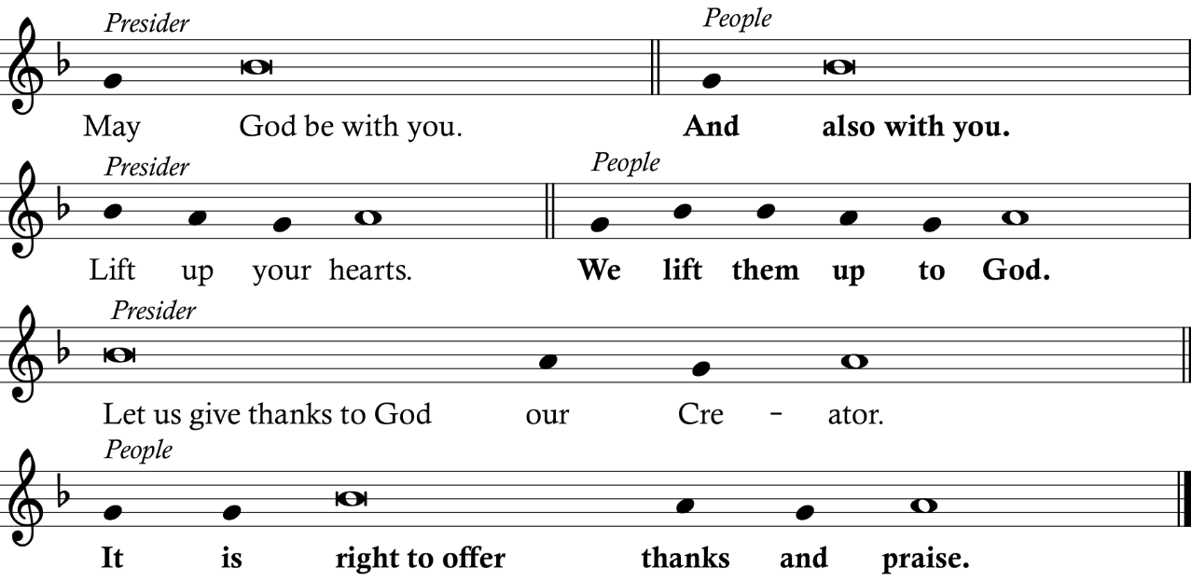
Eucharistic Prayer

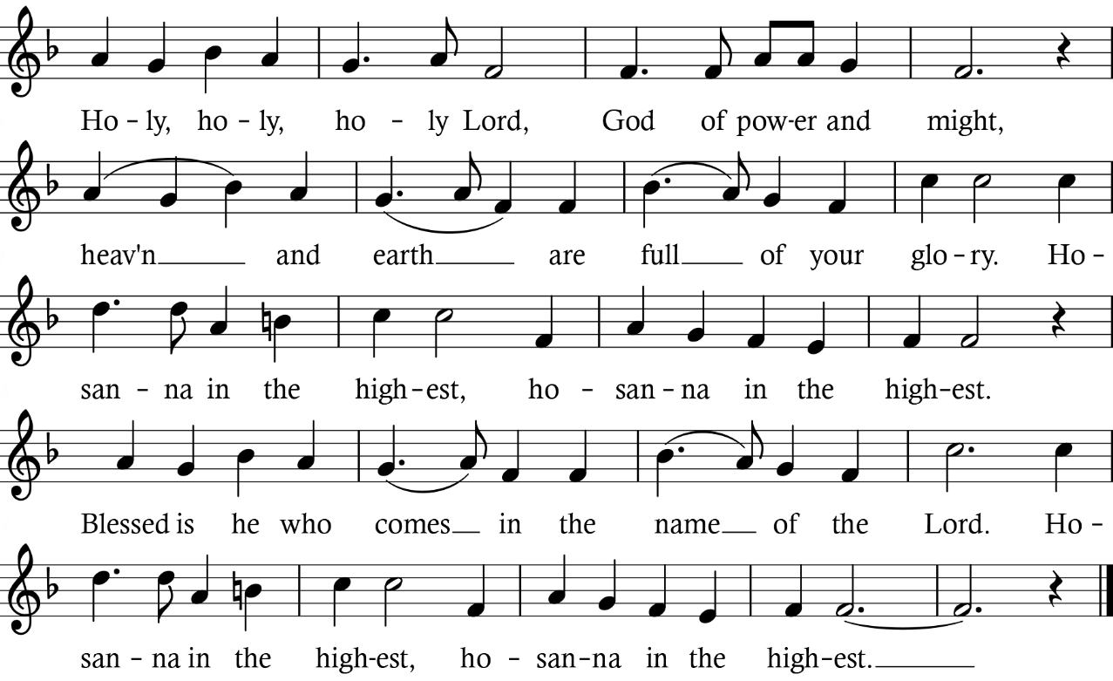
Presider It is indeed right to thank you and praise you, holy and gracious God, creator of all things, ruler of heaven and earth, sustainer of life, for you are the source of all goodness, rich in mercy and abounding in love; you are faithful to your people in every generation, and your word endures for ever. Therefore with angels and archangels, with the fellowship of saints and the company of heaven, we glorify your holy name, evermore praising you and singing:

Presider We praise you, merciful Father, not as we ought, but as we are able, because in your tender love you gave the world your only Son, in order that the world might be saved through him. He made you known by taking the form of a servant, healing the sick,
liberating the oppressed, reaching out to the lost.
Betrayed, reviled, and nailed to the cross, he confronted the power of sin and disarmed it for ever. In his offering of himself, he became the perfect and sufficient sacrifice
for the sins of the whole world. Redeemed by Christ, we have been adopted as your children; by your pardon you have made us worthy to praise you.
On the night he was betrayed, Jesus, at supper with his friends, took bread, gave you thanks, broke the bread, gave it to them, and said, “Take and eat: this is my body which is given for you. Do this for the remembrance of me.” After supper he took the cup of wine, and when he had given thanks, he gave it to them, and said, “Drink this all of you: this is my blood of the new covenant which is shed for you and for many for the forgiveness of sins. Whenever you drink it, do this for the remembrance of me.”
In obedience to him and with grateful hearts we approach your holy table, remembering our Saviour’s sacrifice, and rejoicing in his victory. Confident in his sovereign purpose, we declare our faith.
All Christ has died,
Christ is risen,
Christ will come again.

Presider Send your Holy Spirit on us that as we receive this bread and this cup we may partake of the body and blood of our Lord Jesus Christ, and feed on him in our hearts
by faith with thanksgiving.
May we be renewed in his risen life, filled with love, and strengthened in our will to serve others; and make of our lives, we pray, a pure and holy sacrifice, acceptable to you, knitting us together as one in your Son Jesus Christ, to whom, with you and the Holy Spirit, be all honour and glory, now and forever.
All Amen.

The Lord’s Prayer
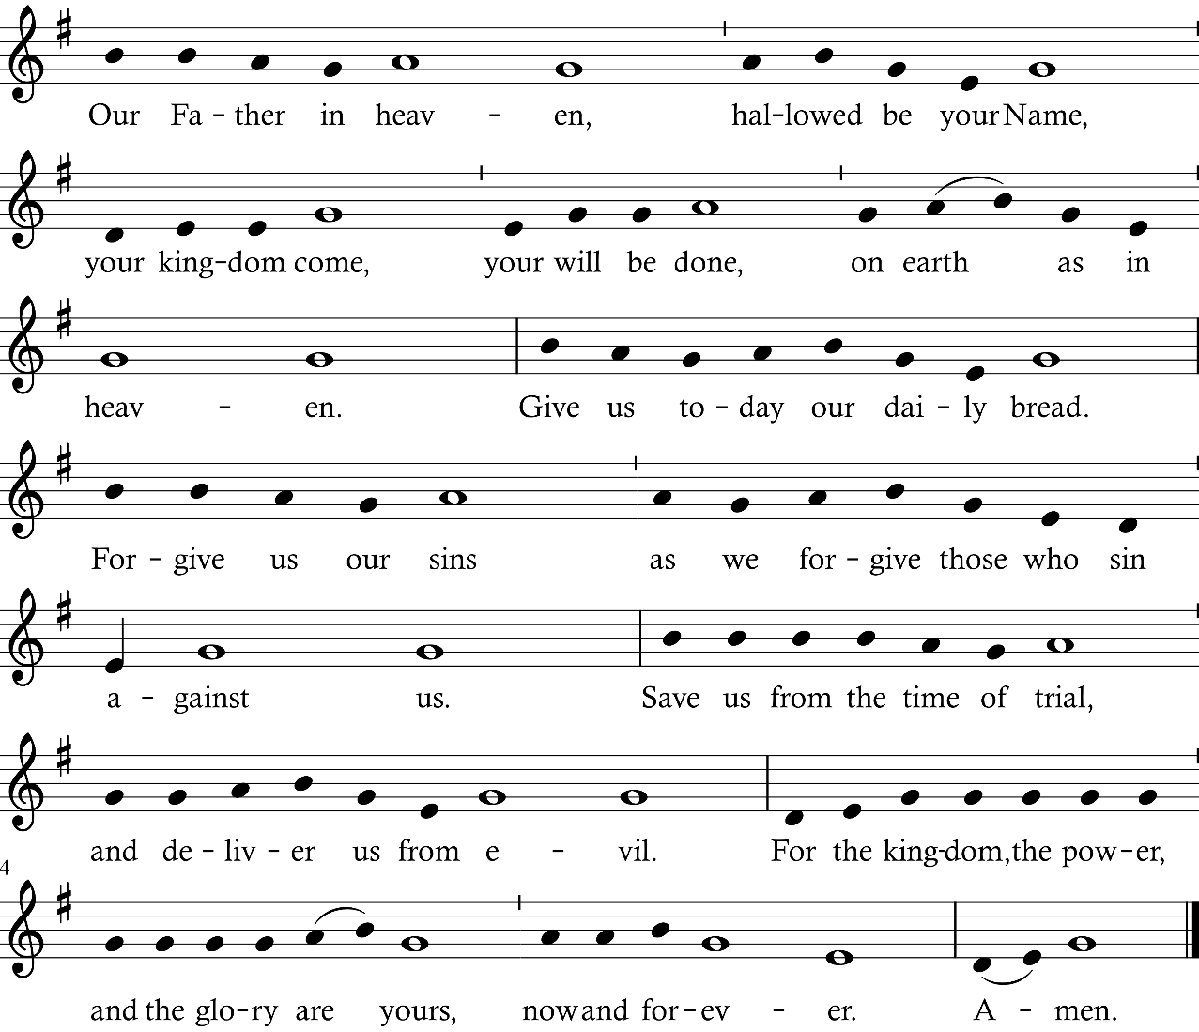
Presider As our Saviour taught us, let us pray,

Breaking of the Bread
Presider Creator of all, you gave us golden fields of wheat,
whose many grains we have gathered and made into this one bread.
All So may your Church be gathered from the ends of the earth into your kingdom.

Presider The gifts of God for the People of God.
All Thanks be to God.

Presider Dear friends, I invite you in this moment, wherever you may be, to receive Christ, in communion with the saints, and the gathering of God’s people, unseen and yet present with us now. In this Eucharist, many are made one.
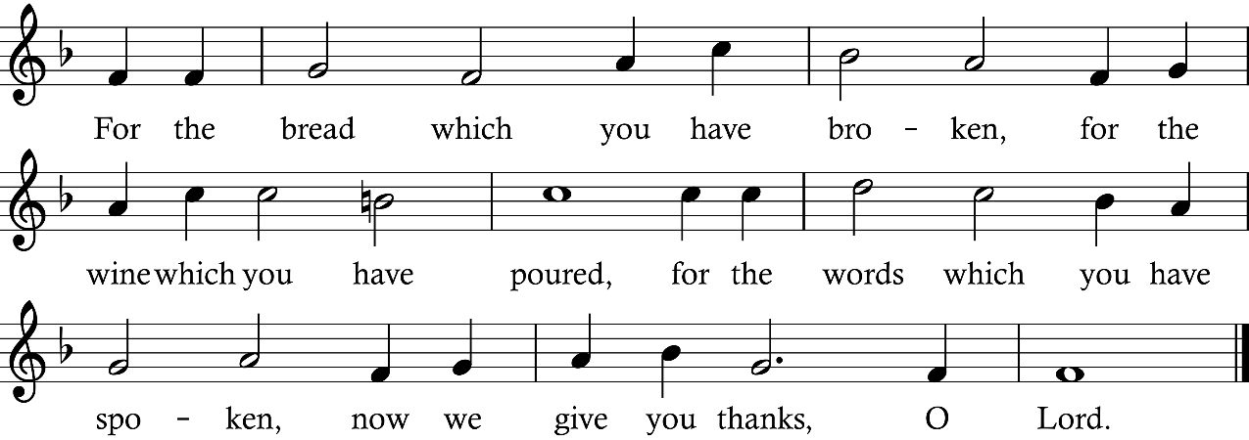
Fraction Anthem 74

The Congregation sits.

Communion
For those who are present in person, all baptised persons may receive Communion. Please come forward to the Chancel step via the centre aisle and return to your seat via the side aisles. Gluten free Hosts are available upon request. Those who find walking difficult may request that Communion be brought to them. Those who wish to receive a blessing instead of Communion may indicate their desire by crossing their arms over their breast when they approach the Presider.

Hymn: 76—Thee We Adore, O Hidden Saviour Thee Adoro Te

Duet “Prayer of St. Richard of Chichester” L.J. White;
soloists Robyn Hawthorne and Lucas Paradis
O holy Jesus, most merciful redeemer, friend and brother, may I know thee More clearly, love thee more dearly and follow thee more nearly. Amen. (Text: St. Richard of Chichester 1197-1253)

Anthem “O for a Closer Walk with God” C.V. Stanford
Choir O for a closer walk with God, a calm and heav’nly frame; a light to shine upon the road that leads me to the Lamb! Return, O holy Dove, return! Sweet messenger of rest; I hate the sins that made thee mourn and drove thee from my breast. So shall my walk be close with God, calm and serene
my frame; so purer light shall mark the road that leads me to the Lamb.
(Text: William Cowper 1731-1800)

Commissioning and Sending

Announcements

Prayer after Communion
Presider All your works praise you, O Lord,
All and your faithful servants bless you.
Gracious God, we thank you for feeding us
with the body and blood of your Son Jesus Christ.
May we, who share his body, live his risen life;
we, who drink his cup, bring life to others;
we, whom the Spirit lights, give light to the world.
Keep us firm in the hope you have set before us,
so that we and all your children shall be free,
and the whole earth live to praise your name;
through Christ our Lord. Amen.

Blessing

Hymn 631—The Kingdom of God Is Justice and Joy Paderborn

Dismissal
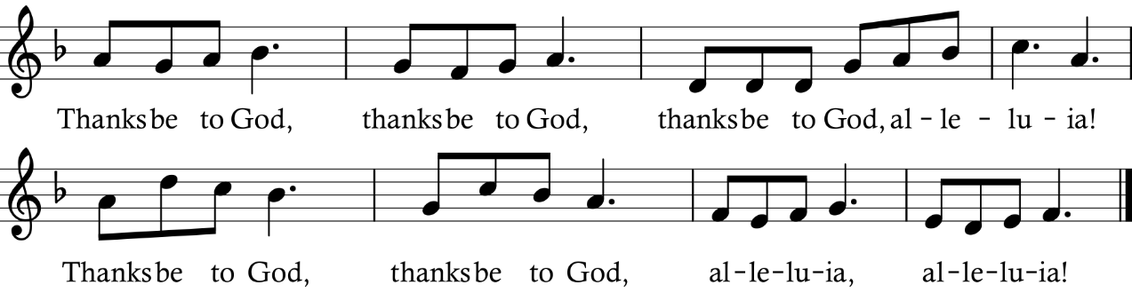
Presider Followers of Jesus, inspired by the Holy Spirit, serve the world God loves!
All

Postlude Postlude on a Theme of Orlando Gibbons C.V. Stanford

TODAY’S MUSIC

PRELUDE: Today’s communion hymn “Adoro Te Devote” (Thee We Adore) receives three varied settings this morning. The words are a prayer written by Thomas Aquinas, sung to an anonymous 13th Century plainsong tune. The French composer, professor and organist Alexandre Guilmant (1837-1911) wrote a set of ten books entitled L’Organiste Liturgique, containing numerous preludes on various plainsong chants. His “Offertoire on Adoro Te” is in the form of a moderately quiet but rhythmic fugue, using the first phrase of the hymn, with added notes, as the theme for his fugue. After going through various keys, both major and minor, the theme enters for a final time, back in the home key of F major. Contrasting this is a setting by Canadian composer Barrie Cabena (1933-2025). His peaceful setting places the tune in both the pedals and one bar later in the right hand, enveloping an accompaniment of mainly sustained chords. The third setting of the hymn is in the form of a handbell arrangement by American composer Jason W. Krug. His haunting setting includes the use of handchimes for the familiar melody, surrounded by block chords. After some original music by the composer, the melody returns in the bass bells, while the upper bells play with mallets. A hint of Christmas creeps in with the inclusion of a few phrases of “Of the Father’s Love Begotten”. The tune returns, followed by another entrance of his original music, and the piece concludes quietly.

DUET: L.J. White (1910-1973) was a British composer, organist and Deputy Head of St. Andrew’s School in London. He is best known for his two-part treble voice anthem “A Prayer of St. Richard of Chichester”, which uses a 13th century text by St. Richard, who is said to have spoken the words of the prayer on his deathbed – words popularized in the song “Day by Day” from the Broadway musical Godspell.

ANTHEM: The Chancel Choir dips into traditional Anglican repertoire today and offers Irish composer Charles Villiers Stanford’s beautiful setting of William Cowper’s text “O for a Closer Walk with God”. It is an expanded arrangement for choir and organ of the familiar tune to those words. The name of the hymn-tune is “Caithness”, first published in the 1635 Scottish Psalter. Stanford (1852-1924) was also a teacher at the Royal College of music in London, and is a significant musical figure in the Anglican tradition, having written numerous anthems and settings of the morning and evening canticles.

POSTLUDE: Continuing with the music of C.V. Stanford, we hear his “Postlude on a Theme of Orlando Gibbons”, from his second set of “Six Short Preludes and Postludes”, Op. 105. It is based on Gibbon’s hymn-tune “Song 22” which is sung in some denominations to the words “Love of the Father, Love of God the Son”, although those words have fallen out of use recently. Stanford took snippets of the tune and expanded upon them, creating a majestic work that builds to full organ at the end.

Liturgical Ministers

Presider and Preacher The Rev. Canon Brad Smith
Organist Robert Grandy
Cantors Alex Meinhardt
Tower Chimes Glen Caradus
Greeters John Perkins
Readers
Intercessor Ian Storey
Sacrist Owen van Slageren
Crucifer Cathy Brunger
Server Elijah van Slageren
Chalice Administrators Ian Storey
Chancel Betty Hinton, Trisha Black and Sandy Hoult
Refreshments Hosts St Margaret’s Guild
A/V Andrew Vreugdenhil

Acknowledgements

The liturgy is from the Book of Alternative Services (1985) copyright © 2004 by the General Synod of the Anglican Church of Canada. All rights reserved. Reproduced under license from ABC Publishing, Anglican Book Centre, a ministry of the General Synod of the Anglican Church of Canada, from Anglican Liturgical Library. Further copying is prohibited. And from “Trial Use Collects for Years A, B, & C and Seasonal Prayers over the Gifts and After Communion” (Toronto: the Propers Working Group of the Liturgy Task Force of General Synod, 2016). Eucharistic Prayer adapted from the Scottish Liturgy (1982), 1996 revision, used with permission. Scripture quotations from the New Revised Standard Version Bible: Anglicized Edition, copyright © 1989, 1995 National Council of the Churches of Christ in the United States of America. Used by permission. All rights reserved worldwide. Music is from Common Praise (1998) or copied and broadcast/archived under CCLI # 2281450 or One License # A-729171. Psalm words trad., chant © 2001 George Black, used with permission. Gospel Acclamation, music © 1985 Fintan O’Carroll and Christopher Walker, published by OCP Publications, all rights reserved. “Holy, Holy, Holy Lord”, words traditional; music Community Mass, Richard Proulx © 1971, 1977, G.I.A. Publications, Inc., used with permission under One License. The Lord’s Prayer, words traditional, in the public domain; setting McNeil Robinson © 1979, Theodore Presser Co., used with permission. “For the Bread Which You Have Broken”, words Louis Fitzgerald Benson, alt; melody Gross Catholisch Gesangbuch, Nurnberg, 1631; arr. William Smith Rockstro; in the public domain. Hymns: “Lo, God Is Here! Let Us Adore” words Gerhard Tersteegan, tr. John Wesley, alt.; music Henri F. Hemy; adapt. James G. Walton; in the public domain. “Be Thou My Vision”, words 8th cent. Irish hymn, tr. Mary Elizabeth Byrne, vers. Eleanor H. Hull, alt., in the public domain; music Martin Shaw, alt.; arr.© Oxford University Press, used with permission. “Praise, My Soul”, words Ps. 103, para. Henry Francis Lyte; music John Goss; in the public domain. “Thee We Adore, O Hidden Saviour, Thee”, words Thomas Aquinas, tr. James Russell Woodford, alt.; melody Mode 5, Processionale, Paris, 1697; in the public domain; harm. © Margaret Dryman, used with permission. “The Kingdom of God is Justice and Joy” words Byrn Austin Rees © Olwen A. Scott; music German trad. Melody, harm. attrib. Sydney Hugo Nicholson, Hymns Ancient and Modern, 2nd Supplement, 1916; in the public domain.
To the right are some commonly-asked questions by visitors. If you have a question that is not answered here, please do not hesitate to ask one of the greeters or clergy for assistance.
Welcome!

Children’s Ministry
We welcome children and youth, who may remain with you to worship and do not have to remain perfectly still and quiet! Please feel free to allow them to roam if they wish. Families are most welcome to use the activities in the children’s area in the church and to bring colouring sheets, toys, and snacks for their children.

On Posture in Worship
It is customary that we stand to pray and sing and sit to hear God’s Word proclaimed and interpreted. Some people prefer to kneel to pray. Please adopt the posture that helps you to worship.

Visitor’s Cards
If you’re visiting, please do take the time to complete a visitor’s card, which can be found in the rack on the bookcase in the Chapel. We would love the opportunity to stay in touch with you.

Making an Offering (Donation)
To support the ministry of the parish, an offering may be made by placing cash or a cheque in an envelope available where you picked up this order of service. Please write your name and address on the envelope, then place it on the brass offering plate. Tax receipts are issued for gifts of $25 or more. We also have a convenient pre-authorised giving program for monthly donations that are debited from your bank account or we accept e-transfers to office@stjohnspeterborough.ca. Please visit www.stjohnspeterborough.ca/donate for more information.

Accessibility
The facility is entirely accessible through the Brock St entrance, from where all levels of the facility are accessible via elevator.

Washrooms/Change Table
Accessible washrooms are located down the hall from the narthex (lobby). A change table is in the Armour Room at the end of the hall.

Fragrances
We ask that you refrain from wearing strong fragrances in order to accommodate those with breathing sensitivities.

Fellowship & Refreshments
All are welcome to stay after the liturgy for fellowship and refreshments in the Guild Hall.

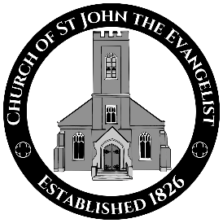

The Rev. Canon Brad Smith
Rector

The Rev. Ruth Adams
The Rev. Mary Bell-Plouffe
The Rev. Steve Smith
Honorary Assistants

Mr. Robert Grandy
Director of Music

Dr. Andrew Vreugdenhil
Mr. Colin Walsh
Churchwardens

Mrs. Tammy Delahey
Deputy Churchwarden

Mrs. Carolyn Porteous
Parish Administrator

stjohnspeterborough.ca

www.facebook.com/
StJohnsPtbo

Instagram
@stjohnspeterborough

