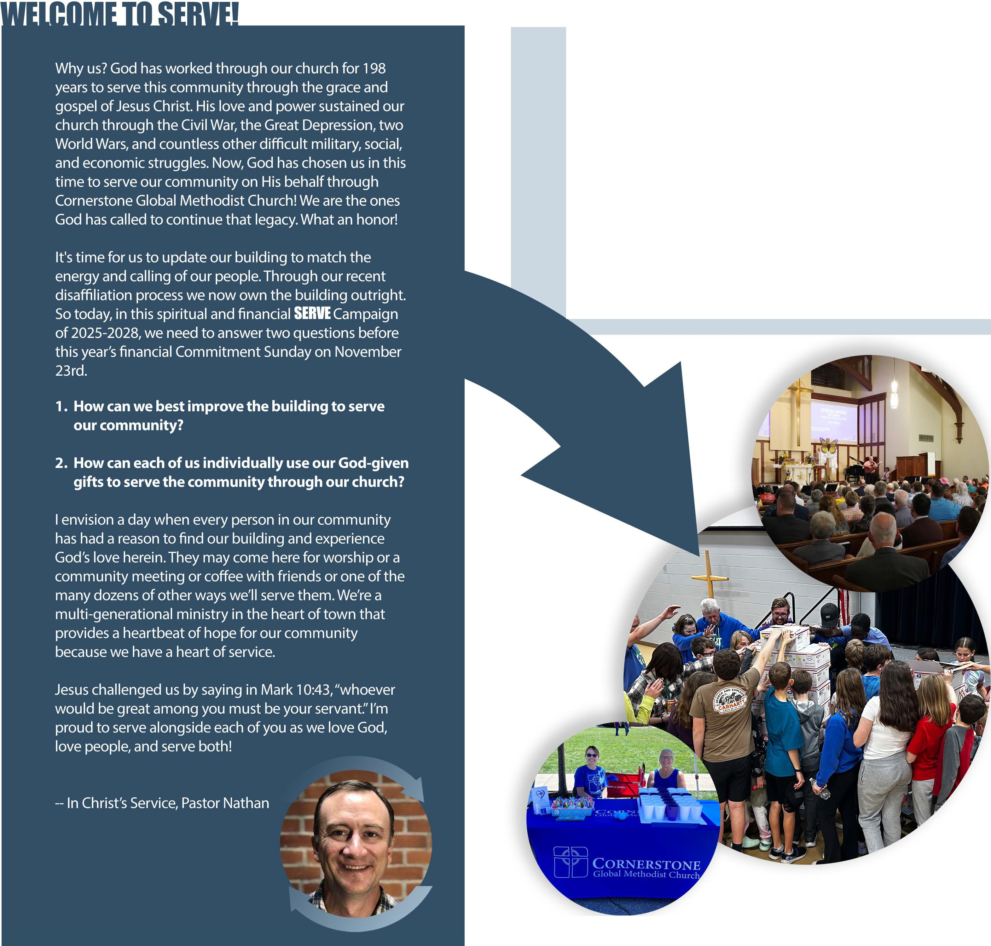


Please PRAY for the overall plans to be what GOD wants, and for your own participation: how does God want you to participate in this SERVE campaign? We'll utilize much volunteer help throughout this year and then receive financial pledges in November.

Please stav informed! We'll create an extensive booklet with more information as it is developed and hold other meetings and discussion times over the next 6 months. So please listen, read, and attend whenever possible to know and share the details. You can be our ambassador of good information!

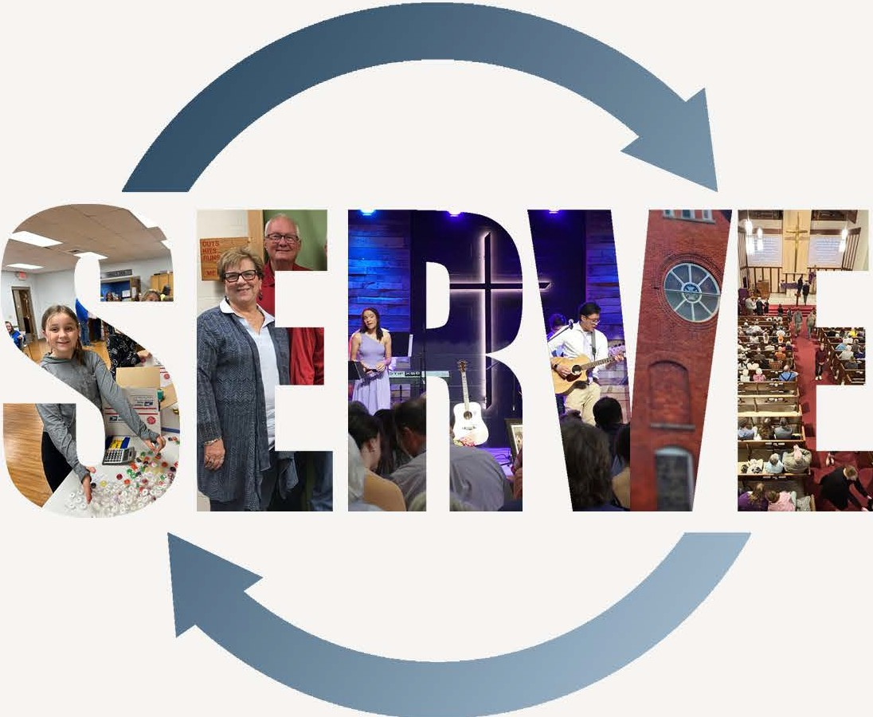

207S.ConnStreet• Marvsville, OH • 43040 • (9371642-4712 • info@ourcornerstone.org

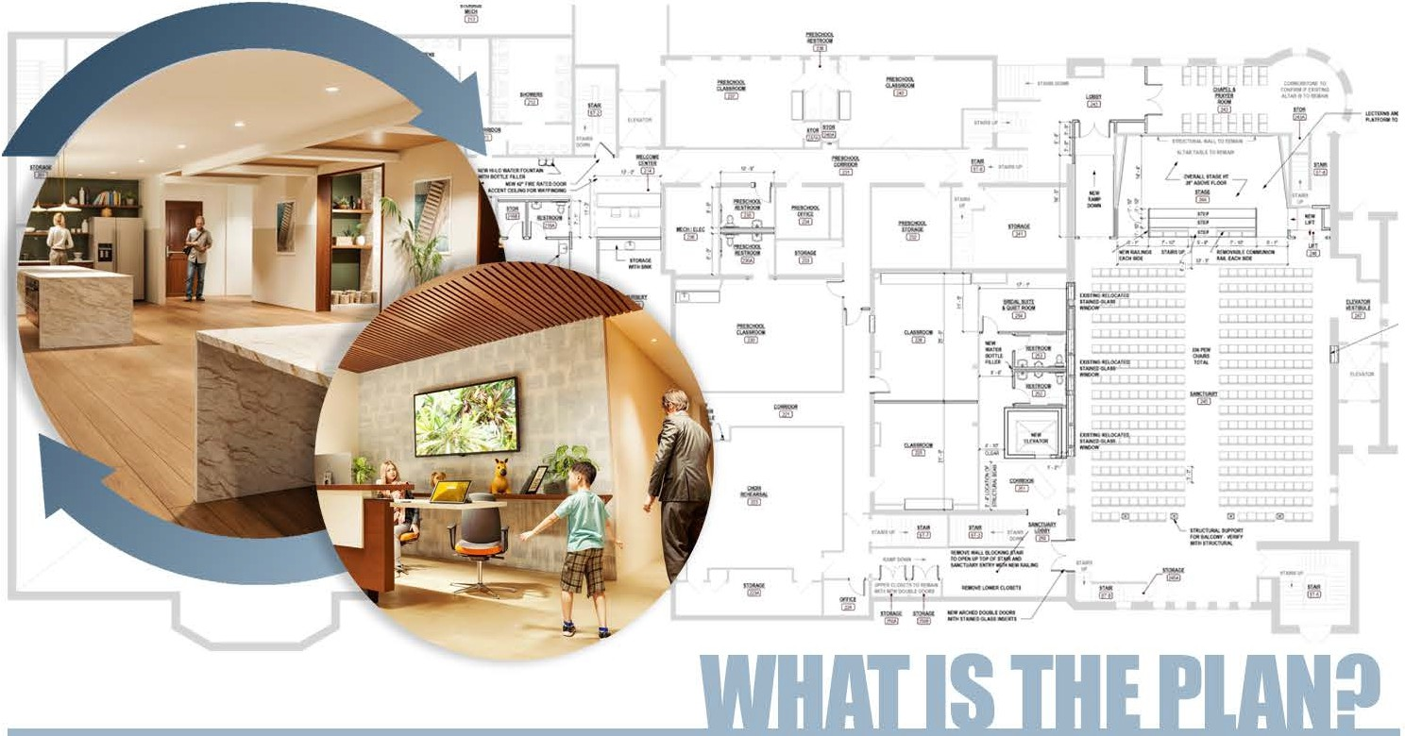
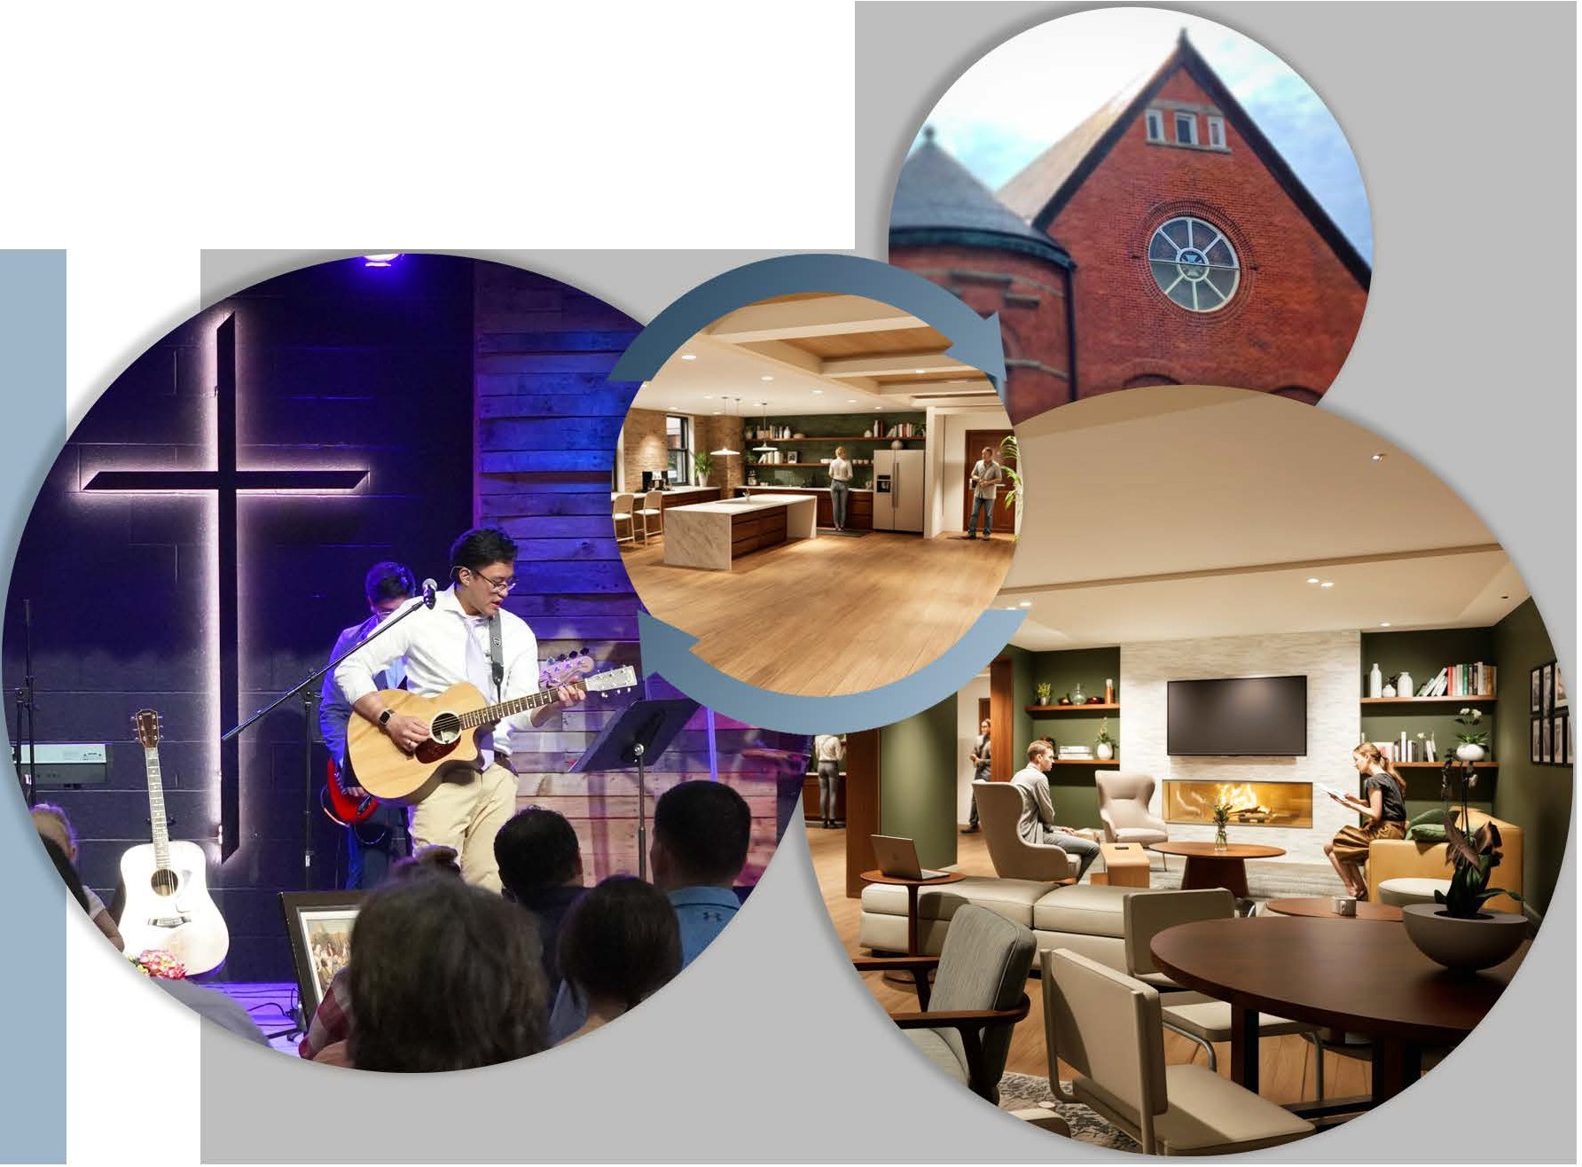
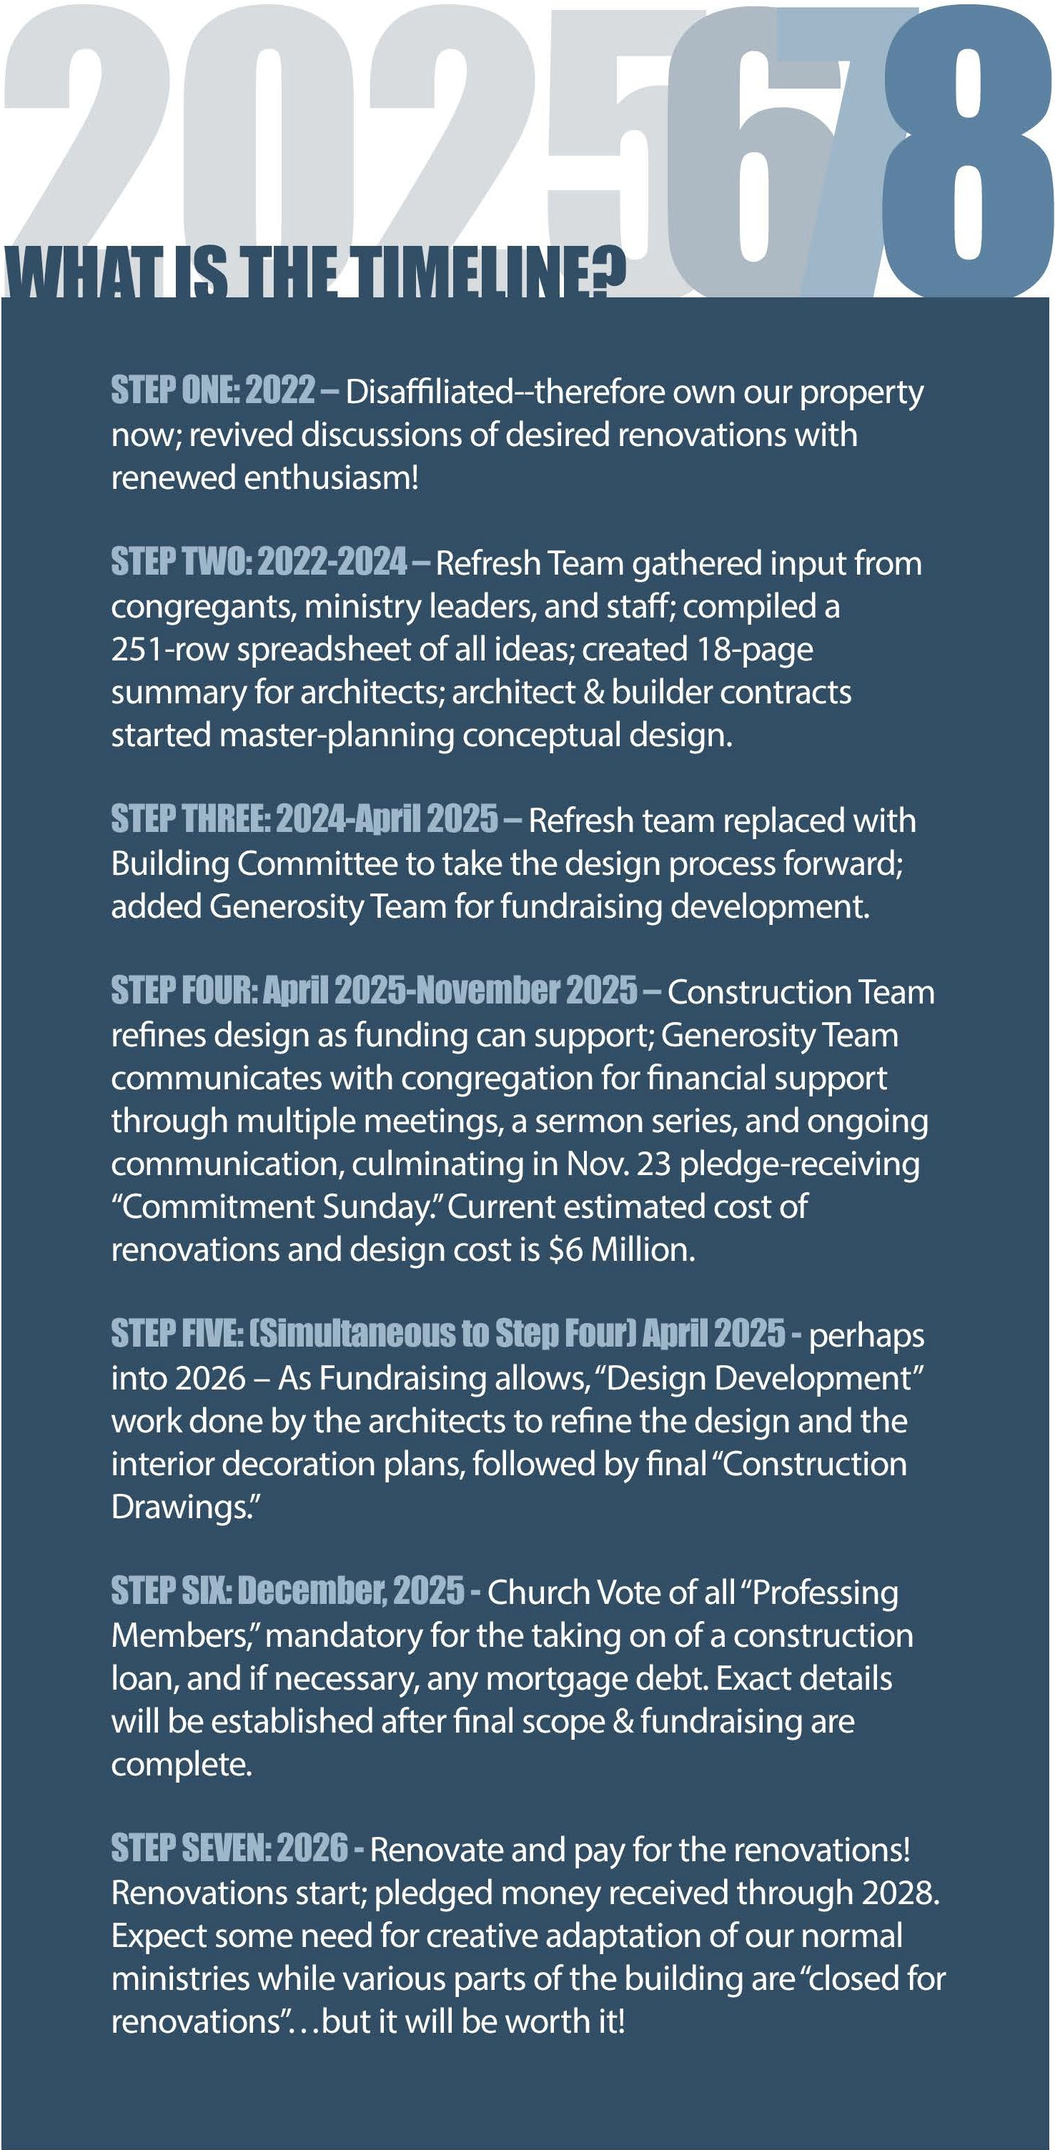

Based on extensive input and planning, we plan to renovate the current facilities in the following ways:

TO SERVE CHILDREN & FAMILIES:
- Children's ministry (nursery through 4th Grade) move to the second floor.
- New children's welcome center, nursery, and toddler room with a restroom.
- New sensory room for children with special needs.
- Refresh the other children & preschool rooms.

TO SERVE LOW-MOBILITY FRIENDS:
- New ADA restrooms on same level as the sanctuary.
- New ADA family-style restroom near BFLC entrance.
- New elevator to sanctuary from Court St.
- Improved wayfinding signage.

TO SERVE YOUTH AND AllADULTS WITHIN & OffllDE Of THE CHURCH:
- New cafe with plumbing & two new first-floor gathering areas with natural light.
- New multiuse room with natural light.
- Refreshed youth ministry rooms.
- Traditional sanctuary upgrades including wooden wall enhancements, new seating, renovated stage with handrails and movable pulpit, improved flooring and lighting, balcony and bell choir loft safety improvements.
- Newcomer hospitality improvements including better exterior and interior signage, fresh paint, new flooring, safety & security enhancements.
- Kitchen ventilation and electric power improvements.
- Office space renovations.
- Chapel enhancements for usage as Prayer Room.
Sacrificial giving over and above our yearly giving to the ministry of the church pledged to be given within the next three years of the SERVE campaign. Our ongoing ministries exist because of regular 'tithes and offerings' given throughout each year that will need to remain strong and vital.This campaign will require giving over and above that, and everyone can contribute with equal sacrifice rather than equal gifts.Where are you on your generosity journey? Wherever you are, simply take the next step God leads you to take without pressure or condemnation.

Between now and Commitment Sunday in November, prayerfully consider whether your next step in your journey might be:

To become an initial giver who starts giving regularly? To become a consistent giver who moves into tithing? To become a sacrificial giver who gives over and above annual support of the church to support our SERVE Campaign?
To become a lifetime giver, who gives a legacy gift that empowers the church for decades to come?

God has prepared you for such a time as this. He sacrificed for us, and in response we sacrifice for Him. Just take your next step with His guidance.

