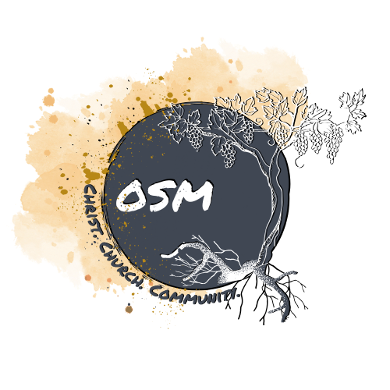

**When** Jan. 9th - 11th, 2026

**Where** KI Convention Center, Green Bay, WI

**What is it?** Districts is a three-day youth conference that brings in some of the best

talent and speakers in the country to encourage students to fellowship, worship, and connect with Jesus. Each year, Districts has over 4,000 students and leaders in attendance. This year, Districts will include: prime time rallies with keynote speakers, breakout sessions to discuss the message further, Going Deeper seminars on various topics, service opportunities, performance by Christian band Gable Price & Friends, and the option to participate in an open mic.

**Cost $140/person.** This covers registration, hotel fees, four meals, and

transportation costs. Additional money will be needed for dinner on Friday night. ***We do not want finances to be the deciding factor for a student to enjoy this experience. If the cost is not manageable, contact Alex, and we can work something out.***

**Discounts** Register before **Sun, Oct. 5th,** and your student can attend for only **$100.**

**Deadlines** Spaces are limited and are not guaranteed after **Sun, Oct. 5th**. The final

registration deadline is **Sun, Nov. 9th**; full payment and forms must be turned in by this date.

**What to do** Fill out and return the **DYC Guidelines** and **Participation Agreement**

along with the **non-refundable payment** for each attendee. Once

these are collected, Alex will register your student(s). Checks can be made out to **Oakbrook Church**.

**Please Note** A detailed schedule, packing list, hotel address, and meal plan will be

provided as soon as it is available.

**Questions?**  Contact Alex Herman at alex.oakbrook@gmail.com or (920) 216-4285.

**DYC Guidelines and Expectations**

Name tags will be received at the beginning of the conference and must be worn around your neck at all times. If no name tag is present, a leader from your group must vouch for you being with the conference. This is for safety and security purposes.

Students must attend all Prime Time rallies and Breakout Sessions and at least two seminars.

Do not throw anything over railings. Anything thrown over railings can be cause for immediate dismissal from the conference.

No running anywhere in the buildings.

Students are not permitted in the room of the opposite sex.

Clothing and swimwear should be modest. Any adult leader may request that a student change into more modest attire if necessary.

Possession of fireworks, alcohol, illegal drugs or weapons is strictly prohibited. Those caught with such materials may be reported to local authorities and sent home.

No smoking or vaping allowed.

Students are responsible to obey all adult leaders, as well as conference and hotel staff, without complaint.

Remember you are representing Jesus Christ, your church, and your family. Please act responsibly.

Should a student repeatedly fail to comply with the above guidelines, a parent will be contacted and expected to pick them up **immediately**.

**KEEP THIS COPY**

**DYC Guidelines and Expectations**

Name tags will be received at the beginning of the conference and must be worn around your neck at all times. If no name tag is present, a leader from your group must couch for you being with the conference. This is for safety and security purposes.

Students must attend all Prime Time rallies and Breakout Sessions and at least two seminars.

Do not throw anything over railings. Anything thrown over railings can be cause for immediate dismissal from the conference.

No running anywhere in the buildings.

Students are not permitted in the room of the opposite sex.

Clothing and swimwear should be modest. Any adult leader may request that a student change into more modest attire if necessary.

Possession of fireworks, alcohol, illegal drugs or weapons is strictly prohibited. Those caught with such materials may be reported to local authorities and sent home.

No smoking or vaping allowed.

Students are responsible to obey all adult leaders, as well as conference and hotel staff, without complaint.

Remember you are representing Jesus Christ, your church, and your family. Please act responsibly.

Should a student repeatedly fail to comply with the above guidelines, a parent will be contacted and expected to pick them up **immediately**.

**By signing below, I acknowledge that I have reviewed the DYC Guidelines and Expectations with my student.**

**Student’s Signature_______________________________________________**

**Parent’s Signature________________________________________________**



**Activity Participation Agreement & Medical Release** 

Sponsoring Organization: Oakbrook Evangelical Free Church, 3126 W. 20th Ave, Oshkosh, WI 54904

Description of Activity: Districts Youth Conference, KI Convention Center, 333 Main St, Green Bay, WI 54304

Date(s) of Activity: Jan. 9th - 11th, 2026

**PARTICIPANT INFORMATION:**

Name of Participant:_________________________________________________ Date of Birth:___________________

Name of Parents/Guardians:__________________________________________________________________________

Address:_______________________________________________________Phone:__________________________

**EMERGENCY CONTACTS:**

Mother:___________________________________ Phone: __________________________

Father:____________________________________Phone:___________________________

Other:__________________________Relationship to Participant:_________________Phone: ___________________

**MEDICAL INFORMATION:**

Is the sponsor authorized to approve medical treatment?: Yes No

List any medications the participant will need to take during the activity: ____________________________________________________________________________________

Can the participant self-administer the medications listed above: Yes No

My child is allergic to the following foods or medication: ____________________________________________________________________________________

List any medical conditions or medical history of which Oakbrook Church and the chaperones should be aware:___________________________________________________________________________________________________________________________________________________________________

**INSURANCE INFORMATION**:

Is the participant covered by personal/family medical insurance?: Yes No 

If yes, name of Insurer: ________________________ Group # ________________ Policy Number: _________________

**Participation Agreement:** I acknowledge that participation in the activity described above involves risk to the participant (and to the participant’s parents or guardians, if the participant is a minor), and may result in various types of injury including, but not limited to, the following: sickness, bodily injury, death, emotional injury, personal injury, property damage, and financial damage.

In consideration for the opportunity to participate in the activity described above (the “activity”), the participant (or parent/guardian if the participant is a minor) acknowledges and accepts the risks of injury associated with participation in and transportation to and from the activity. The participant (or parent/guardian) accepts personal financial responsibility for any injury or other loss sustained during the activity or during transportation to and from the activity, as well as for any medical treatment rendered to the participant that is authorized by the sponsor or its agents, employees, volunteers, or any other representatives (collectively referred to as the “activity sponsor”). Further, the participant (or parent/guardian) releases and promises to indemnify, defend, and hold harmless the activity sponsor for any injury arising directly or indirectly out of the described activity or transportation to and from the activity, whether such injury arises out of the negligence of the activity sponsor, the participant, or otherwise.

If a dispute over this agreement or any claim for damages arises, the participant (or parent/guardian) agrees to resolve the matter through a mutually acceptable alternative dispute resolution process. If the participant (or parent/guardian) and the activity sponsor cannot agree upon such a process, the dispute will be submitted to a three-member arbitration panel for resolution in accordance with the rules of the American Arbitration Association.

**Medical Release:** I give permission for my child to participate in the activity listed above and authorize the adult leaders supervising this event to administer emergency treatment to the above named participant for any accident or illness and to act in my stead in approving necessary medical care. This authorization shall cover this event and travel to and from this event.

In the event of a medical emergency and a parent or other contact person named above cannot be reached by telephone or otherwise, I authorize Oakbrook Church and the chaperones to obtain medical treatment for my child and authorize any physician to examine my child and render such medical and/or surgical treatment which, in such physician's reasonable judgment, may be deemed reasonably necessary for my child's health and safety.

Signature:______________________________________________ Date:_______________________

Signature:______________________________________________ Date:_______________________

*(Participant and/or parents/guardians if participant is a minor)*