G-3 Group Weekly Bible Study Guide
Week 8/30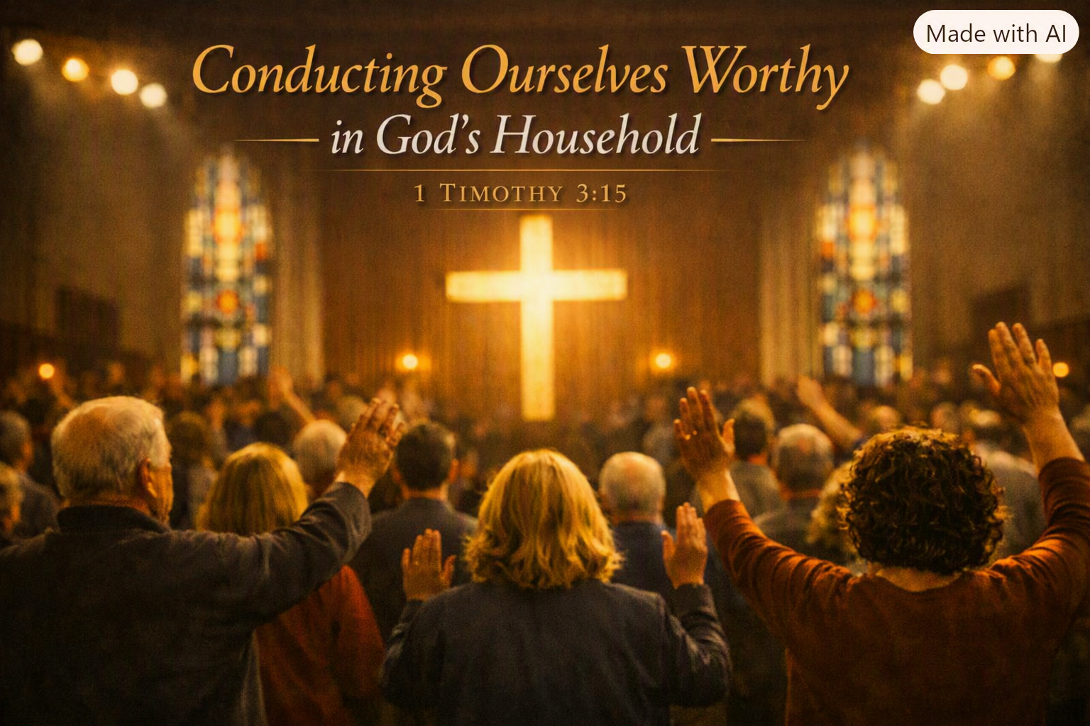6/2026
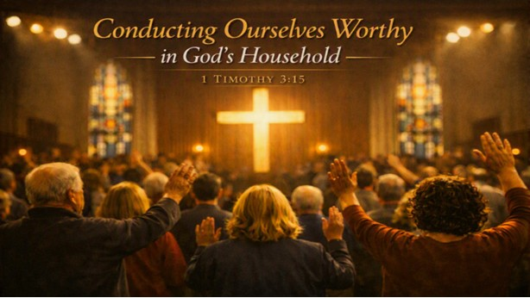

A church that lives worthy of 1 Timothy 3:15 understands that it is not a human institution but God’s household, the dwelling place of His presence and the pillar and foundation of His truth. Such a church conducts itself with reverence, unity, and integrity, knowing that its character reflects the God who redeemed it. In God’s household, relationships are marked by sacrificial love, leaders shepherd with humility and holiness, and members pursue purity, prayer, and devotion to the Word. The church guards doctrine carefully, practices accountability graciously, and orders its life in a way that displays the beauty of Christ to the world. To “conduct themselves” worthily means the people of God live as a family shaped by the gospel—honoring one another, submitting to godly leadership, resisting false teaching, and walking in holiness so that the world sees the truth of Christ embodied in His people.

This week is simple: read 1 Timothy.

Paul wrote 1 Timothy to strengthen a young pastor who was leading a fragile, pressured, and spiritually contested church in Ephesus. Timothy was facing false teachers, confused worship practices, disordered leadership, and relational tensions that threatened the church’s witness. Paul’s purpose was to give Timothy a clear blueprint for how God’s household must function—how to guard the gospel, appoint qualified elders and deacons, cultivate prayerful worship, confront error, care for different groups within the church, and model godliness in both life and doctrine. At its core, 1 Timothy is a pastoral letter designed to stabilize a church in danger, equip a leader who felt overwhelmed, and ensure that the people of God lived in a way that displayed the truth of Christ to the world.
Outline of First Timothy
I. Greeting and Purpose (1:1–2)
Paul identifies himself, Timothy, and the purpose of the letter: strengthening Timothy for faithful ministry in Ephesus.
II. Guard the Gospel (1:3–20)
A. Confront False Teachers (1:3–11)
Timothy must silence false doctrine and restore gospel clarity.
B. Paul’s Testimony of Grace (1:12–17)
Paul models how the gospel transforms leaders.
C. Timothy’s Charge to Fight the Good Fight (1:18–20)
Timothy must hold faith and a good conscience.
III. Order the Church in Prayer and Worship (2:1–15)
A. Prayer for All People, Especially Rulers (2:1–7)
The church’s mission begins with intercession.
B. Conduct in Worship (2:8–15)
Instructions for men and women in gathered worship.
IV. Qualifications for Elders and Deacons (3:1–13)
A. Elders / Overseers (3:1–7)
Character-driven leadership: above reproach, able to teach, self-controlled.
B. Deacons (3:8–13)
Servant-leaders marked by dignity, faithfulness, and integrity.
V. The Church as God’s Household (3:14–16)
The church is the pillar and foundation of truth, called to conduct itself worthily.
VI. Warnings Against False Teaching and Instructions for Godly Living (4:1–16)
A. Recognize and Resist False Teaching (4:1–5)
B. Train Yourself for Godliness (4:6–10)
C. Set an Example and Guard Your Life and Doctrine (4:11–16)
VII. Instructions for Various Groups in the Church (5:1–6:2)
A. Older and Younger Men and Women (5:1–2)
B. Widows (5:3–16)
C. Elders (5:17–25)
Honor faithful elders; discipline sinning elders carefully.
D. Slaves and Masters (6:1–2)
Live out the gospel in all relationships.
VIII. Final Charge: Pursue Godliness and Guard the Faith (6:3–21)
A. Dangers of False Teachers and Greed (6:3–10)
B. Fight the Good Fight of Faith (6:11–16)
C. Instructions to the Rich (6:17–19)
D. Final Warning and Benediction (6:20–21)

APPLICATION QUESTIONS FOR EACH SECTION
1. Guarding the Gospel (1:3–20)
- What false teachings or distractions threaten the purity of the gospel today?
- How does remembering your testimony strengthen your ministry?
- Where do you need to “fight the good fight” with renewed courage?
2. Prayer and Worship (2:1–15)
- Do your prayers reflect God’s desire to save all people?
- How does your church’s worship reflect humility, order, and reverence?
- What attitudes or habits hinder your participation in gathered worship?
3. Qualifications for Elders and Deacons (3:1–13)
- Why are Biblical Elders and Deacons essential to healthy churches?
- How does your church evaluate leaders—by character or by talent?
- What steps can you take to cultivate a healthy environment of Elders and Deacons?
4. Conduct in God’s Household (3:14–16)
- Does your life reflect the holiness expected in God’s household?
- How does your church display the truth of Christ to the world?
- What habits help you “conduct yourself” in a way worthy of Christ?
5. Godliness and Doctrine (4:1–16)
- What spiritual disciplines do you need to strengthen?
- How can you set a better example in speech, conduct, love, faith, and purity?
- Are you guarding both your life and your doctrine with intentionality?
6. Instructions for Church Relationships (5:1–6:2)
- How do you treat older and younger believers as family?
- What does honoring faithful elders look like in practice?
- How can you help protect unity in your church?
7. Final Charge: Fight the Good Fight (6:3–21)
- What competes for your loyalty—money, comfort, approval, distraction?
- How can you pursue righteousness, godliness, faith, love, endurance, and gentleness?
- What does it look like to “guard the deposit” entrusted to you?

The responsibilities of elders are summed up under two heads: governing and teaching.
GOVERNING
1 Timothy 5:17
Let the elders who rule [proestotes] well be considered worthy of double honor.
1 Timothy 3:4–5
He must manage [proistamenon] his own household well, keeping his children submissive and respectful in every way; for if a man does not know how to manage [prostenai] his own household, how can he care for God’s church?
Acts 20:28; 1 Peter 5:2
The duty of elders to “oversee” or “supervise” the flock implies a governing function.
1 Thessalonians 5:12
But we beseech you, brethren, to respect those who labor among you and are over you [proistamenous] in the Lord and admonish you.
(No reference to “elders” but the function of the leaders is governing and the natural assumption is that the leaders are elders that Paul had appointed.)
Hebrews 13:17
Obey your leaders and submit to them; for they are keeping watch over your souls, as men who will have to give account.
(Obedience and submission implies a role of leadership and governance and again the reference is probably to the elders though the leaders are not described.)
TEACHING
Ephesians 4:11
Pastors and teachers are pictured as one office, so that the pastor (whom we have identified as an elder) has the responsibility of teaching.
1 Timothy 3:2
The overseer must be “able to teach.” And we have seen that the overseer and elder are the same office.
1 Timothy 5:17
Let the elders who rule well be considered worthy of double honor, especially those who labor in preaching and teaching.
(Not that all don’t have to be able to teach—they do; but some “labor,” that is, they devote more time and energy to it, perhaps earning their living by it.)
Titus 1:9
He must hold firm to the sure word as taught, so that he may be able to give instruction in sound doctrine and also to confute those who contradict it.

