G-3 Group Weekly Bible Study Guide
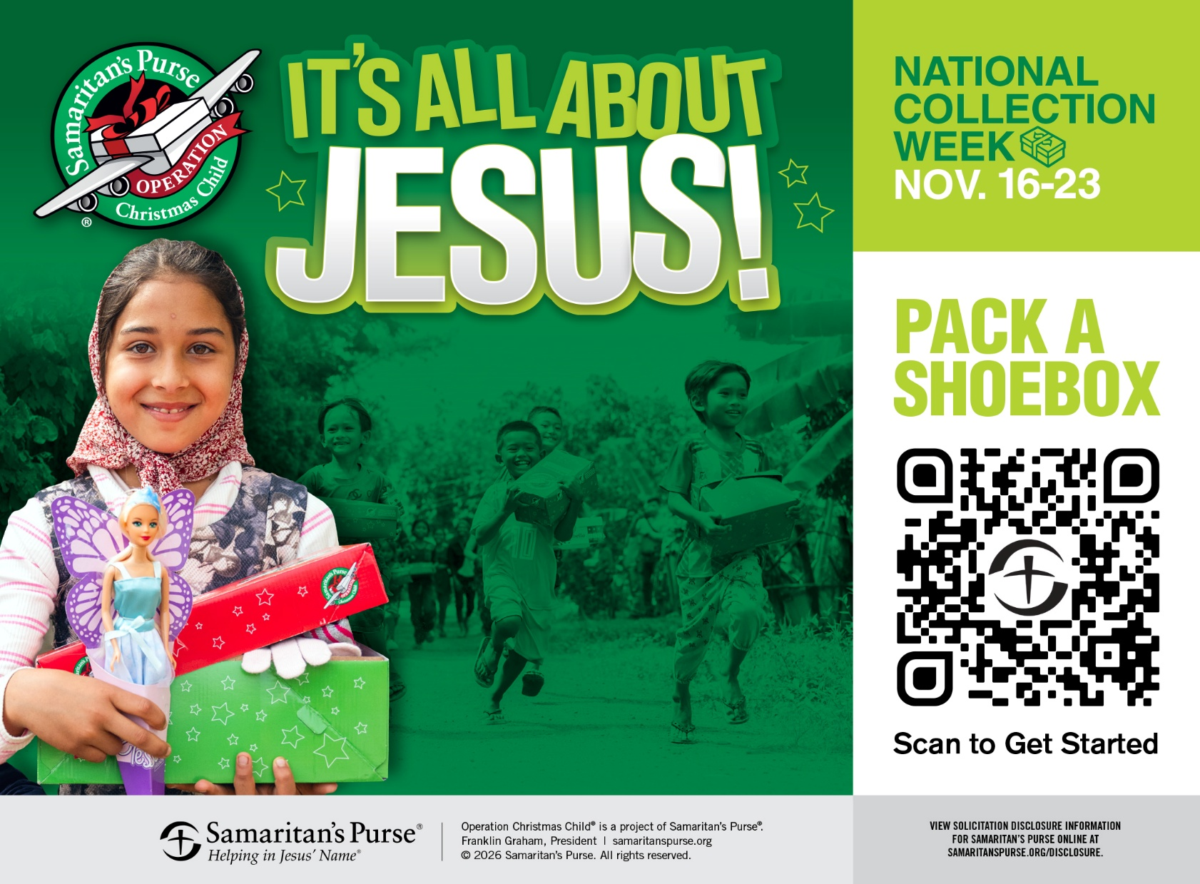

Week 8/9/2026

Operation Christmas Child is one of the most far-reaching, child-centered ministries in the world because it carries the love of Jesus into places where hope is scarce and resources are limited. Each shoebox becomes a small missionary—crossing borders, languages, and cultures to reach children who may never have received a gift or heard the gospel. What looks simple on the outside is actually a powerful ministry tool: it opens doors for local pastors, strengthens struggling churches, and creates opportunities for evangelism and discipleship through programs like The Greatest Journey. In villages affected by poverty, conflict, or spiritual darkness, a shoebox communicates dignity, joy, and the truth that God sees and loves every child. For ministries around the world, these boxes are not just gifts—they are bridges that connect communities to the hope of Christ, encourage local believers, and ignite gospel movements that continue long after the lid is opened.

SENT WITH LOVE
DAY 1
THE GOD WHO SENDS
Scripture: John 20:21 — “As the Father has sent Me, I also send you.”
Spiritual Thought: Operation Christmas Child is more than packing boxes—it is stepping into the mission of Jesus. The Father sent Christ into the world with love, rescue, and hope. Now He sends us with the same heart. Every shoebox becomes a small echo of the Incarnation: God’s love entering a child’s world in a tangible way.
Reflection:
- Where is Jesus sending me today?
- Do I see OCC as a task or a mission?
- How can I reflect Christ’s love as I pack?
Prayer: Lord Jesus, You were sent to save us. Send us now with Your compassion and courage. Let every box carry Your presence. Amen.
Application: Before packing, pause and pray over an empty box. Ask God to send it exactly where He desires.
THE GOSPEL IN A SHOEBOX
Scripture: Romans 1:16 — “For I am not ashamed of the gospel, for it is the power of God for salvation…”
Spiritual Thought: A shoebox cannot save a child—but the gospel can. OCC opens doors for the greatest message ever given. The toys and supplies soften hearts, but the gospel transforms them. Many children who receive boxes hear the name of Jesus for the first time. The gospel is the power of God, and OCC is one of the ways He carries that power into unreached places.
Reflection:
- Do I believe the gospel can change a child’s life?
- How can I pray intentionally for gospel fruit?
- What does “packing with gospel purpose” look like?
Prayer: Father, let Your gospel run swiftly through every shoebox. Prepare hearts and draw children to Jesus. Amen.
Application: Include a handwritten note sharing the love of Jesus. Your words may be the first gospel message a child ever reads.

GOD SEES EVERY CHILD
Scripture: Matthew 19:14 — “Let the little children come to Me… for to such belongs the kingdom of heaven.”
Spiritual Thought: Jesus never overlooked children. In a world that often pushes them aside, He pulled them close. OCC reflects that same heart—every box says, “Jesus sees you. Jesus loves you.” Many children who receive boxes live in war zones, refugee camps, or deep poverty. Yet Jesus sees them all. When we pack a box, we join His mission of welcoming children into His kingdom.
Reflection:
- How does Jesus’ love for children shape my service?
- Do I see each box as going to a real child with real needs?
- What does it mean to value children the way Jesus does?
Prayer: Lord, You welcome children with joy. Let every child who receives a box feel seen, valued, and loved by You. Amen.
Application: Pray specifically for the child who will receive your box—their safety, family, and future.
GENEROSITY THAT REFLECTS GOD’S HEART
Scripture: 2 Corinthians 9:7 — “God loves a cheerful giver.”
Spiritual Thought: Packing a shoebox is an act of generosity—but not reluctant generosity. God delights in cheerful giving because it mirrors His own heart. He gives joyfully, abundantly, and sacrificially. When we pack with joy, we reflect the Father’s character. Our generosity becomes a testimony of His grace.
Reflection:
- Am I giving joyfully or out of obligation?
- How can I pack in a way that reflects God’s generosity?
- What does cheerful giving look like in my life beyond OCC?
Prayer: Father, make my heart generous like Yours. Let my giving overflow with joy, love, and gratitude. Amen.
Application: Add one “extra” item to your box—something that brings joy. Let it be a symbol of cheerful giving.

DAY 3
PRAYING FOR ETERNAL IMPACT
Scripture: Colossians 4:3 — “Pray… that God may open a door for the word.”
Spiritual Thought: Operation Christmas Child is not finished when the box is packed. It is finished when the gospel takes root. Prayer turns a shoebox into a spiritual harvest. Children who receive OCC boxes are invited to The Greatest Journey, a discipleship program where many come to Christ and share the gospel with their families. Your prayers today can shape a child’s eternity.
Reflection:
- Do I pray for long-term fruit from OCC?
- How can I pray for discipleship, not just distribution?
- What doors do I want God to open through my box?
Prayer: Lord, open doors for the gospel through every shoebox. Let children hear, believe, and follow Jesus. Raise up young disciples who shine Your light in dark places. Amen.
Application: Commit to praying for OCC for the next 30 days—children, teachers, pastors, and the spread of the gospel.
LOVE THAT CROSSES BORDERS
Scripture: Acts 1:8 — “You will be My witnesses… to the ends of the earth.”
Psalm 67:2 — “That Your way may be known on earth…”
Spiritual Insight
Jesus calls us to reach the ends of the earth. OCC crosses borders, cultures, and languages with the love of Christ. Your box may travel farther than you ever will—but your love goes with it.
Reflection
- How does OCC expand my view of mission?
- What borders—emotional or spiritual—do I need to cross?
- How can I cultivate a global heart?
Prayer
Holy Spirit, empower global gospel impact. Carry Your love across borders through every box. Amen.
Application
Pray for the specific region your box may reach.
DAY 4
SMALL GIFTS, BIG GOD
Scripture
John 6:11–13 — Jesus multiplies the loaves.
Zechariah 4:10 — “Do not despise the day of small things.”
Spiritual Insight
Jesus delights in using small offerings to accomplish great things. A shoebox may seem small—but God multiplies its impact. Your simple gift can become a catalyst for salvation, discipleship, and transformation.
Reflection
- Do I trust God to multiply my small offering?
- What “small things” in my life need fresh faith?
- How can I pack with expectation?
Prayer
Lord, take what I give and multiply it. Use small gifts for great glory. Amen.
Application
Add something meaningful that reflects God’s abundance.
COMPASSION THAT MOVES US
Scripture
Matthew 9:36 — “He was moved with compassion…”
1 John 3:18 — “Let us love not in word only, but in deed…”
Spiritual Insight
Jesus was moved with compassion when He saw the crowds. Compassion is not emotion—it is movement. OCC is compassion in motion: love that acts, gives, and goes.
Reflection
- What moves my heart toward compassion?
- How can I let compassion lead my decisions?
- Who in my life needs compassion today?
Prayer
Jesus, give me Your compassion for children. Let my heart move like Yours. Amen.
Application
Invite someone else to pack a box with you.
DAY 5
THE JOY OF THE LORD IN EVERY BOX
Scripture
Nehemiah 8:10 — “The joy of the Lord is your strength.”
Psalm 16:11 — “In Your presence is fullness of joy.”
Spiritual Insight
Joy is strength. Joy is mission fuel. Many children experience joy for the first time when they open a shoebox. Joy softens hearts and prepares them to hear the gospel.
Reflection
- How does joy strengthen my service?
- What steals my joy—and how can I reclaim it?
- How can I pack joyfully?
Prayer
Lord, fill each box with Your joy. Let joy open hearts to Your truth. Amen.
Application
Choose one item specifically to spark joy.
ETERNAL HOPE FOR EVERY CHILD
Scripture
1 Peter 1:3 — “He has caused us to be born again to a living hope…”
Romans 15:13 — “May the God of hope fill you…”
Spiritual Insight
We pack shoeboxes because we believe in a living hope—Jesus Christ. OCC is not about temporary gifts but eternal hope. Your box is a small vessel carrying the greatest hope the world has ever known.
Reflection
- How does eternal hope shape my giving?
- What does it mean to pack with eternity in mind?
- How can I pray for generational impact?
Prayer
God of hope, let children find life in Christ. Let hope rise in families, villages, and nations. Amen.
Application
Commit to praying for OCC for the next 30 days.
