G-3 Group Weekly Bible Study Guide

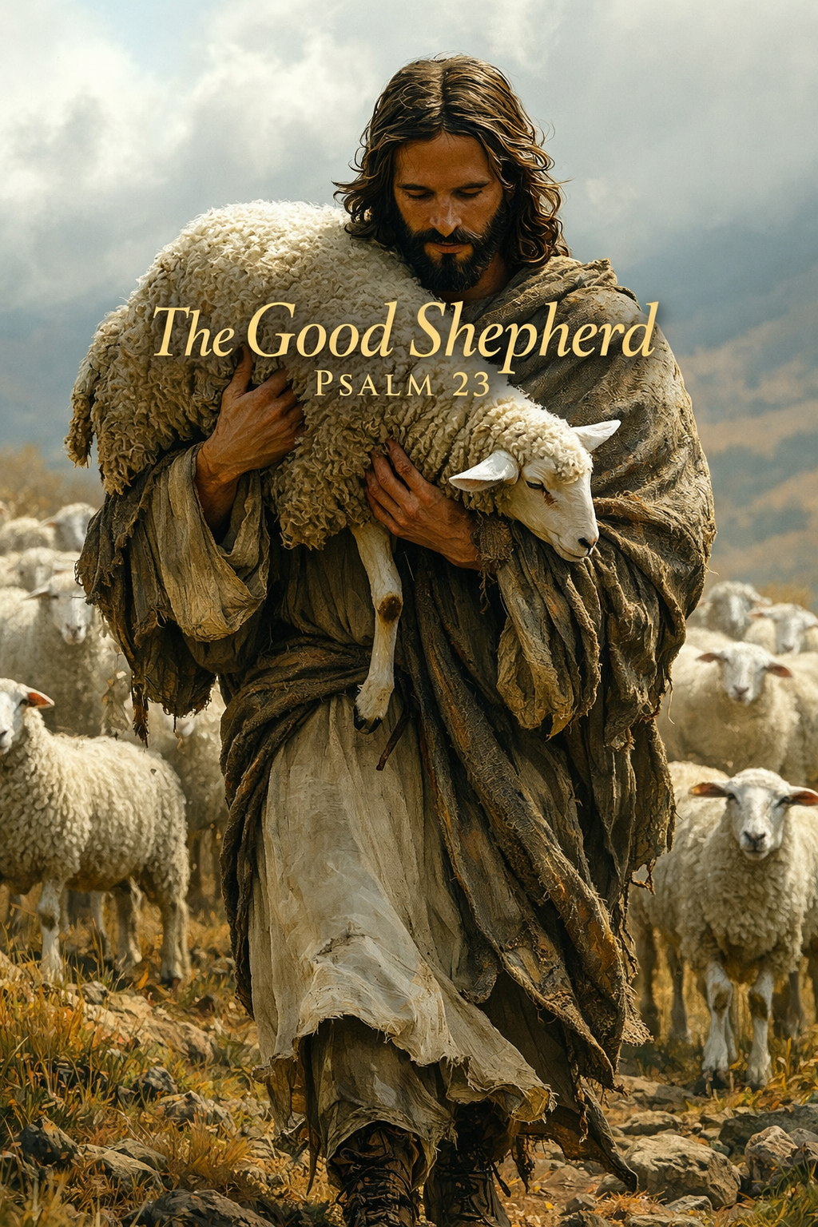
Week 7/18/2026
Day 1 — The Lord Is My Shepherd
Scripture
- Psalm 23:1 — “The Lord is my shepherd; I shall not want.”
- John 10:11 — “I am the good shepherd. The good shepherd lays down his life for the sheep.”
- Philippians 4:19 — “And my God will supply every need of yours according to his riches in glory in Christ Jesus.”
Summary
David begins with a declaration of belonging and sufficiency. The Shepherd’s presence transforms scarcity into abundance. This verse is not about possessions but about peace — the assurance that every need is met in God’s care.
Spiritual Insight
The Lord being our Good Shepherd is central to understanding His heart and our identity as His people. A shepherd’s role is intimate of guiding, protecting, and providing for the flock with constant vigilance and tender care. When Scripture calls God our Shepherd, it reveals His personal involvement in every detail of our lives. He doesn’t lead from afar; He walks among us, knowing each sheep by name. This truth anchors believers in security and peace, reminding us that divine leadership is not about control but compassion. In a world of uncertainty, the Shepherd’s presence assures us that we are never lost, never forgotten, and always pursued by His goodness and mercy.

Application
- Rest in God’s provision rather than striving for control.
- Identify areas where fear of lack replaces faith in the Shepherd’s sufficiency.
- Encourage your team to practice gratitude as a spiritual discipline.
Famous Quote
“The Lord is my Shepherd; I shall not want. He makes me lie down in green pastures — not in restless anxiety.” — Charles Spurgeon
Prayer
Lord, remind me that You are enough. Teach me to trust Your provision and rest in Your care. Amen.

Day 2 — He Leads Me Beside Still Waters
Scripture
- Psalm 23:2 — “He makes me lie down in green pastures. He leads me beside still waters.”
- Isaiah 26:3 — “You keep him in perfect peace whose mind is stayed on You.”
- Matthew 11:28–29 — “Come to Me, all who labor and are heavy laden, and I will give you rest.”
Summary
The Shepherd restores peace through rhythm — rest and refreshment. Still waters symbolize spiritual renewal and emotional calm. God’s leadership is gentle, not forceful.
Spiritual Truth
Jesus leads us beside quiet waters by guiding us into places of peace and restoration through His presence and Word. In Psalm 23:2, the “still waters” symbolize spiritual calm — not the absence of trouble, but the assurance of His control amid it. He doesn’t drive His sheep; He leads them gently, inviting rest for weary souls. Through prayer, Scripture, and the Holy Spirit’s whisper, He calms our anxieties and renews our strength. Just as a shepherd knows where the flock can drink safely, Jesus knows exactly what our hearts need to be refreshed — His peace that surpasses understanding (Philippians 4:7) becomes the quiet water that restores our soul.
Application
- Create intentional pauses in ministry life for spiritual renewal.
- Model rest for volunteers and teams; it’s a form of worship.
- Replace hurry with holy stillness.
Famous Quote
“Peace is not the absence of trouble, but the presence of Christ.” — Sheila Walsh
Prayer
Shepherd of my soul, lead me to quiet waters today. Calm my spirit and restore my joy. Amen.

Day 3 — He Restores My Soul
Scripture
- Psalm 23:3 — “He restores my soul. He leads me in paths of righteousness for His name’s sake.”
- Psalm 51:10–12 — “Create in me a clean heart, O God, and renew a right spirit within me.”
- 2 Corinthians 5:17 — “If anyone is in Christ, he is a new creation.”
Summary
Restoration is not repair — it’s renewal. The Shepherd doesn’t patch brokenness; He transforms it. His guidance in righteousness reflects His character, not our merit.
Spiritual Truth
Jesus restoring our souls is essential because it reaches the deepest places of our identity, healing what weariness, sin, disappointment, and spiritual battle have fractured. Soul-restoration is not surface-level encouragement — it is the Shepherd renewing the very core of who we are. When David says, “He restores my soul” in Psalm 23:3, he is describing a God who brings back vitality, clarity, purity, and purpose. Life drains us; Jesus replenishes us. Sin distorts us; Jesus realigns us. Suffering wounds us; Jesus binds us up. Without His restoration, we operate from depletion rather than abundance, from striving rather than peace. But when the Good Shepherd restores our soul, He makes us whole again — able to walk in righteousness, love others well, and live with a steady confidence anchored in His presence. His restoration is the ongoing miracle that keeps our faith alive, our hope strong, and our hearts tender.
Application
- Invite God to renew your motives and ministry direction.
- Walk in integrity; righteousness honors His name.
- Encourage confession and restoration within your teams.
Famous Quote
“God never leads His children otherwise than they would choose to be led, if they saw the end from the beginning.” — John Newton
Prayer
Restore me, Lord. Lead me in righteousness that reflects Your glory. Amen.

Day 4 — Even Though I Walk Through the Valley
Scripture
- Psalm 23:4 — “Even though I walk through the valley of the shadow of death, I will fear no evil, for You are with me.”
- Isaiah 41:10 — “Fear not, for I am with you.”
- Romans 8:38–39 — “Nothing can separate us from the love of God.”
Summary
The valley is inevitable, but fear is optional. The Shepherd’s presence transforms danger into courage. Shadows cannot exist without light — His nearness is our defense.
Spiritual Insight
Historically, the “valley of the shadow of death” in Psalm 23 likely refers to real geographic terrain familiar to shepherds in ancient Israel — steep, narrow ravines with high walls that blocked sunlight and created long, dark shadows. One commonly referenced area is the Wadi Qelt, a deep gorge running between Jerusalem and Jericho. Its winding paths, sheer cliffs, and sudden drop-offs made it dangerous for travelers and shepherds guiding their flocks. Predators often hid in the shadows, and flash floods could sweep through without warning.
Shepherds knew these valleys were unavoidable routes between grazing areas. They weren’t places to stay — they were places to pass through. David uses this imagery intentionally: even in the most threatening, shadow-filled terrain, the Shepherd’s presence removes the power of fear. The geography reinforces the message — God guides His people through real danger, not around it, and His nearness transforms the darkest valley into a place of courage and trust.
Application
- Teach resilience rooted in God’s presence, not circumstances.
- Encourage believers to walk through trials, not camp in them.
- Use this passage to comfort those in grief or uncertainty.
Famous Quote
“Faith is taking the first step even when you don’t see the whole staircase.” — Martin Luther King Jr.
Prayer
Lord, in my valleys, remind me You walk beside me. Replace fear with faith. Amen.

Day 5 — Surely Goodness and Mercy
Scripture
- Psalm 23:6 — “Surely goodness and mercy shall follow me all the days of my life.”
- Lamentations 3:22–23 — “His mercies never come to an end; they are new every morning.”
- John 14:2–3 — “I go to prepare a place for you.”
Summary
The Shepherd’s care doesn’t end at the pasture — it continues into eternity. Goodness and mercy are not passive; they pursue us. The journey ends in dwelling, not wandering.
Spiritual Insight
“Surely goodness and mercy shall follow me all the days of my life” is one of the most comforting promises in Scripture because it reveals the ongoing, active pursuit of God’s love toward His people. David isn’t describing occasional blessings — he’s declaring that God’s goodness (His generous, protective care) and His mercy (His steadfast, covenant love) will chase after him every single day. This means that no season is wasted, no moment is abandoned, and no path is walked alone. Even when life feels uncertain or painful, God’s goodness is working for our growth, and His mercy is covering our weakness. The Shepherd doesn’t simply lead us; He follows us with blessing, restoration, and faithful love. This verse anchors believers in lifelong confidence: God’s presence surrounds us from ahead and behind, and His goodness and mercy will never stop pursuing us until we dwell with Him forever.
Application
- Live with eternal perspective — ministry is preparation for dwelling with God.
- Reflect His goodness and mercy toward others daily.
- Celebrate the Shepherd’s faithfulness in every season.
Famous Quote
“Where God guides, He provides; where He leads, He feeds.” — Unknown
Prayer
Thank You, Lord, for Your goodness and mercy that never fail. Help me dwell in Your presence forever. Amen.

