G-3 Group Weekly Bible Study Guide
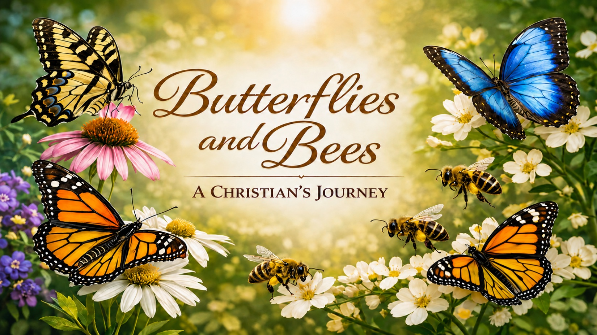

Week 8/2/2026

The butterfly and the bee preach a quiet but powerful truth about the Christian life: in Christ, we are transformed into something entirely new, not just forgiven but remade, lifted from what we once were into what God is shaping us to become. Like the butterfly, we rise from the old self into a beauty only grace can produce, and like the bee, that transformation leads to purpose—serving, building, and multiplying life wherever God sends us. Together they remind us that salvation is not only a rescue but a rebirth, and that the Spirit’s work in us is meant to be both seen and shared, turning our renewed identity into fruitful Kingdom impact.
This week’s journey is a simple reminder of the Christian life, seen through two small creatures from God’s creation. Two of the daily readings come from the same chapter in Ephesians, but each day is strengthened by additional Scriptures listed in the final section of this handout.

DAY 1 — The Caterpillar: Your Past Is Real, But Not Final
Scripture: Ephesians 2
Ephesians 2:1–5 — “You were dead in trespasses and sins… but God made us alive together with Christ.”
Spiritual Thought
A caterpillar is limited, earth-bound, and easily overlooked — yet its beginning never defines its destiny. In the same way, our past is real, but it is not final. Christ meets us in our brokenness, not to polish the old self, but to begin a transformation that only He can accomplish.
Application
- Stop believing your past is your ceiling.
- Identify one “old self” pattern Christ is calling you to surrender.
- Celebrate the grace that found you where you were but refuses to leave you unchanged.
Challenge Questions
- What part of your “caterpillar life” tries to tell you who you still are?
- Where do you need to embrace the truth that Christ has made you alive?
Prayer
Lord, thank You for meeting me in my old life and calling me into something new. Help me release the past and trust Your transforming work. Make me alive in You today. Amen.

DAY 2 — The Chrysalis: Transformation Happens in Hidden Places
Scripture: Romans 12
Romans 12:2 — “Be transformed by the renewing of your mind.”
Spiritual Thought
The chrysalis is the place no one sees — the hidden work, the quiet reshaping. God often transforms us in seasons where nothing looks impressive, where change feels slow, and where we wonder if anything is happening at all. But the deepest spiritual work is usually done in the unseen places.
Application
- Embrace the hidden season you’re in; God is working even when you can’t see it.
- Practice one quiet discipline this week: prayer, Scripture meditation, silence, or fasting.
- Trust that transformation is happening even when it feels invisible.
Challenge Questions
- What hidden work is God doing in you right now?
- Where do you resist slow, quiet transformation?
Prayer
Father, work in the hidden places of my heart. Renew my mind, reshape my desires, and form Christ within me. Help me trust Your slow and steady work. Amen.

DAY 3 — The Butterfly: New Identity, New Life
Scripture: 2 Corinthians 5
2 Corinthians 5:17 — “If anyone is in Christ, he is a new creation.”
Spiritual Thought
A butterfly never apologizes for no longer being a caterpillar. It simply lives in the freedom of its new nature. In Christ, you are not a slightly improved version of your old self — you are a new creation. Transformation is not cosmetic; it is identity-level renewal.
Application
- Walk confidently in the identity Christ has given you.
- Reject the lies that say you are still who you used to be.
- Live today as someone who has wings — not someone who still crawls.
Challenge Questions
- Where are you still living like a caterpillar even though Christ made you a butterfly?
- What new identity truth do you need to embrace today?
Prayer
Jesus, thank You for making me new. Teach me to live in the freedom, beauty, and purpose of the new creation You’ve formed in me. Help me fly where I once crawled. Amen.

DAY 4 — The Bee: Transformation Leads to Purpose
Scripture: Ephesians 2
Ephesians 2:10 — “We are His workmanship… created in Christ Jesus for good works.”
Spiritual Thought
Butterflies display beauty; bees display purpose. Bees pollinate, build, serve, and multiply life wherever they go. Christian transformation is never just about becoming beautiful — it’s about becoming useful. God reshapes us so we can bless others, strengthen the church, and bring life into barren places.
Application
- Serve someone today in a way that multiplies life.
- Identify one “pollination point” — a place where God wants you to bring encouragement, truth, or love.
- Ask God to make your transformed life fruitful.
Challenge Questions
- Where is God calling you to bring life, not just beauty?
- What good work has God prepared for you that you’ve been avoiding?
Prayer
Lord, make me a person who multiplies life. Use my transformed heart to serve, build, encourage, and bless others. Let my life be fruitful for Your Kingdom. Amen.

DAY 5 — The Garden: A Community Shaped by Transformation
Scripture: John 15
John 15:5 — “Whoever abides in Me… bears much fruit.”
Spiritual Thought
Butterflies and bees together create a thriving ecosystem — beauty and purpose working side by side. The church is meant to be a spiritual garden where transformed people display God’s beauty and serve with God’s purpose. When believers abide in Christ, the community becomes a place of fruitfulness, healing, and growth.
Application
- Strengthen your connection to the church community.
- Encourage someone’s transformation journey.
- Commit to being both a butterfly (beauty) and a bee (purpose) in your church.
Challenge Questions
- How is your life contributing to the spiritual “garden” of your church?
- What fruit is God calling you to bear in your community?
Prayer
Jesus, make our church a garden of transformed lives. Help me abide in You so I can bear fruit that blesses others. Shape me into someone who brings beauty and purpose to Your people. Amen.

Scriptures on Transformation (Becoming New)
- 2 Corinthians 5:17 — “If anyone is in Christ, he is a new creation…”
- Romans 12:2 — “Be transformed by the renewing of your mind…”
- Colossians 3:10 — “Put on the new self, which is being renewed…”
- Titus 3:5 — “He saved us… by the washing of regeneration and renewal of the Holy Spirit.”
Scriptures on Dying to the Old Self (The Caterpillar Life)
- Romans 6:6 — “Our old self was crucified with Him…”
- Romans 6:11 — “Consider yourselves dead to sin and alive to God…”
- Galatians 2:20 — “I have been crucified with Christ…”
- Galatians 5:24 — “Those who belong to Christ have crucified the flesh…”
- Colossians 3:3 — “For you have died, and your life is hidden with Christ…”
- Ephesians 4:22 — “Put off your old self…”
Scriptures on Renewal and Inner Transformation (The Chrysalis Work)
- Philippians 1:6 — “He who began a good work in you will bring it to completion…”
- 2 Corinthians 3:18 — “We are being transformed into His image from glory to glory…”
- Psalm 51:10 — “Create in me a clean heart… renew a right spirit within me.”
- Ezekiel 36:26 — “I will give you a new heart and put a new spirit within you.”
Scriptures on New Identity (The Butterfly Life)
- Ephesians 2:10 — “We are His workmanship… created for good works.”
- 1 Peter 2:9 — “You are a chosen people… called out of darkness into His marvelous light.”
- Galatians 6:15 — “What counts is the new creation.”
- Colossians 3:1 — “Since you have been raised with Christ…”
Scriptures on Fruitfulness and Purpose (The Bee Life)
- John 15:5 — “Whoever abides in Me… bears much fruit.”
- Matthew 5:16 — “Let your light shine… that they may see your good works…”
- James 2:17 — “Faith by itself… is dead.”
- Galatians 5:22–23 — The fruit of the Spirit.
- Philippians 2:4 — “Look not only to your own interests, but also to the interests of others.”
- Hebrews 10:24 — “Stir up one another to love and good works.”
Scriptures on Calling, Mission, and Kingdom Impact (The Garden)
- Matthew 28:19–20 — The Great Commission.
- Acts 1:8 — “You will receive power… and be My witnesses.”
- 1 Corinthians 3:6–9 — “We are God’s fellow workers… God gives the growth.”
- Isaiah 61:3 — “Oaks of righteousness… the planting of the Lord.”

