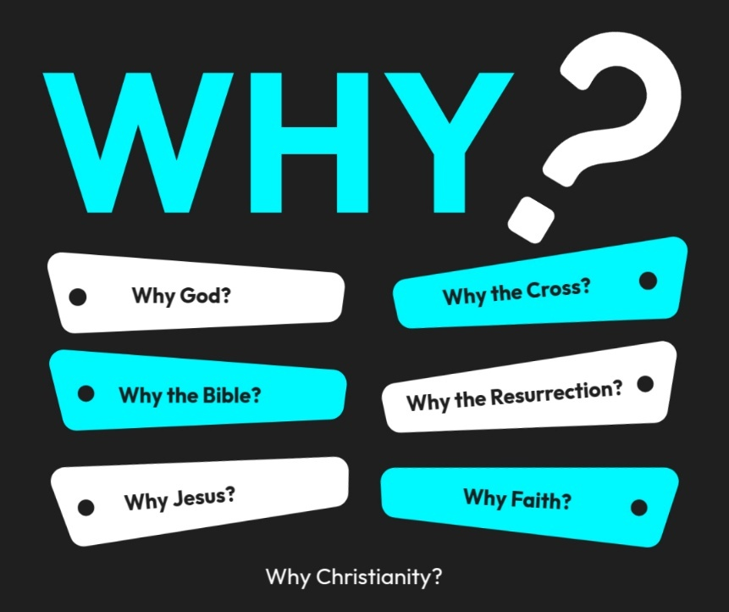

Introduction to the “WHY’s” of Christianity. These classes are designed to help us try and understand the “why” of the things in Christianity. There are important questions that we ask that we need to seek out answers for to help us build a solid foundation for our belief system!
- 10/26/25 – Why God? (Ps. 19:1-4; Rom. 1:20)
- 11/2/25 – Why the Bible? Text: 2 Timothy 3:16–17; 2 Peter 1:20–21
- 11/9/25 – Why Believe? (John 20:30,31)
- 11/16/25- Unity Sunday (No Class)
- 11/23/25 – Why Jesus? Text: John 14:6; Colossians 1:15–20
- 11/30/25 – 5th Sunday (No Class)
- 12/7/25 – Combined HS & JH Classes (Group Discussion)
- 12/14/25 – Why the Cross? Text: 1 Corinthians 15:3–4; Isaiah 53
- 12/21/25 - Why the Resurrection? Text: 1 Corinthians 15:17–20; Luke 24:1–12
- 12/28/25 - Why Faith? Text: Hebrews 11:1–6; Ephesians 2:8–9
- 1/4/26 - Why the Church? Text: Acts 2:42–47; Hebrews 10:24–25

Why the Church?
Why Is the Church So Important? And Why Every Believer Needs to Be Part of It
I. The Church Was Designed by God, Not Man
Key Truth: The church is God’s idea, not a human organization.
- Matthew 16:18 – “I will build My church…” → Jesus claims ownership and authorship.
- Acts 20:28 – Purchased with His own blood.
- Ephesians 3:10–11 – The church reveals God’s eternal purpose.
Teaching Point: To neglect the church is to neglect something Christ died to create.

II. The Church Is the Body of Christ
Key Truth: Christ works through His people together, not in isolation.
- 1 Corinthians 12:12–27 – Many members, one body.
- Ephesians 1:22–23 – The church is His body, the fullness of Him.
- Romans 12:4–5 – Each believer has a necessary role.
Illustration: A severed limb cannot function—believers detached from the church weaken spiritually.

III. The Church Is Essential for Spiritual Growth
Key Truth: Growth happens best in community, not solitude.
- Acts 2:42 – Teaching, fellowship, breaking of bread, prayers.
- Ephesians 4:11–16 – Growth comes through equipped believers working together.
- Colossians 2:19 – Growth comes from being connected to the body.
Application: Online sermons alone cannot replace biblical fellowship and accountability.

IV. The Church Provides Protection and Accountability
Key Truth: God uses the church to guard believers spiritually.
- Hebrews 3:12–13 – Exhort one another to avoid hardened hearts.
- Proverbs 27:17 – Iron sharpens iron.
- Ecclesiastes 4:9–12 – Two are better than one.
Teaching Point: Isolation often precedes spiritual drift and moral failure.

V. The Church Is Where Love Is Practiced and Displayed
Key Truth: Christian love is lived out, not just believed.
- John 13:34–35 – Love identifies Christ’s disciples.
- Galatians 6:2 – Bear one another’s burdens.
- 1 John 3:16–18 – Love shown in action and truth.
Insight: You cannot obey “one another” commands without “one another.”

VI. The Church Is God’s Instrument for His Mission
Key Truth: God reaches the world through His gathered people.
- Matthew 28:19–20 – The Great Commission.
- Acts 1:8 – Witness through the church.
- 1 Timothy 3:15 – Pillar and ground of the truth.
Result: A disconnected Christian limits their gospel impact.

VII. The Church Is Central to God’s Future Plan
Key Truth: The church has eternal significance.
- Ephesians 5:25–27 – Christ will present the church to Himself.
- Revelation 19:7–9 – The marriage supper of the Lamb.
- Hebrews 12:23 – The assembly of the redeemed.
Perspective: If heaven celebrates the church, believers should value it now.
VIII. Scripture Warns Against Neglecting the Church
Key Truth: Faithful Christians gather intentionally.
- Hebrews 10:24–25 – Do not forsake assembling together.
- Acts 2:44–47 – Believers were continually together.
- Psalm 92:13 – Those planted in God’s house flourish.

Why the Church?
Why Is the Church So Important? And Why Every Believer Needs to Be Part of It
I. The Church Was Designed by ______, Not _______
- Matthew 16:18; Acts 20:28; Ephesians 3:10–11

II. The Church Is the _________ of __________
- 1 Corinthians 12:12–27; Ephesians 1:22–23; Romans 12:4–5

III. The Church Is ______________ for Spiritual _____________
- Acts 2:42; Ephesians 4:11–16; Colossians 2:19

IV. The Church Provides ________________ and ____________________
- Hebrews 3:12–13; Proverbs 27:17; Ecclesiastes 4:9–12

V. The Church Is Where Love Is ______________ and __________________
- John 13:34–35; Galatians 6:2; 1 John 3:16–18

VI. The Church Is God’s Instrument for His ________________
- Matthew 28:19–20; Acts 1:8; 1 Timothy 3:15

VII. The Church Is ______________ to God’s Future _________
- Ephesians 5:25–27; Revelation 19:7–9; Hebrews 12:23

VIII. Scripture Warns Against _________________ the Church
- Hebrews 10:24–25; Acts 2:44–47; Psalm 92:13

