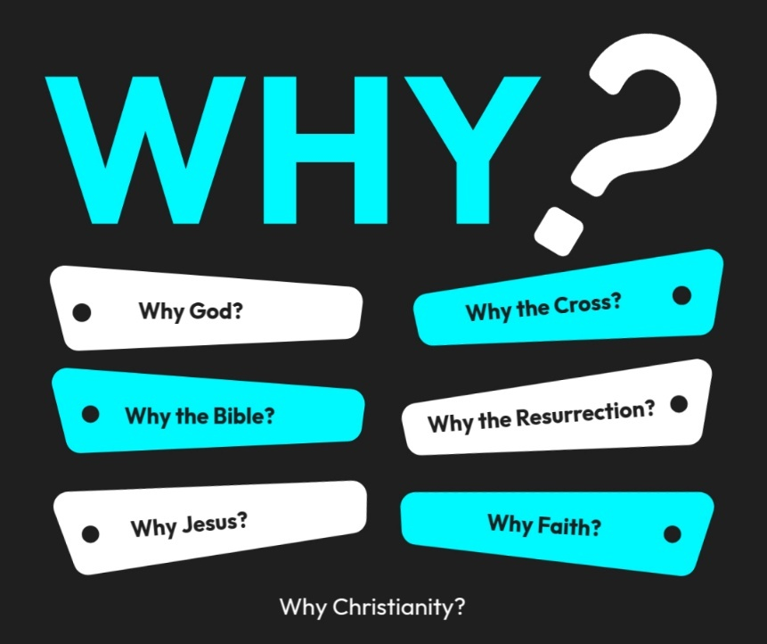

Introduction to the “WHY’s” of Christianity. These classes are designed to help us try and understand the “why” of the things in Christianity. There are important questions that we ask that we need to seek out answers for to help us build a solid foundation for our belief system!
- 10/26/25 – Why God? (Ps. 19:1-4; Rom. 1:20)
- 11/2/25 – Why the Bible? Text: 2 Timothy 3:16–17; 2 Peter 1:20–21
- 11/9/25 – Why Believe? (John 20:30,31)
- 11/16/25- Unity Sunday (No Class)
- 11/23/25 – Why Jesus? Text: John 14:6; Colossians 1:15–20
- 11/30/25 – 5th Sunday (No Class)
- 12/14/25 – Why the Cross? Text: 1 Corinthians 15:3–4; Isaiah 53
- 12/21/25 - Why the Resurrection? Text: 1 Corinthians 15:17–20; Luke 24:1–12
- 12/28/25 - Why Faith? Text: Hebrews 11:1–6; Ephesians 2:8–9

Why the Resurrection?
- Text: 1 Corinthians 15:17–20; Luke 24:1–12
Introduction:
The cross shows Christ’s love — but the resurrection shows His power.
Without the resurrection, Christianity collapses into hopelessness. Paul said plainly,
“If Christ has not been raised, your faith is futile; you are still in your sins.” (1 Cor. 15:17)
The empty tomb is not just an event in history — it’s the foundation of our hope, faith, and future.

I. The Resurrection Proves That Jesus Is Who He Claimed to Be
Text: Luke 24:1–12
- The angels said, “He is not here; He has risen!” — just as He said.
- The resurrection validates Jesus’ claims to be the Son of God (John 2:19–22).
- Without it, He would have been just another martyred teacher.
- The empty tomb confirms that His words are true and His promises can be trusted.
🕊 Key thought: The resurrection proves Jesus is Lord and Savior.

II. The Resurrection Secures Our Forgiveness
Text: 1 Corinthians 15:17
- “If Christ has not been raised, your faith is futile; you are still in your sins.”
- The cross paid the penalty for sin, but the resurrection shows the payment was accepted.
- It’s God’s stamp of approval on the sacrifice of Jesus.
- Through His resurrection, we are justified (Romans 4:25).
🩸 Key thought: The resurrection is God’s receipt that the debt of sin has been paid in full.

III. The Resurrection Guarantees Our Future Hope
Text: 1 Corinthians 15:20
- “But Christ has indeed been raised from the dead, the firstfruits of those who have fallen asleep.”
- Because He lives, we too shall live (John 14:19).
- The resurrection is not just about Jesus coming back to life — it’s the promise that all who belong to Him will rise again.
- Death is not the end but the beginning of eternal life with Him.
🌅 Key thought: The resurrection turns the grave into a gateway of glory.
IV. The Resurrection Empowers Us to Live with Purpose
Application from Luke 24:9–12
- The women who discovered the empty tomb didn’t stay silent — they ran to tell others.
- The resurrection ignited boldness in fearful disciples.
- It gives us courage to live for Christ today because we serve a living Savior.
- “Therefore, my beloved brethren, be steadfast, immovable, always abounding in the work of the Lord…” (1 Cor. 15:58).
🔥 Key thought: The risen Christ transforms fearful witnesses into faithful servants.

Conclusion:
Without the resurrection —
- Our faith is empty,
- Our message is powerless,
- Our hope is gone.
But because He lives —
- Our sins are forgiven,
- Our future is secure,
- Our lives have meaning. 🎶 “Because He lives, I can face tomorrow…”

Supplemental Material for Proofs of the Resurrection:

Accounts of the Resurrection:
Matt. 27:59 – 28:8 – The burial and Risen Lord; Mk 15:42 – 16:13; Lk 23:50 – 24:12; Jn 19:38 – 20:18
Swoon Theory – Jesus was not really dead. - The Swoon Theory is the belief that Jesus didn’t really die at His crucifixion, but was merely unconscious when He was laid in the tomb and there He resuscitated.
- The Tomb was Open & Empty
  - The empty tomb may be the strongest proof Jesus Christ rose from the dead. Two major theories have been advanced by unbelievers: someone stole Jesus' body or the women and disciples went to the wrong tomb. The Jews and Romans had no motive to steal the body. Christ's apostles were too cowardly and would have had to overcome the Roman guards. The women who found the tomb empty had earlier watched Jesus being laid away; they knew where the correct tomb was. Even if they had gone to the wrong tomb, the Sanhedrin could have produced the body from the right tomb to stop the resurrection stories. Jesus' burial cloths were left neatly folded inside, hardly the act of hurrying grave robbers. Angels said Jesus had risen from the dead.
    - Was it the Disciples who stole the body?
    - Sufficient steps to prevent this –Roman guard (Matt. 27:62-66)
    - Was it the Jews?
      - This would have been completely contrary to their own statement of intent to keep Christ in the tomb until the 3rd day. (Matthew 27:63)

  - The Grave Clothes
    - John tells us the grave cloths were left “Lying” (John 20:7)
    - Burial custom of the Jews - Lazarus (John 11:44) – “Loose him, and let him go.” = assistance needed
    - If Jesus was stolen then, who quietly rolled away the stone, took time to unwrap him and then again wrapped the grave clothes with such skill that eyewitnesses could not detect the deception, and then carry away the body without detection?

  - Discovered by women
    - In patriarchal Jewish society the testimony of women was not highly regarded. In fact, the Jewish historian Josephus says that women weren’t even permitted to serve as witnesses in a Jewish court of law. Now in light of this fact, how remarkable it is that it is women who are the discoverers of Jesus’ empty tomb. Any later legendary account would certainly have made male disciples like Peter and John discover the empty tomb. The fact that it is women, rather than men, who are the discoverers of the empty tomb is best explained by the fact that they were the chief witnesses to the fact of the empty tomb, and the Gospel writers faithfully record what, for them, was an awkward and embarrassing fact.

  - The Significance of the 3rd Day
    - Jesus prophesied He would raise the 3rd day.
    - Death by crucifixion (Matt. 20:19; John 3:14; 8:28; 12:32-33)
      - Significant because the Jews made a number of attempts to kill Jesus by different means.
      - Fulfillment of prophecy!!!
        - John 2:13-22 – Jesus pointed to His resurrection on the 3rd day
        - Matt. 12:3 – Jesus appealed to the sign of Jonah.
    - It became common knowledge - (Matt. 27:62-66)
    - Christianity and the 1st day of the Week. – IMPORTANCE!!!
    - Christ did rise from the dead – He overcame death.

- The Apostles New- Found Courage
  - After the crucifixion, Jesus' apostles hid behind locked doors, terrified they would be executed next. But something changed them from cowards to bold preachers. Anyone who understands human character knows people do not change that much without some major influence. That influence was seeing their Master, bodily risen from the dead. Christ appeared to them in the locked room, on the shore of the Sea of Galilee, and on the Mount of Olives. After seeing Jesus alive, Peter and the others left the locked room and preached the risen Christ, unafraid of what would happen to them. They quit hiding because they knew the truth. They finally understood that Jesus is God incarnate, who saves people from sin.
  - Acts 4:2; 4:33; Acts 17:18, 32

- Eyewitnesses
  - You believe in George Washington, Tomas Jefferson, etc..
  - Jesus Christ = Eyewitness accounts
  - Must have 2 witnesses
    - Deut. 19:15 - A matter must be established by the testimony of two or three witnesses.
    - Matt. 18:16 - But if they will not listen, take one or two others along, so that ‘every matter may be established by the testimony of two or three witnesses.’
  - Thomas - John 20:26-28
  - 500 – 1 Cor. 15:3-8

- Conversion of Paul
  - His manner of persecuting Christians seems to be unthinkable if not impossible to convert him.
  - Gal. 1:13-14
    - Saul was among those who consented to the death of Stephen (Acts 7:58)
    - Saul entered Christian homes and dragged them to prison (Acts 8:1-3)
    - Obtained Jewish letters empowering him to arrest Christians (Acts 9:1-2)
  - Was there ulterior motives for Paul’s conversion?
    - Wealth?
      - He had wealth with the Jews and left if for poverty of Christianity (Acts 20:33-34; 1 Cor. 4:11-12)
    - Reputation?
      - Saul had reputation among kings (Acts 26:24)
      - Renounced reputation to become “a fool for Christ” (1 Cor. 4:10,13)
    - Passion?
      - Immoral reasoning? No- he preached against it & made enemies.
    - Power?
      - He had this with the Jews and left if for Christ. (Acts 26:1-12)
  - Paul met the resurrected Christ on the road to Damascus and believe in the risen Savior. (Acts 9)

- People died for Jesus
  - Countless people have died for Jesus, absolutely certain that the resurrection of Christ is an historical fact. Even today, people suffer persecution because they have faith that Christ rose from the dead. An isolated group may give up their lives for a cult leader, but Christian martyrs have died in many lands, for nearly 2,000 years, believing Jesus conquered death to give them eternal life.
  - People gave their lives for Jesus based upon the facts of Christ’s resurrection.
    - Will you give your life for Him today?

Conclusion: 1 Corinthians 15:12-22; 1 Peter 1:3
Why the Resurrection?

- Text: 1 Corinthians 15:17–20; Luke 24:1–12
Introduction:
The cross shows Christ’s _______ — but the resurrection shows His ___________.
Without the resurrection, Christianity collapses into _______________. (1 Cor. 15:17)

The empty tomb is not just an event in history — it’s the foundation of our _______, ________, and future.

I. The Resurrection Proves That Jesus Is Who He _______________ to Be
Text: Luke 24:1–12
- The angels said, “He is not here; He has _________!” — just as He said.
- The resurrection validates Jesus’ claims to be the _______ of _______ (John 2:19–22).
- Without it, He would have been just another martyred ____________.
- The empty tomb confirms that His words are ________ and His promises can be trusted.
  - The resurrection proves Jesus is ________ and ________.

II. The Resurrection Secures Our _________________
Text: 1 Corinthians 15:17
- “If Christ has not been raised, your faith is futile; you are still in your ________.”
- The cross paid the penalty for sin, but the resurrection shows the payment was __________.
- It’s God’s stamp of ___________ on the sacrifice of Jesus.
- Through His resurrection, we are ____________ (Romans 4:25).

III. The Resurrection Guarantees Our Future __________
Text: 1 Corinthians 15:20
- Because He lives, we too shall _______ (John 14:19).
- Death is not the ______.

IV. The Resurrection Empowers Us to Live with ____________
Application from Luke 24:9–12
- The women ran to ________ others.
- The resurrection ignited ____________ in fearful disciples.
- It gives us _____________ to live for Christ.
  - (1 Cor. 15:58).

Conclusion:
Without the resurrection —
- Our faith is _________,
- Our message is _________,
- Our hope is _________.
But because He lives —
- Our sins are _________,
- Our future is _________,
- Our lives have _________.
🎶 “Because He lives, I can face tomorrow…”

