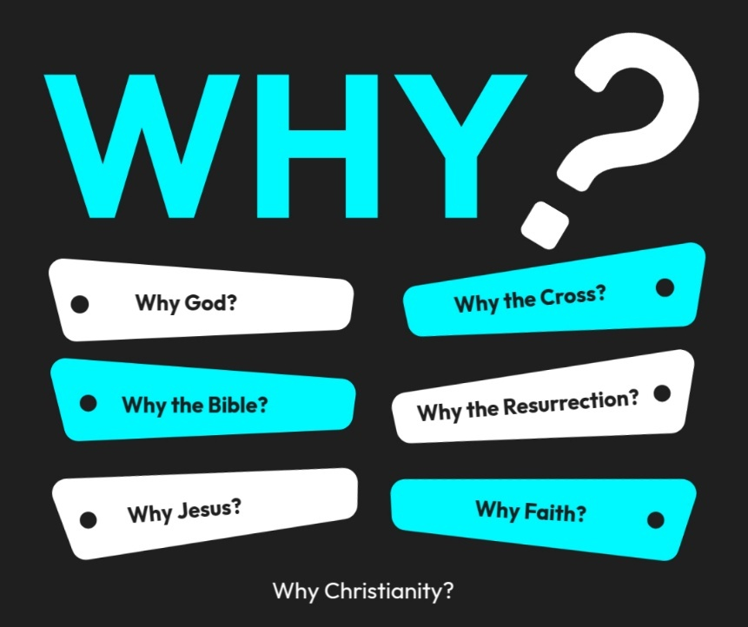

Introduction to the “WHY’s” of Christianity. These classes are designed to help us try and understand the “why” of the things in Christianity. There are important questions that we ask that we need to seek out answers for to help us build a solid foundation for our belief system!
- 10/26/25 – Why God? (Ps. 19:1-4; Rom. 1:20)
- 11/2/25 – Why the Bible? Text: 2 Timothy 3:16–17; 2 Peter 1:20–21
- 11/9/25 – Why Believe? (John 20:30,31)
- 11/16/25- Unity Sunday (No Class)
- 11/23/25 – Why Jesus? Text: John 14:6; Colossians 1:15–20
- 11/30/25 – 5th Sunday (No Class)
- 12/7/25 – Why the Cross? Text: 1 Corinthians 15:3–4; Isaiah 53
- 12/14/25 - Why the Resurrection? Text: 1 Corinthians 15:17–20; Luke 24:1–12
- 12/21/25 - Why Faith? Text: Hebrews 11:1–6; Ephesians 2:8–9
- 12/28/25 - Why the Church? Text: Acts 2:42–47; Hebrews 10:24–25

Why the Cross?
- Text: 1 Corinthians 15:3–4; Isaiah 53 … Heb. 12:2

- The Cross Was God’s Plan to Deal with Sin
  - From the beginning, sin separated humanity from God (Isaiah 59:2; Romans 3:23).
God is holy and just, so sin couldn’t simply be ignored — it had to be paid for (Romans 6:23).
  - In the Old Testament, animal sacrifices symbolized that “without the shedding of blood there is no forgiveness” (Hebrews 9:22). But those sacrifices were temporary and pointed forward to something greater — Jesus, the perfect Lamb of God (John 1:29).

- The Cross Shows God’s Justice and Love
  - At the cross, justice and mercy met.
  - God’s justice was satisfied because sin received its rightful penalty.
  - God’s love was revealed because He took that penalty Himself.
  - Romans 5:8 — “But God demonstrates his own love for us in this: While we were still sinners, Christ died for us.”
  - The cross shows that God didn’t ignore sin — He bore it Himself.

- The Cross Was the Place of Exchange
  - At the cross, a divine exchange took place:
  - Jesus took our sin → We receive His righteousness.
  - He experienced God’s wrath → We receive God’s favor.
  - He died → We gain eternal life.
  - 2 Corinthians 5:21 — “God made him who had no sin to be sin for us, so that in him we might become the righteousness of God.”

- The Cross Defeated the Power of Evil and Death
  - What looked like defeat was actually victory.
  - Through the cross, Jesus disarmed Satan’s power over humanity.
  - Colossians 2:14–15 — “He canceled the record of the charges against us and took it away by nailing it to the cross. He disarmed the rulers and authorities and put them to open shame.”

- The Cross Calls Us to Surrender
  - Jesus said, “If anyone would come after me, let him deny himself and take up his cross daily and follow me.” (Luke 9:23)
  - The cross isn’t just about salvation — it’s about transformation.
It’s where we die to our old ways and live a new life through Him (Galatians 2:20).

The Meaning of the Cross:
Simply put, the meaning of the cross is death. From about the 6th century BC until the 4th century AD, the cross was an instrument of execution that resulted in death by the most torturous and painful of ways. In crucifixion a person was either tied or nailed to a wooden cross and left to hang until dead. Death would be slow and excruciatingly painful; in fact, the word excruciating literally means “out of crucifying.” However, because of Christ and His death on the cross, the meaning of the cross today is completely different.
In Christianity, the cross is the intersection of God’s love and His justice. Jesus Christ is the Lamb of God who takes away the sin of the world (John 1:29). The reference to Jesus as the Lamb of God points back to the institution of the Jewish Passover in Exodus 12. The Israelites were commanded to sacrifice an unblemished lamb and smear the blood of that lamb on the doorposts of their homes. The blood would be the sign for the Angel of Death to “pass over” that house, leaving those covered by blood in safety. When Jesus came to John to be baptized, John recognized Him and cried, “Behold, the Lamb of God, who takes away the sin of the world!” (John 1:29), thereby identifying Him and God’s plan for Him to be sacrificed for sin.
One might ask why Jesus had to die in the first place. This is the over-arching message of the Bible—the story of redemption. God created the heavens and the earth, and He created man and woman in His image and placed them in the Garden of Eden to be His stewards on the earth. However, due to the temptations of Satan (the serpent), Adam and Eve sinned and fell from God’s grace. We too fall short of the glory of God when we sin. God the Father sent his one and only Son into the world to take on human flesh and to be the Savior of His people. Born of a virgin, Jesus avoided the curse of the fall that infects all other human beings. As the sinless Son of God, He could provide the unblemished sacrifice that God requires. God’s justice demanded judgment and punishment for sin; God’s love moved Him to send His one and only Son to be the propitiation (appeasement) for sin.
Because of Jesus’ atoning sacrifice on the cross, those who place their faith, trust & obedience in Him alone for salvation are receive eternal life (John 3:16, Acts 2:38; 1 Pet. 3:21). However, Jesus called His followers to take up their cross and follow Him (Matthew 16:24). This concept of “cross-bearing” today has lost much of its original meaning. Typically, we use “cross-bearing” to denote an inconvenient or bothersome circumstance (e.g., “my troubled teen is my cross to bear”). However, we must keep in mind that Jesus is calling His disciples to engage in radical self-denial. The cross meant only one thing to a 1st-century person—death. “Whoever would save his life will lose it, but whoever loses his life for my sake will find it” (Matthew 16:25). Galatians reiterates this theme of death of the sinful self and rising to walk in new life through Christ: “I have been crucified with Christ. It is no longer I who live, but Christ who lives in me. And the life I now live in the flesh I live by faith in the Son of God, who loved me and gave himself for me” (Galatians 2:20).
There are places in the world where Christians are being persecuted, even to the point of death, for their faith. They know what it means to carry their cross and follow Jesus in a very real way. For those of us who are not being persecuted in such fashion, our job is still to remain faithful to Christ. Even if we are never called to give the ultimate sacrifice, we must be willing to do so out of love for the One who saved us and gave His life for us.

Why the Cross?

Text: 1 Corinthians 15:3–4; Isaiah 53; Heb. 12:2

- The Cross Was God’s __________ to Deal with _________
  - Sin ____________ humanity from God (Isaiah 59:2; Romans 3:23).
God is holy and just, so sin couldn’t simply be ignored — it had to be paid for (Romans 6:23).
  - ____________, the perfect Lamb of God (John 1:29).

- The Cross Shows God’s _____________ and __________
  - God’s love was revealed because He took that ____________ Himself.
  - Romans 5:8

- The Cross Was the Place of ___________________
  - Jesus took ______ sin → We receive _____ righteousness.
  - He experienced God’s __________ → We receive God’s _________.
  - He ________ → We gain eternal ___________.
  - 2 Corinthians 5:21

- The Cross ______________ the Power of Evil and ___________
  - Colossians 2:14–15

- The Cross Calls Us to ________________
  - Luke 9:23
  - The cross isn’t just about salvation — it’s about _____________________. (Galatians 2:20).

