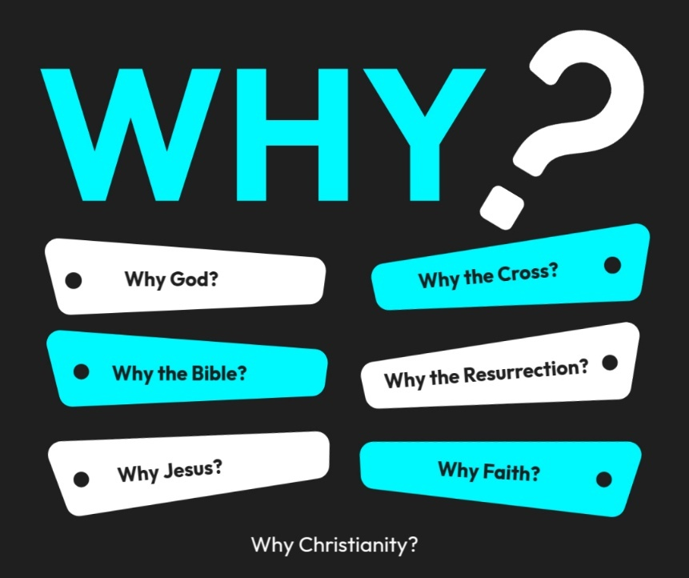

Introduction to the “WHY’s” of Christianity. These classes are designed to help us try and understand the “why” of the things in Christianity. There are important questions that we ask that we need to seek out answers for to help us build a solid foundation for our belief system!

Why Jesus? Text: John 14:6; Colossians 1:15–20
John 14:6 - Jesus said to him, “I am the way, and the truth, and the life. No one comes to the Father except through me.
Col. 1:15-20 - He is the image of the invisible God, the firstborn of all creation. ¹⁶ For by^{[f]} him all things were created, in heaven and on earth, visible and invisible, whether thrones or dominions or rulers or authorities—all things were created through him and for him. ¹⁷ And he is before all things, and in him all things hold together. ¹⁸ And he is the head of the body, the church. He is the beginning, the firstborn from the dead, that in everything he might be preeminent. ¹⁹ For in him all the fullness of God was pleased to dwell, ²⁰ and through him to reconcile to himself all things, whether on earth or in heaven, making peace by the blood of his cross.

There are many questions we struggle with in life, but one that you have probably asked that we want to consider today is that of Jesus? Why follow Jesus? Why is He so important? Why did He have to die? Why choose Him?
We will look briefly at each of these:
Was Jesus Real?
- https://apologeticspress.org/can-we-prove-jesus-was-a-real-person-876/
- Many people today question if Jesus was even real or just a fantasy figure.
  - Do you believe in George Washington? (Why?) – Probably because eyewitnesses wrote about him and its recorded in a history book.
  - Jesus had eyewitnesses that wrote about Him in the Bible, but not only that we have historians who wrote about Jesus such as:
    - Josephus (Jewish historian) mentions Jesus in Antiquities of the Jews
    - Tacitus (Roman historian) wrote about Christ (Annals 15:44)
    - Thallas (52 A.D.) in 3rd book of histories would write about Christ, but try and explain away why there was darkness on the face of the earth at His crucifixion.
    - Mara-Bar-Serapion (Manuscript in the British Museum preserves the text of a letter written after 73 A.D. to his son talking about Christ)
    - Plinius Secundus (Pliny the Younger) Gov. of Bithynia, wrote to Emperor Trajan asking about people who worshipped Christ.
  - Why choose Jesus? Because He is real and true as He claims.

We Should Follow Jesus because He is God:
- https://apologeticspress.org/video/is-jesus-really-god/
- https://apologeticspress.org/did-jesus-claim-to-be-god/

  - John 1:1 - In the beginning was the Word, and the Word was with God, and the Word was God. ² He was in the beginning with God. ³ All things were made through Him, and without Him nothing was made that was made.

  - Col. 1:16 - For by Him all things were created that are in heaven and that are on earth, visible and invisible, whether thrones or dominions or principalities or powers. All things were created through Him and for Him.

  - Gen. 1:26 - Then God said, “Let Us make man in Our image, according to Our likeness

  - Jesus claimed to be eternal which means He is Deity:
    - “Before Abraham was born, I am” (Jn. 8:58)
    - Rev. 1:17-18 – “First & Last” = eternal one

Jesus is Important because He Provided a Way for Us to have a Relationship with God
- John 14:6 – Jesus is the Way to God
- Rom. 5:10-11 – We can be reconciled through Him.
- 1 Tim. 2:5 – Jesus is the bridge between God and man.
- 2 Cor. 5:18-19 – God reconciled us to Himself through Christ.
Jesu had to Die so that We Might Live
- https://www.gotquestions.org/why-Jesus-die.html
- https://apologeticspress.org/why-did-jesus-have-to-die/
- Jesus had to die because sin has consequences. When law is broken, punishment is given.
  - Rom. 3:23 – we all sin
  - Isa. 59:1-2 – sin separates us from God.
  - Rom. 6:23 – wages of sin is death.

- Life is in the blood
  - Leviticus 17:11 says:“For the life of the flesh is in the blood, and I have given it to you upon the altar to make atonement for your souls; for it is the blood that makes atonement by reason of the life.”
  - God designed blood to represent life itself.
  - When sin entered the world, it brought death (Genesis 2:17; Romans 6:23). So, when blood was shed in sacrifice, it symbolized that a life had been given to pay the penalty that sin demanded.
- Sin costs life. Blood represents life given to cover that cost.
- Because God is holy and just
  - God’s holiness cannot overlook sin. His justice requires that sin’s penalty be paid.
  - Hebrews 9:22 – “Without the shedding of blood there is no forgiveness.”
  - Romans 3:25–26 – God presented Christ as a sacrifice “to demonstrate His righteousness… so that He might be just and the justifier.”
- Jesus Loved us Enough to humble Himself to become man on the earth and to give His life on the cross so that the payment for sin might be appeased and we could be forgiven. (Rom. 5:6-8)

Why Choose Him?
Review what you just learned in class. Let the students answer.
Illustration of God’s Love for us!
The King and the Maiden (Søren Kierkegaard)
Suppose there was a king who loved a humble maiden. The king was like no other king. Every statesman trembled before his power. No one dared breathe a word against him, for he had the strength to crush all opponents.
And yet this mighty king was melted by love for a humble maiden who lived in a poor village in his kingdom. How could he declare his love for her? In an odd sort of way, his kingliness tied his hands. If he brought her to the palace and crowned her head with jewels and clothed her body in royal robes, she would surely not resist-no one dared resist him. But would she love him?
She would say she loved him, of course, but would she truly? Or would she live with him in fear, nursing a private grief for the life she had left behind? Would she be happy at his side? How could he know for sure? If he rode to her forest cottage in his royal carriage, with an armed escort waving bright banners, that too would overwhelm her. He did not want a cringing subject. He wanted a lover, an equal. He wanted her to forget that he was a king and she a humble maiden and to let shared love cross the gulf between them. For it is only in love that the unequal can be made equal.
The king, convinced he could not elevate the maiden without crushing her freedom, resolved to descend to her. Clothed as a beggar, he approached her cottage with a worn cloak fluttering loose about him. This was not just a disguise – the king took on a totally new identity – He had renounced his throne to declare his love and to win hers.
Why Jesus? Text: John 14:6; Colossians 1:15–20
Text: John 14:6; Col. 1:15-20
Why follow Jesus? Why is He so important? Why did He have to die? Why choose Him?
Was Jesus Real?
- If so, how do you know?
  - _______________ (Jewish historian) mentions Jesus in Antiquities of the Jews
  - Tacitus (___________ historian) wrote about Christ (Annals 15:44)
  - Thallas (52 A.D.) in 3rd book of histories; try and explain away the _______________.
  - Mara-Bar-Serapion (Manuscript in the British Museum preserves the text of a letter written after 73 A.D. to his son talking about _____________)
  - Plinius Secundus (Pliny the ______________) Gov. of Bithynia, wrote to Emperor Trajan asking about people who worshipped Christ.

We Should ______________ Jesus because He is __________:
- John 1:1; Col. 1:16; Gen. 1:26
- Jesus claimed to be eternal which means He is Deity:
  - “Before Abraham was ________, I am” (Jn. 8:58)
  - Rev. 1:17-18 – “First & __________” = eternal one

Jesus is Important because He ______________ a Way for Us to have a ___________________ with God
- John 14:6 – Jesus is the ________ to God
- Rom. 5:10-11 – We can be _________________ through Him.
- 1 Tim. 2:5 – Jesus is the bridge between God and _________.
- 2 Cor. 5:18-19 – God _____________________________ us to Himself through Christ.

Jesu had to_______ so that We Might _________.
- Jesus had to die because __________ has consequences.
  - Rom. 3:23 – we _______ sin
  - Isa. 59:1-2 – sin ___________________ us from God.
  - Rom. 6:23 – wages of sin is _______________.
- Life is in the _________ (Leviticus 17:11)
  - God designed blood to represent life itself.
- Sin costs life. Blood represents life given to cover that cost.
- Because God is holy and just He requires that sin’s penalty be paid.
  - Hebrews 9:22; Romans 3:25–26
- Jesus _________ us enough to humble Himself to become man on the earth and to give His life on the cross so that the _____________ for sin might be appeased and we could be forgiven. (Rom. 5:6-8)

