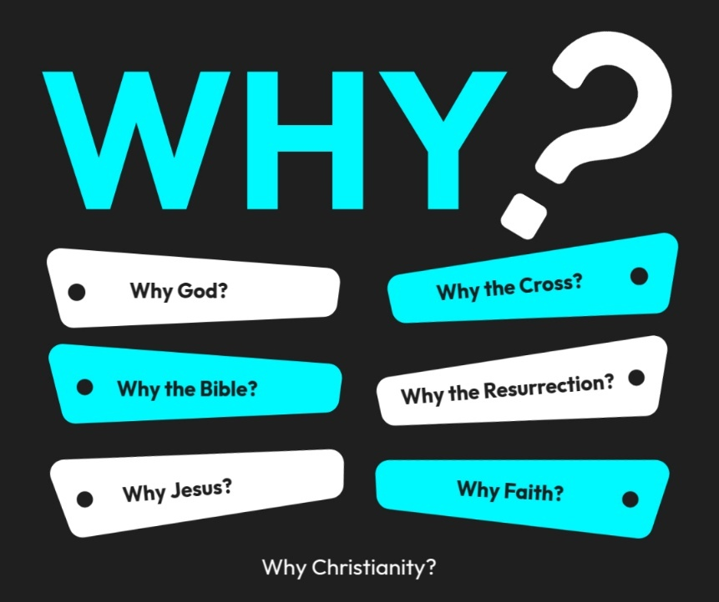

Introduction to the “WHY’s” of Christianity. These classes are designed to help us try and understand the “why” of the things in Christianity. There are important questions that we ask that we need to seek out answers for to help us build a solid foundation for our belief system!
- 10/26/25 – Why God? (Ps. 19:1-4; Rom. 1:20)
- 11/2/25 – Why the Bible? Text: 2 Timothy 3:16–17; 2 Peter 1:20–21
- 11/9/25 – Why Believe? (John 20:30,31)
- 11/16/25- Unity Sunday (No Class)
- 11/23/25 – Why Jesus? Text: John 14:6; Colossians 1:15–20
- 11/30/25 – 5th Sunday (No Class)
- 12/7/25 – Why the Cross? Text: 1 Corinthians 15:3–4; Isaiah 53
- 12/14/25 - Why the Resurrection? Text: 1 Corinthians 15:17–20; Luke 24:1–12
- 12/21/25 - Why Faith? Text: Hebrews 11:1–6; Ephesians 2:8–9
- 12/28/25 - Why the Church? Text: Acts 2:42–47; Hebrews 10:24–25

WHY GOD?
Introduction:
- A small boy once watched his father working in the garden. The father pulled weeds, dug holes, and planted seeds. The boy kept asking, “Why are you pulling those up? Why are you putting that in the ground? Why are you covering it up?”
Finally, the dad smiled and said, “Son, you’ll understand when the flowers bloom.”

- Throughout time people has ask the “Why” about God...

  - Gideon asks, “Why God?”
    - Judges 6:12 - And the angel of the Lord appeared to him (Gideon) and said to him, “The Lord is with you, O mighty man of valor.” ¹³ And Gideon said to him, “Please, my lord, if the Lord is with us, why then has all this happened to us? And where are all his wonderful deeds that our fathers recounted to us, saying, ‘Did not the Lord bring us up from Egypt?’ But now the Lord has forsaken us and given us into the hand of Midian.”
  - Jeremiah asks, “Why God?” –
    - Jer. 12:2 - Why does the way of the wicked prosper?
Why do all who are treacherous thrive?
  - Pharoah asks, “Why obey God?”
    - Ex. 5:2 - But Pharaoh said, “Who is the Lord, that I should obey his voice and let Israel go? I do not know the Lord, and moreover, I will not let Israel go
  - Jesus asks why.
    - Matt. 27:46 - “My God, my God, why have you forsaken me?”

- I bet you have asked before, are asking now, or will ask “Why God?” You might ask in the capacity of what you have read above, or you might simply be asking “Why God” from the thought of “Why even believe in a God?” Why choose the God of the Bible? Why would I follow, obey, or serve Him?
- We are setting our on a quest to answer some of these big, important questions of the Bible to help form and build your faith and to help answer the “WHY’s” of Christianity.
Videos: (There will be a tv set up in your room and you can show video on it. (Stream it)
  - https://apologeticspress.org/video/is-god-important/ (5:52)
  - https://apologeticspress.org/video/4-reasons-to-believe-in-god-5778/ (6:58)

- What is a BIG Question in life? (Does God exist?)
  - Why is God the most IMPORTANT idea?
  - If the God of the Bible exist then…
    - There is a spiritual element to this world (A Soul)
      - What happens to the spiritual element is the most important thing for us to consider.
      - Mark 8:36-37 – “What does it profit…”
    - Everlasting Life is possible to everyone!
How Can We know God Exist?
4 Reasons to Believe in God:
- Matter Demands a Maker
  - Cause & Effect
  - Every effect has a cause. We do not exist in a vacuum or a bubble. Where do we come from? At some point we all recognize that life had a beginning. Logic and design eliminate the idea that we just happened to exist by chance. The God of the Bible is the ultimate answer to the question of our origins, for it is understood that as an infinite being and eternally self-existent He does not require a cause. (Psalm 90:4, Colossians 1:17; II Peter 3:8)
- Life Demands a Life giver
  - How did life come to begin?
  - Law of Biogenesis states that life arises from pre-existing life, not from nonliving matter. It means that a nonliving thing would not have the capacity to engender a living thing. Only another life can do that. The complex, organized structures and processes in living organisms cannot spontaneously arise or develop through chemical reactions or physical means alone. They require a pre-existing living system as the source of new life.

- Design Demands a Designer
  - Complex functional design demands a designer (computer, phone, digestive system of human body)
  - A book requires an author – like a program requires a programmer – like a poem requires a poet – like a design requires a designer – like an invention requires an inventor – like creation requires a Creator.
  - When we see an artwork, do we believe that the artwork created itself or is it self evident that an artist created it?
Animals are programmed for survival (zoologists call it instinct). Who is the programmer?
Science acknowledges that all scientific laws are constant and governed. If this is so, who is the governor?
Science also acknowledges a design to all of creation. Who is the designer?
There is much talk of the Laws of Nature. Who is the one upholding these Laws?
One could argue, it would be easier for the most intricate micro-chip to intelligently form itself from raw matter, than a DNA molecule (the most efficient information storage system in the known universe) to do the same.
Did creation really create itself? There is the option of believing in Darwin’s clever ‘Evolution’ which if given enough time can theoretically create (from nothing) all intricately designed creatures and then program them with a moral sense and instinct. Or, we can believe that behind all things in creation is an incredible Creator.
The heavens declare the glory of God; and the firmament shows His Handiwork. Psalms 19:1

- Intelligence Demands and Intelligent Creator.
  - It’s rather easy to identify certain things that have some measure of intelligence, while recognizing other things (such as rocks and water) that have no intelligence. Humans obviously have an extremely high level of intelligence. They have constructed spaceships that they can guide 240,000 miles to the Moon. They have built artificial hearts. Humans can write poetry, calculate where Mars will be 50 years from now, and build everything from pianos to video game consoles. Humans are intelligent beings.
  - Although there are great differences between mankind and the animal kingdom, animals do possess a measure of intelligence. Dogs can learn to sit, stay, roll over, and play dead. Dolphins can learn to jump through hoops on command. Birds can make helpful “tools” from twigs in order to accomplish some basic tasks. Evolutionary scientists are on record referring to various animals as “sophisticated,” “inventive,” and “intelligent.”
  - But wait a minute! According to atheistic evolution, billions of years ago “nothing” caused a tiny ball of matter to explode. Then, billions of years after this Big Bang, galaxies began to form from lifeless, mindless, unintelligent particles floating around in space in massive clouds of dust. Allegedly, Earth eventually evolved from such a dust cloud, and hundreds of millions of years later, intelligent animals and humans supposedly evolved.
  - What we always observe in nature, however, is that intelligence demands previous intelligence. The reason that humans today are intelligent is because our ancestors were intelligent. The reason that animals have some measure of intelligence is due to intelligent animals that came before them. Dust does not give birth to organized dust particles that have the ability to obtain and apply knowledge. Water does not think. The mindless mud that evolutionists teach gave way to intelligent life on Earth is nothing but a fairy tale unsupported by everything we know from science.
  - So how did the first intelligent creatures come to live in the Universe? Just as the first life demands a supernatural life Giver, so the first intelligent beings demand a supernatural Creator. The existence of intelligence disproves mindless evolution, while at the same time showing that there must be an intelligent Creator.

Ps. 19:1-4 - The heavens declare the glory of God, and the sky above proclaims his handiwork. ² Day to day pours out speech, and night to night reveals knowledge. ³ There is no speech, nor are there words, whose voice is not heard. ⁴ Their voice goes out through all the earth, and their words to the end of the world. In them he has set a tent for the sun,
Rom. 1:20 - For his invisible attributes, namely, his eternal power and divine nature, have been clearly perceived, ever since the creation of the world,^{[a]} in the things that have been made. So they are without excuse.

WHY GOD?

- Throughout time people has ask the “Why” about God...

  - ______________ asks, “Why God?” - Judges 6:12
  - ______________ asks, “Why God?” – Jer. 12:2
  - ______________ asks, “Why obey God?” - Ex. 5:2
  - ______________ asks why. - Matt. 27:46
- What is a BIG Question in life? ____________ _______ ___________?
    - There is a ________________ element to this world = A Soul
    - Everlasting _______ is ____________________ to everyone!

4 Reasons to Believe in God:

- Matter Demands a ______________

- Life Demands a Life ______________
  - ________ of Biogenesis

- Design Demands a ____________________
  - Psalm 19:1

- Intelligence Demands and Intelligent ___________________

Ps. 19:1-4 – (Main thought) -

Rom. 1:20 - For his ____________ attributes, namely, his eternal _____________ and divine nature, have been clearly perceived, ever since the ________________ of the world, in the things that have been __________. So they are without ___________________.

