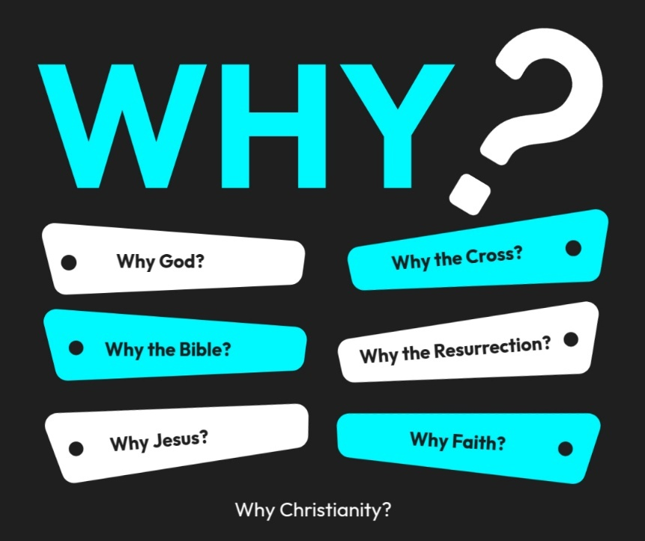

Introduction to the “WHY’s” of Christianity. These classes are designed to help us try and understand the “why” of the things in Christianity. There are important questions that we ask that we need to seek out answers for to help us build a solid foundation for our belief system!
- 10/26/25 – Why God? (Ps. 19:1-4; Rom. 1:20)
- 11/2/25 – Why the Bible? Text: 2 Timothy 3:16–17; 2 Peter 1:20–21
- 11/9/25 – Why Believe? (John 20:30,31)
- 11/16/25- Unity Sunday (No Class)
- 11/23/25 – Why Jesus? Text: John 14:6; Colossians 1:15–20
- 11/30/25 – 5th Sunday (No Class)
- 12/14/25 – Why the Cross? Text: 1 Corinthians 15:3–4; Isaiah 53
- 12/21/25 - Why the Resurrection? Text: 1 Corinthians 15:17–20; Luke 24:1–12
- 12/28/25 - Why Faith? Text: Hebrews 11:1–6; Ephesians 2:8–9

Why Fatih?
Key Texts: Hebrews 11:1, 6; Romans 5:1–2; Ephesians 2:8–9

1. Faith Is How We Connect to God
“Without faith it is impossible to please God…” — Hebrews 11:6
- Faith is the bridge between us and God.
- We can’t see Him physically, but faith lets us trust that He is and that He rewards those who seek Him.
- It’s through faith that we enter into a real, living relationship with Him.
🕊 Faith is the doorway into fellowship with God.

2. Faith Is Essential for Salvation
“For it is by grace you have been saved, through faith…” — Ephesians 2:8
- We don’t earn salvation by works or goodness; we receive it by trusting in what Jesus already did.
- Faith is believing enough to move us to action to be obedient to God.
- It’s about who our faith is in: Jesus Christ.
  - Salvation incurs multiple factors that starts with out faith. (Faith, Repentance, Confession, Baptism) If we don’t have faith then we wont do any of the other things Gods asks of us)
✝️ Faith is trusting that what Christ did on the cross is enough.

3. Faith Is How We Live Each Day
“The righteous will live by faith.” — Romans 1:17
- Faith isn’t a one-time act; it’s a daily walk.
- It shapes how we face trials, make decisions, and hold onto hope when life gets hard.
- Faith says, “Even when I don’t see it, I’ll trust that God is working.”
🌅 Faith is living today with confidence knowing God is in control.

4. Faith Is How God’s Power Works Through Us
“This is the victory that has overcome the world—our faith.” — 1 John 5:4
- Faith unlocks God’s power in our lives.
- Jesus often said, “Your faith has made you well” — showing that faith isn’t passive; it activates God’s promises.
- Faith gives us courage to obey, even when the outcome isn’t visible.
💪 Faith moves mountains because it moves us to trust God.

5. Faith Is the Foundation of Hope
“Faith is the substance of things hoped for, the evidence of things not seen.” — Hebrews 11:1
- Faith anchors our hope in God’s promises, not our circumstances.
- It looks beyond the present to the eternal.
- Faith is what keeps us steady when life shakes us.
🌻 Faith keeps hope alive when everything else looks dead.

Summary:
- We need faith to know God.
- We need faith to be saved.
- We need faith to live daily.
- We need faith to experience God’s power.
- We need faith to hold on to hope.

Illustration:
Imagine sitting in a chair — you don’t test its legs every time. You simply trust it to hold you.
That’s what faith in Christ is: resting your full weight on Him, believing He will hold you up — not because of what you can do, but because of who He is.

Why Fatih?
Key Texts: Hebrews 11:1, 6; Romans 5:1–2; Ephesians 2:8–9

1. Faith Is How We ____________ to God — Hebrews 11:6
- Faith is the ________ between us and God.
- Can we be pleasing to God with out a faith in Him? Y or N

2. Faith Is Essential for _______________ — Ephesians 2:8
- How do we receive God’s grace? _________ ________
- Faith is believing enough to move us to action to be _____________ to God.
- It’s about who our faith is in: _________ _________

3. Faith Is How We ________ Each Day — Romans 1:17
- Faith isn’t a one-time act; it’s a _________ walk.
- It ________ how we make decisions.
- Faith is living today with _____________ that God is in control.

4. Faith Is How God’s _____________ Works Through Us - 1 John 5:4
- Faith unlocks God’s ____________ in our lives.
- Faith gives us courage to __________, even when the outcome isn’t visible.
  - Matt. 17:20

5. Faith Is the Foundation of __________ - Hebrews 11:1
- Faith _________ our hope in God’s promises, not our circumstances. (Heb. 6:19)
- It looks beyond the present to the _____________.
- Faith is what keeps us __________ when life shakes us.

