7 Habits of Effective Christians (Habit 3)
(A Spin off of Stephen Covey’s book: 7 Habits of Effective People)
Introduction: Have you ever looked at a successful person and wished you could be like that? Have you ever wanted to better yourself and wished you knew the “Secret Sauce” to make it happen? If I were a betting man, I would bet that all of us have seen people who we thought to be successful in life and wanted to pattern our lives after them and become successful too. Have you ever felt this way in your Chrisitan life? You wish you were a “better” more “effective” more “successful” Christian. This is your year. In 2026 the elders are challenging the congregation to “Be Better!” Let us strive to improve in our spiritual life and be effective Christians that are learning to faithfully serve God or are continuing to grow in our service to God!
There are many self-help books out on “How to” better yourself in just about anything you want. Some things like, “A Year of Positive Thinking,” “The Total Money Makeover,” “Getting Back into Shape,” “7 Habits of Highly Effective People” by Stephen R. Covey. Here is an overview of that book:
- Do you want to make your life better? Are you struggling in your personal or professional life, your interactions with other people, your life balance, or your life’s purpose? The 7 Habits of Highly Effective People provides an inside-out approach to improving yourself and your life. This method entails examining and adjusting your character, your motives, and how you see the world in order to change how you behave and how you interact with others. Learn how to best focus your time, define your personal mission, and build productive relationships with other people.

These next 2 months (Jan & Feb) we want to use the suggestions Covey uses in his book that he believes helps people to be effective and serve a purpose and translate those same habits into our Chrisitan lives to be more effective and serve our purpose for God. We will look into God’s word to see what He has said about how we can better ourselves in our Christian walk and unveil the “secret sauce” to be effective Christians.
Overview of the 7 Habits we will be discussing:
- Be Proactive: Take responsibility for your life, choices, and actions, focusing on what you can control rather than reacting to circumstances.
- Begin with the End in Mind: (Goals setting; eternity) - Define your personal mission and goals, creating a clear vision of where you want to go before starting.
- Put First Things First: - Prioritize tasks based on importance (goals) rather than just urgency, focusing on significant activities that contribute to your vision.
- Think Win-Win: - Seek mutually beneficial solutions and agreements in all interactions, believing there's enough success for everyone.
- Seek First to Understand, Then to Be Understood: Practice empathetic listening to truly grasp others' perspectives before presenting your own views.

- Synergize: Work cooperatively, valuing differences and combining strengths to create solutions greater than the sum of individual contributions (1+1=3).
- Sharpen the Saw: Continuously renew yourself by maintaining balance across four dimensions: physical, mental, spiritual, and social/emotional.

Lesson 3 Outline: Put First Things First

Theme: A meaningful Christian life is not built on reacting to urgent distractions but on intentionally choosing what God says is most important. Wisdom is deciding between what is good, what is better, and what is best.

Illustration:
- Have a Quarter, Dollar Bill. Ask which would your rather have? (Why?)
  - The dollar is a better choice/option.
- Now put out a Dollar Bill & a $5 Bill. Ask which would you rather have? (Why?)
  - We know the $5 bill is worth more than the dollar bill.
- We have these type of choices everyday! Good, better, best. We must make the choice!
Covey Book: (7 Habits of Effective People)
- Question 1: What one thing could you do (something you aren’t doing now” that, if you di it on a regular basis, would made a tremendous positive difference in your personal life?
- Question 2: What one thing in your Christian life would bring similar results?
Habit 3 (Putting 1st Things 1st) is the personal fruit, the practical fulfillment of Habit 1 (Be Proactive) & Habit 2 (Begin with the End in Mind)
Principles of Personal Management:
- Things which matter most must never be at the mercy of things which matter least. – Goethe
We can become principle-centered in our living by practicing effective self-management.
It boils down to the human will & the choices you make (or fail to make)

** Effective Management = Putting 1st things 1st!
- Management is discipline, carrying it out.
  - Discipline derived from disciple = live out a set of principles or set of values or what we follow.
  - The Successful Person/ Christian has the habit of doing thing the things other don’t want to (Put 1st Things 1st)
The Management Matrix
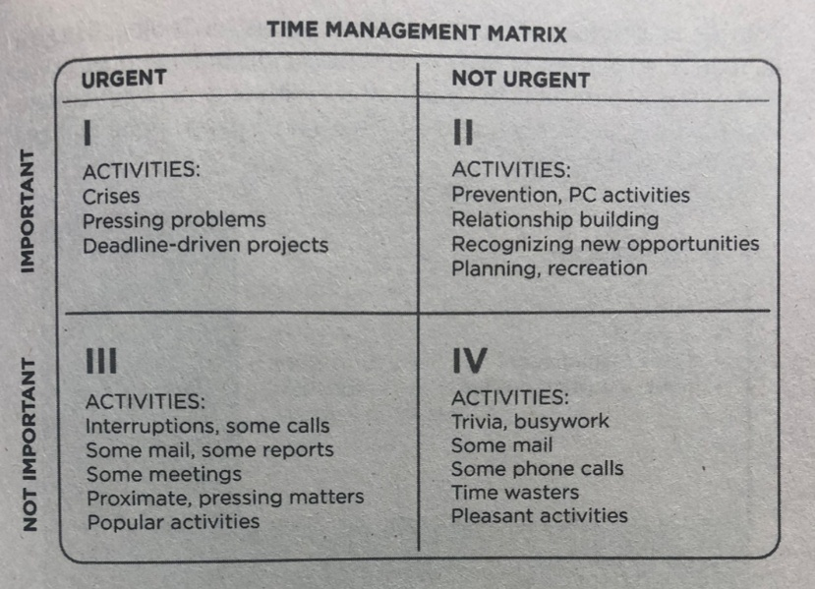
Urgent = “Now” - Ringing phone during service. (people move fast) = urgent
Importance = has to do with results that contribute to your mission, your values, your high-priority goals.
The Results of how people live their lives in different Quadrants:
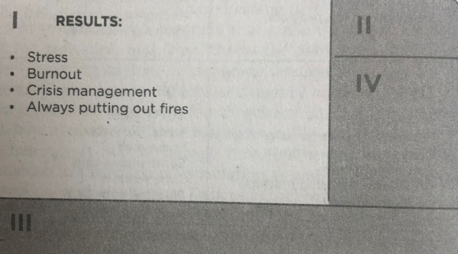
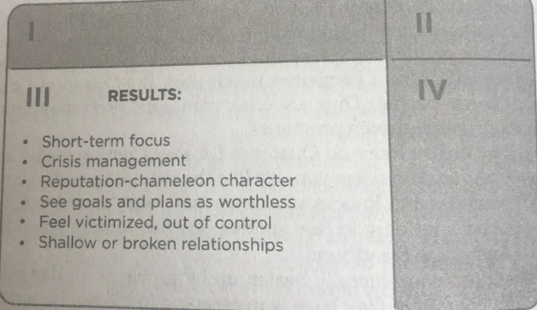
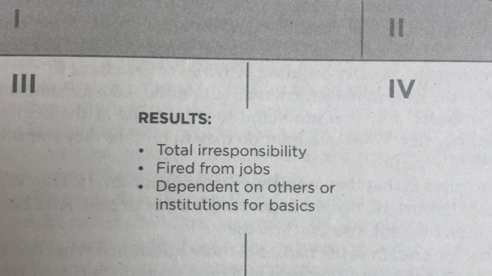
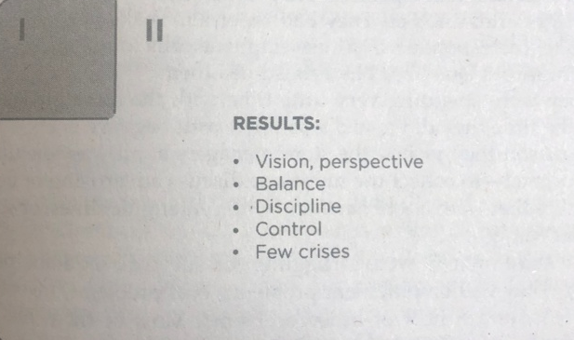
Activity | Approx. Time Per Day
Sleep | ~9 hours
Work (population average) | ~3.2–3.6 hours
Leisure & Recreation | ~5 hours
Eating & Drinking | ~1.2 hours
Household Activities (chores, cleaning, etc.) | ~2 hours
Other (childcare, socializing, errands) | ~1–2 hours

Illustration: Jug filled with balls & beans – (concept) - https://www.google.com/search?q=priority+illustrtation+with+jar%2C+beans+rice&rlz=1C1CHBF_enUS937US937&oq=priority+illustrtation+with+jar%2C+beans+rice+&gs_lcrp=EgZjaHJvbWUyBggAEEUYOTIJCAEQIRgKGKABMgkIAhAhGAoYoAEyCQgDECEYChigATIJCAQQIRgKGKABMgkIBRAhGAoYoAEyCQgGECEYChirAjIJCAcQIRgKGKsCMgcICBAhGI8C0gEJMTk5NjlqMGo3qAIIsAIB8QVbrPohhjIoEg&sourceid=chrome&ie=UTF-8#fpstate=ive&vld=cid:9b6546c6,vid:6_N_uvq41Pg,st:0
Point: We tend to get occupied with things that aren’t that important, and they take over out lives. We have to live intentionally and prioritize the things that are important to us.
What It Takes to Say “NO”
The only place to get time for Quadrant II in the beginning is from Quadrant III & IV. You can’t ignore the urgent & important activities from Quad I, although it will shrink in size as you spend more time with prevention and preparation in QII.
To say “YES” to QII, you have to learn to say “NO” to other activities.
- Decide what you highest priorities are and have the courage to pleasantly, smilingly, non-apologetically say “NO” to other things.

  - REMEMBER: Whey you say “YES” to something you are always saying “NO” to something else.

- When we work on Habit 1:
- Be Proactive: Take responsibility for your life, choices, and actions, focusing on what you can control rather than reacting to circumstances.

- Begin with the End in Mind: (Goals setting; eternity) - Define your personal mission and goals, creating a clear vision of where you want to go before starting.

  - These will help in Put First Things First:
    - Make Schedule/Calendar
      - This means it is a priority.

The Habit that Stephen Covey is trying to instill is a Biblical habit that we need to grasp!

Transition: Jesus repeatedly taught His followers to prioritize the most important things.

1. Jesus Priority Framework
- (OT) Ex. 20:1-3 – (Very 1st Commandment) - And God spoke all these words: ² “I am the Lord your God, who brought you out of Egypt, out of the land of slavery. ³ “You shall have no other gods before me.
- (NT) Matt. 6:33 - But seek first his kingdom and his righteousness, and all these things will be given to you as well.
  - Context
2. IDENTIFY YOUR PRIORITIES
  - Identify your top 3 priorities? _______________________________________
    - If you don’t schedule the big rocks first, the small things will fill your entire life.

  - “Seek first” = highest priority, not leftover time or energy.
  - All other needs fall into place when God’s priorities come first.
  - Priorities must be determined before the day begins.
Application: Ask: What would it look like to seek the Kingdom first in my schedule?

3. CHOOSING WHAT IS BETTER
- (Luke 10:38–42) - As Jesus and his disciples were on their way, he came to a village where a woman named Martha opened her home to him. ³⁹ She had a sister called Mary, who sat at the Lord’s feet listening to what he said. ⁴⁰ But Martha was distracted by all the preparations that had to be made. She came to him and asked, “Lord, don’t you care that my sister has left me to do the work by myself? Tell her to help me!” ⁴¹ “Martha, Martha,” the Lord answered, “you are worried and upset about many things, ⁴² but few things are needed—or indeed only one. Mary has chosen what is better, and it will not be taken away from her.”
  - Martha = urgent things (immediate tasks, pressure).
  - Mary = important things (time with Jesus).
    - Jesus didn’t rebuke Martha’s service; He corrected her priorities.
    - We often sacrifice what is important for what is urgent.
Application: Identify your “Martha moments” where urgent tasks push out spiritual priorities.

- LET GO OF DISTRACTIONS (Hebrews 12:1)
  - Heb. 12:1 - Therefore, since we are surrounded by such a great cloud of witnesses, let us throw off everything that hinders and the sin that so easily entangles. And let us run with perseverance the race marked out for us, ² fixing our eyes on Jesus, the pioneer and perfecter of faith
  - Not all distractions are sinful—some are just weights.
  - Prioritizing means removing anything that slows spiritual progress.
  - Choosing the best requires saying “no” to many good things.
Activity: Students write: “What is one distraction I need to remove or limit?”_________________

Closing Challenge: - “What ‘first thing’ does God want you to put first this week?”

Action Items:
- Identify your top 3 priorities (Write them down) 1. 2. 3.
- What would it look like to seek the Kingdom first in my schedule?
  - (Put your priorities in your schedule for this week (Make sure they happen)
- Identify your “Martha moments” where urgent tasks push out spiritual priorities.
  - Think of a recent situation where you had a choice and chose a Martha Moment.
    - _____________________________________
- “What is one distraction I need to remove or limit this week? (work on it)

