7 Habits of Effective Christians (Habit 3)
Put First Things First

Question 1: What one thing could you do (something you aren’t doing now” that, if you did it on a regular basis, would made a tremendous positive difference in your personal life?
Question 2: What one thing in your Christian life would bring similar results?
The Management Matrix
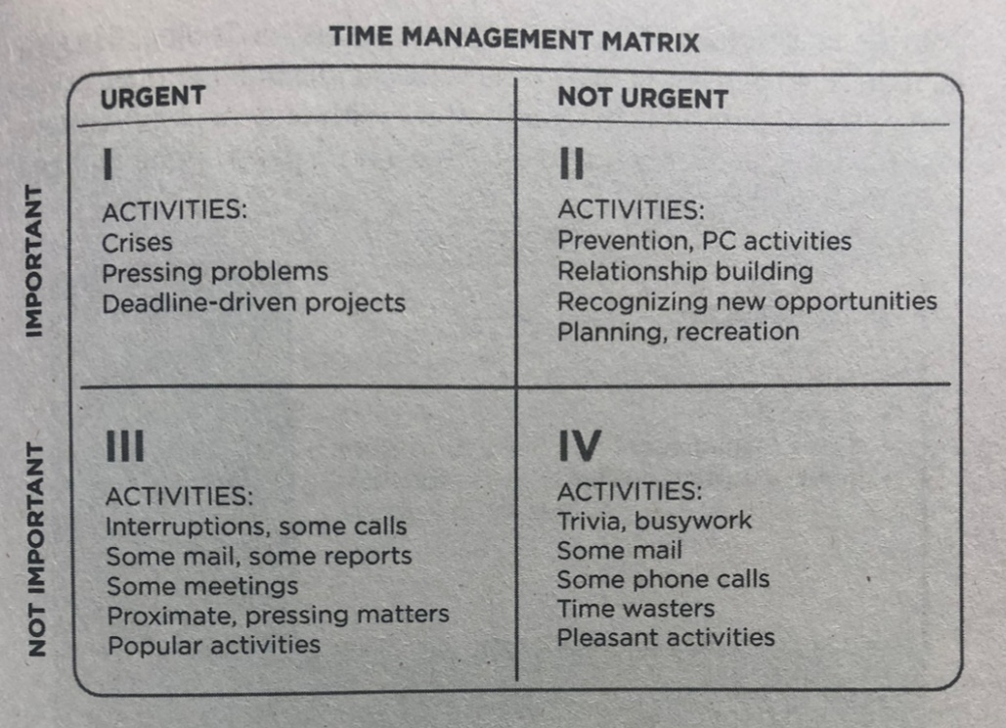

What It Takes to Say “NO”
To say “________” to QII, you have to learn to say “______” to other activities.
Remember: Whey you say “______” to something you are always saying “______” to something else.

7 Habits of Effective Christians (Habit 3)
Put First Things First

Question 1: What one thing could you do (something you aren’t doing now” that, if you did it on a regular basis, would made a tremendous positive difference in your personal life?
Question 2: What one thing in your Christian life would bring similar results?
The Management Matrix

What It Takes to Say “NO”
To say “________” to QII, you have to learn to say “______” to other activities.
Remember: Whey you say “______” to something you are always saying “______” to something else.

1. JESUS PRIORITY ___________________
- (OT) Ex. 20:1-3 (NT) Matt. 6:33
2. IDENTIFY YOUR ______________________

3. CHOOSING WHAT IS _____________________ (Luke 10:38–42)
- LET GO OF ____________________ (Hebrews 12:1)

Action Items:
- Identify your top 3 priorities (Write them down)
1.
2.
3.

- What would it look like to seek the Kingdom first in my schedule?
  - (Schedule priorities this week (Make them happen)
Sunday | Monday | Tuesday | Wednesday | Thursday | Friday | Saturday

- Identify your “Martha moments” where urgent tasks push out spiritual priorities.
  - Think of a recent situation where you had a choice and chose a Martha Moment.
    - _____________________________________

- “What is one distraction I need to remove or limit this week? (Work on it)
  - _____________________________________

1. JESUS PRIORITY ___________________
- (OT) Ex. 20:1-3 (NT) Matt. 6:33
2. IDENTIFY YOUR ______________________

3. CHOOSING WHAT IS _____________________ (Luke 10:38–42)
- LET GO OF ____________________ (Hebrews 12:1)

Action Items:
- Identify your top 3 priorities (Write them down)
1.
2.
3.

- What would it look like to seek the Kingdom first in my schedule?
  - (Schedule priorities this week (Make them happen)
Sunday | Monday | Tuesday | Wednesday | Thursday | Friday | Saturday

- Identify your “Martha moments” where urgent tasks push out spiritual priorities.
  - Think of a recent situation where you had a choice and chose a Martha Moment.
    - _____________________________________

- “What is one distraction I need to remove or limit this week? (Work on it)
  - _____________________________________

