Lesson 2: Begin With the End in Mind
Proactive v. ___________________

“Why do people often drift spiritually?” - ________________________________________________________
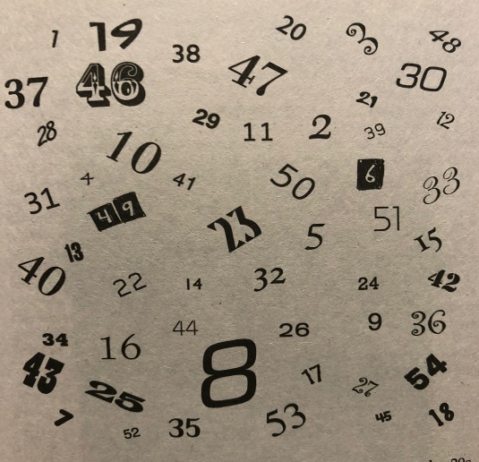

Begin With the End in Mind
  - 4 speakers
    - 1st Speaker – ___________________
    - -

    - 2nd Speaker – ___________________
      - -

    - 3rd Speaker – ___________________
      - -

    - 4th Speaker –
      - -
Lesson 2: Begin With the End in Mind
Proactive v. ___________________

“Why do people often drift spiritually?” - ________________________________________________________

Begin With the End in Mind
  - 4 speakers
    - 1st Speaker – ___________________
    - -

    - 2nd Speaker – ___________________
      - -

    - 3rd Speaker – ___________________
      - -

    - 4th Speaker –
      - -
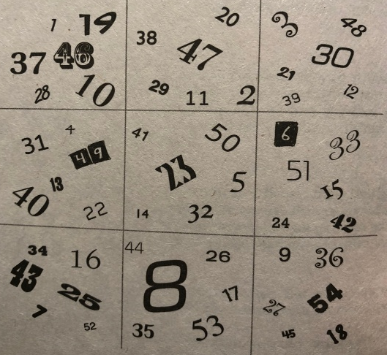

Begin With the End in Mind:

    - LOOK TO THE ULTIMATE __________.
Matt. 24:13; Rev. 2:10; 2 Cor. 4:16-18; Colossians 3:1–4

    - GOD’S VISION FOR YOU: ___________________ (Romans 8:29)

  - _______________ THE VISION (Habakkuk 2:2)

- Hab. 2:2; Dt. 6:4-9
- Activity: Write a 1–2 sentence mission for your life.

Begin With the End in Mind:

    - LOOK TO THE ULTIMATE __________.
Matt. 24:13; Rev. 2:10; 2 Cor. 4:16-18; Colossians 3:1–4

    - GOD’S VISION FOR YOU: ___________________ (Romans 8:29)

  - _______________ THE VISION (Habakkuk 2:2)

- Hab. 2:2; Dt. 6:4-9
- Activity: Write a 1–2 sentence mission for your life.

____________________________________________________________

