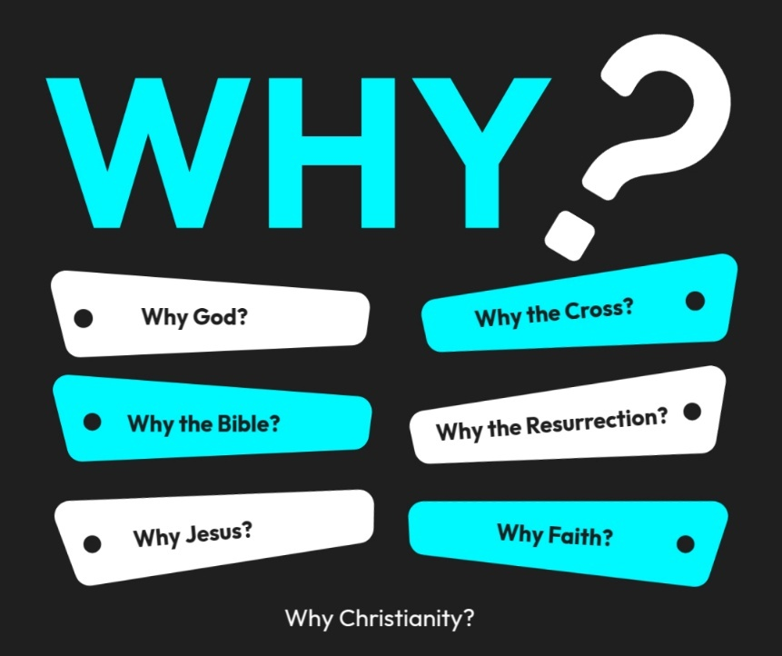

Introduction to the “WHY’s” of Christianity. These classes are designed to help us try and understand the “why” of the things in Christianity. There are important questions that we ask that we need to seek out answers for to help us build a solid foundation for our belief system!
- 10/26/25 – Why God? (Ps. 19:1-4; Rom. 1:20)
- 11/2/25 – Why the Bible? Text: 2 Timothy 3:16–17; 2 Peter 1:20–21
- 11/9/25 – Why Believe? (John 20:30,31)
- 11/16/25- Unity Sunday (No Class)
- 11/23/25 – Why Jesus? Text: John 14:6; Colossians 1:15–20
- 11/30/25 – 5th Sunday (No Class)
- 12/7/25 – Why the Cross? Text: 1 Corinthians 15:3–4; Isaiah 53
- 12/14/25 - Why the Resurrection? Text: 1 Corinthians 15:17–20; Luke 24:1–12
- 12/21/25 - Why Faith? Text: Hebrews 11:1–6; Ephesians 2:8–9
- 12/28/25 - Why the Church? Text: Acts 2:42–47; Hebrews 10:24–25

WHY BELIEVE?
I BELIEVE BECAUSE….

6 classic reasons to believe in God

1. The Universe Had a Beginning — The Cosmological Argument
Everything that begins to exist has a cause.
The universe began to exist — therefore, it must have a cause beyond itself.
That cause must be eternal, powerful, and immaterial — characteristics that fit the description of God.
🪐 Illustration: Just as a painting points to a painter, the cosmos itself points to a Creator.
Scripture: “In the beginning, God created the heavens and the earth.” — Genesis 1:1

2. The Design in Nature — The Teleological Argument
The universe displays incredible order, complexity, and fine-tuning — from DNA’s code to the laws of physics.
Such design suggests a Designer, not random chance.
🔬 Example: The human eye, the precise constants that allow life, or the structure of a single cell — all exhibit purpose and intelligence.
Scripture: “The heavens declare the glory of God; the skies proclaim the work of his hands.” — Psalm 19:1

3. The Moral Law Within — The Moral Argument
Every culture has a sense of right and wrong.
Where did this universal moral awareness come from?
If moral values truly exist, there must be a Moral Lawgiver beyond human opinion.
❤️ Example: We instinctively know that love is good and cruelty is evil — even when it costs us to do what’s right.
Scripture: “The law is written on their hearts, their conscience also bearing witness.” — Romans 2:15

4. The Existence of Meaning and Purpose
If life were purely accidental, meaning would be an illusion.
Yet humans long for purpose, justice, love, and eternity — desires that point beyond this life.
Our deepest needs (to be loved, to matter, to live forever) make sense if we are made by and for God.
🌅 Example: Every heart’s search for “something more” is like a homing signal pointing to its Source.
Scripture: “He has set eternity in the human heart.” — Ecclesiastes 3:11

5. The Historical Reality of Jesus Christ
Jesus claimed to be God and proved it through His life, teachings, miracles, and resurrection.
The historical evidence for the resurrection — empty tomb, eyewitness accounts, and transformed disciples — provides a solid foundation for belief in God.
✝️ Example: The apostles went from fear to boldness because they were convinced they had seen the risen Christ.
Scripture: “He presented himself alive after his suffering by many infallible proofs.” — Acts 1:3

6. Science Points to God
* Earth rotates in 24 hr. and if that revolution were delayed, life would be impossible
* If the gases in the atmosphere were slightly changed , it could be fatal
* Water is the only known substance which becomes lighter as it freezes. This is tremendously important to life. B/c of it , ice floats instead of sinking to the bottom of lakes and rivers and gradually forming a solid mass. On the top of the water it forms as layer of insulation to maintain the water below at a temperature above freezing. Fish and other marine life are preserved …
I) Field of Astronomy:
1) Earth is not FLAT. Isa. 40:22 — "It is He who sits above the circle of the earth..." Hebrew - Khug = circle, roundness, sphere.
- Pythagoras, mathematician theorized earth as a sphere, supported by Aristotle 100 yrs. later. *(3 AD) Eratosthenes an astronomer, historian, geographer, philosopher, and a mathematician. Discovered Sun Position by sticks in Alexandria, Egypt and Syene modern day Aswan. On June 21 summer solstice. (Shadow)
- Concept of Geocentricity: Thought that sun revolves around Earth (center of universe) Ptolemy (theologians) 130 A.D. planets moving in small circles along a larger circular path around the earth. Model accepted until 1543 Copernicus —heliocentric / Galileo - Inquisition in 1632 / Kepler formulated planetary motion/ Newton explained Keplers laws based on Law of Gravity.
- Our Sun is a medium-sized star with a radius of about 435,000 miles (700,000 kilometers). Many stars are much larger – but the Sun is far more massive than our home planet: it would take more than 330,000 Earths to match the mass of the Sun, and it would take 1.3 million Earths to fill the Sun's volume.
- The Sun is about 93 million miles (150 million kilometers) from Earth
  - Ps. 19:6 — "It's rising is from one end of heaven, and its circuit to the other end; And there is nothing hidden from its heat."
Light & Dark Job 38:19 — "Where is the way to the dwelling of light? And darkness, where is its place?" Darkness — (maxim) "place thereof'/ Light —(Derek) "way"
- 1879 Thomas Edison & Sir Joseph Wilson Swan
- Isaac Newton (1643-1727)— Light composed of small particles that travel in a straight line. Newton — Light parted by Prism. — broken into a band of seven colored lights.
  - Job 38:24 — "by what way is light parted?"
Field of Oceanography
- Solomon said in Eccl. 1:7 — "All rivers run into the sea, Yet the sea is not full; To the place from which the rivers come, There they return again." Ex: Mississippi River dumps = 6 mil. Gal/sec into Gulf of Mexico.
- Where does all water go (Hydrologic cycle)= water cycle
- Ecc.11: 3 — "If the clouds are full of rain, They empty themselves upon the earth." Amos 9:6 — "He who builds His layers in the sky, And has founded His strata in the earth; who calls for the waters of the sea, And pours them out on the face of the earth — The Lord is His name."
- 1676 Pierre Perault & Edme Mariotte discovered the water cycle.

- Job 38:16 — "Hast thou entered into the springs of the sea?" Southernmost tip of Maui — Frenchman (La Perouse) discovered fresh water springs in ocean. * used to shower off & gather drinking water. – (The Popular Science Monthly; Dec. 1905; Fresh Water Springs in Ocean; by: Professor C.H. Hitchcock; Dartmouth College)

- Mid 1800's man lay sick. Son read Ps. 8:8 — "The birds of the air, And the fish of the sea that pass through the paths of the seas." Pursued investigation solely on this verse & lead to be true. Matthew Fontaine Maury, a U.S. Naval officer discovered =1840's. (Ocean currents) Ideal for plankton, key to sea life. *Isa. 43:16 — "Thus says the Lord, who makes a way in the sea and a path through the mighty waters.

- Job 38:16 — "Have you entered the springs of the sea? Or have you walked in search of the depths."

- 1873 — British scientists in Pacific Ocean found a "recess" 5.5 mi. & 35,000ft. over 6mi.

Noah Gen 6:15 — build an ark — 300L, 50W, 30H (cubits) 17.5-18 in. Ratio 30:5:3
- Until 1858 — Ark = largest seagoing vessel= 450 ft. long = 1 ¹/2 football fields. App.1.5 million. Cubic ft. of space =55 box cars reg. size
- 1844 Isambard K. Brunnett constructed 30:5:3 ship — "Great Britain" same as ark
- WWII S.S. Jeremiah O'Brien — carried tremendous amts of cargo. {Perfect dimensions for seagoing ship/ not for speed}
Field of Physics
- Gen. 2:1 — Moses said, "heaven and earth were finished..." Finished — Heb.- past definite tense indicating completion in the past.
- 1st Law of Thermodynamics — neither matter nor energy can be created or destroyed. 1847 German DR. Hermann Helmholtz
- Henry M Morris, "there is nothing now being created anywhere in the known universe." NOTHING IS DESTROYED!!
- Neh. 9:6 - "You alone are the Lord, You have made heaven, The heaven of heavens, with all their host. The earth and everything on it, The seas and all that is in them, And You preserve them all. The hosts of heaven worship You.
- Heb. 1:3 - "Who being the brightness of His glory and the express image of His person, and upholding all things by the word of His power...
  - If God upholds all things by his word, man cannot destroy them.

2)Earth is wearing out — Heb. 1:11 — "They will perish, but You remain; And they will all grow old like a garment."
- Isa. 51:6 — "Lift up your eyes to the heavens, And look on the earth beneath. For the heavens will vanish away like smoke, The earth will grow old like a garment, And those who dwell in it will die in like manner; but my salvation will be forever, And my righteousness will not be abolished."
- Ps. 102:26 — They will perish, but You will endure; Yes, they will all grow old like a garment; like a cloak You will change them, And they will be changed."

- 2nd Law of Thermodynamics — Things become more disorderly as time passes. 1850-51 French — Sadi Carnot American — Richard Feynmann
  - Ex. Child, born, grows, & dies
  - House in 250 yrs.= junk
  - Car in 40 yrs. = junk — Physics discovered recently, bible teaches it 1000 yrs. Ago Science contradicts the Theory of evolution"!

Field of Medicine
- Deut. 23:12-14 — Israel instructed by Moses to rid (bury) human waste products. "Middle Ages" disease — Black Plague killed over 13 mil. more than WW2 Hygienic law practiced by God's people (1347 AD)
- Gen. 17:12 — 8th Day Circumcision. Commanded by God to Abraham. Why 8th?? 3 things depend on blood clotting. Platelets, Vitamin K, & Prothrombin
- 1935 Professor H. Dam discovered vit. K is responsible for the production (by the liver) of prothrombin. Quantity of K = deficient / Prothrombin =deficient
- Days 5 — 7 K is present in adequate quantities, but only Day 8 Prothrombin elevates above 100% of normal = perfect day to circumcise.
- Quote: "As we congratulate science for this recent finding, we can almost hear the Leaves of the Bible rustling. They would like to remind us that 4000 yrs. ago, when God initiated circumcision w/ Abraham, He said, "And he that is 8 days old Shall be circumcised..." Abraham did not pick the 8 days after many centuries of trail and error experiments. Neither he nor any of his company from the ancient city of Ur in the Chaldees had ever been circumcised. It was a day picked by the Creator of Vitamin K." (S. I. McMillian)

- George Washington, "Father of our country," = died, b/c of Laryngitis. Cure = rid blood from body. 1799 discovered blood-sustained life.

- Red blood cells carry oxygen (due 2 hemoglobin in cells) life is made possible. Ex: Red blood cells carry= 270 mill. Molecules of hemoglobin per cell.

- Moses said 1500 yrs. B.Sc. in Lev.17:11-14, "the life of the flesh is in the blood."
BLOOD
- Lev. 17 — Blood was used to forgive the sins of the people by means of sacrifice. Heb. 10:4 — The blood of bulls and goats could not take away sin.
- 1 Cor. 6:20 — You were bought at a price, therefore glorify God in your body. Acts 20:28 — God purchased you with his own blood.
- Rom. 5:9 - Having been justified by his blood, we shall be saved from wrath through him.
- Matt. 26:28 — For this is my blood of the new covenant, which is shed for many for the remission of sins.
- Acts 2:38 — Repent and be baptized everyone of you in the name of Jesus Christ for the remission of your sins and you will receive the gift of the holy spirit.
- Rom. 6 - Explanation of baptism.

I CAN BELIEVE BECAUSE:
1. The Universe Had a Beginning — The Cosmological Argument
2. The Design in Nature — The Teleological Argument
3. The Moral Law Within — The Moral Argument
4. The Existence of Meaning and Purpose
5. The Historical Reality of Jesus Christ
6. Science Points to God

WHY BELIEVE?
I BELIEVE BECAUSE….
- The Universe Had a ________________ — The Cosmological Argument
  - “In the beginning, God created the heavens and the earth.” — Genesis 1:1

- The ____________ in Nature — The Teleological Argument
  - “The heavens declare the glory of God; the skies proclaim the work of his hands.” — Psalm 19:1

- The __________ Law Within — The Moral Argument
  - “The law is written on their hearts, their conscience also bearing witness.” — Romans 2:15

- The Existence of Meaning and ________________
  - “He has set eternity in the human heart.” — Ecclesiastes 3:11

- The Historical ____________ of Jesus Christ
  - “He presented himself alive after his suffering by many infallible proofs.” — Acts 1:3

- _____________ Points to God
  - “Test everything; hold fast what is good.” – 1 Thess. 5:21
  - Earth rotates in 24 hr. and if that revolution were _____________, life would be impossible.
  - If the gases in the atmosphere were slightly __________, it could be fatal.
  - Water is the only known substance which becomes _____________ as it freezes.
Field of Astronomy:
  - Earth is not ____________. - Isa. 40:22; Ps. 19:6
  - Job 38:24 “by what way is light _____________?"
Field of Oceanography
- Eccl. 1:7; Ecc.11: 3 -1676 Pierre Perault & Edme Mariotte discovered the _________ _________.
- Ps. 8:8 - "The birds of the air, And the fish of the sea that pass through the ________ of the seas."
  - Matthew Fontaine Maury found paths in the sea in 1840. *Isa. 43:16
- Gen 6:15 – The ________ - 1844 I. K. Brunnett made 30:5:3 ship (Perfect dimensions for seagoing ship)
Field of Physics
- Gen. 2:1 - ____^{st} Law of Thermodynamics — neither matter nor energy can be created or destroyed.
- 2nd ______ of Thermodynamics — Things become more disorderly as time passes.
Field of Medicine
- Deut. 23:12-14 - Hygienic law practiced by God's people.
- Gen. 17:12 ____^{th} Day

