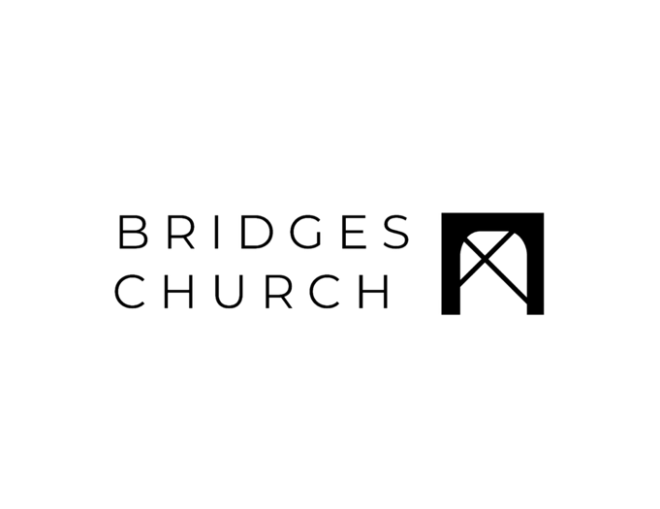

God will judge the wicked and save the righteous. Psalm 7
Pastor Brian Drummond | July 20, 2025 | Bridges Church 10 AM
Point 1: God you are my (v.1-2) (Psalm 11:1, Psalm 31:15, Psalm 7:2)

Point 2: God please (v.3-5) (1 Samuel 24:12, 1 Samuel 26:18)
Point 3: God (v.6-7) (Psalm 5:4)

Point 4: God will judge the wicked and (v.8-16) (Ecclesiastes 1:9, Ezekiel 6:9, John 14:6-9, Genesis 6:5-6, Matthew 23:37, Luke 19:41-42, James 1:14-15, Psalm 94:23, Psalm 141:10)

Point 5: I will (v.17) (Psalm 145:1)

