I, the undersigned, certify that I am the parent or legal guardian of __________________ (hereafter the “minor child”).
I hereby give my consent to have my minor child participate in the following activity of Bethel Church of the Nazarene: ___Youth Group Gatherings + Events, Summer Camp, Retreats____ (hereafter “the activity”) for the year __2026__.
I recognize that there are risks involved in participating in this activity and hereby assume all risk of injury, harm, damage, or death to my minor child in connection with his/her participation in this activity.
To the fullest extent permitted by law, I release Bethel Church of the Nazarene, its trustees, officers, directors, employees, agents and representatives from any injury, harm, damage or death which may occur to my minor child while participating in the activity and agree to save and hold harmless Bethel Church of the Nazarene, its trustees, officers, directors, employees, agents and representatives from any claims arising out of my minor child’s participation in the activity.
Further, being the parent or legal guardian of the minor child, I do consent to any medical, surgical, x-ray, anesthetic, or dental treatment that may be deemed necessary for my minor child. I understand that efforts will be made to contact me prior to treatment but, in the event I cannot be reached in an emergency, I give permission to the activity leader to make the decisions necessary for treatment. Should there be no activity leader available, I give permission to the attending physician to treat my minor child. As parent or legal guardian, I understand that I am responsible for the health care decisions of my minor child and agree that my insurance plan is the primary plan to pay for the medical, dental, or hospital care or treatment that is given to my minor child. Any insurance policy of the church or organization sponsoring this event will be used as the secondary coverage.

Executed this _____ day of ___________, 20__.

Signature ________________________________________________________

Printed Name _____________________________________________________

Witness: _________________________________________________________

Witness: _________________________________________________________
I give permission for my child to have their picture taken to be used on the church bulletin board, social media pages, church website, and slide shows shown to the church. ________ (Initial)

I give permission for my child to be transported with an adult volunteer or paid staff.

___________________________________(Signature)

__________________Date
Contact Information:
Student’s Name:___________________________________________________________

Parent(s)/Guardian(s) Name(s):______________________________________________

Address:________________________________________________________________
(street) (city) (state) (zip)

Child’s Birthdate:__________________ Parent Phone #:______________________________
Parent Cell Phone #:_____________________________
Receive Text Notifications about Youth events and meetings? Y____ N___

Parent Email__________________________________________________________________
Student Email_________________________________________________________________
Would you like to be added to the email list for Youth events and gatherings? Y____ N_____

Emergency Contact Person and Phone:____________________________________________
Relationship to student (grandma, neighbor, family friend, etc.) __________________________

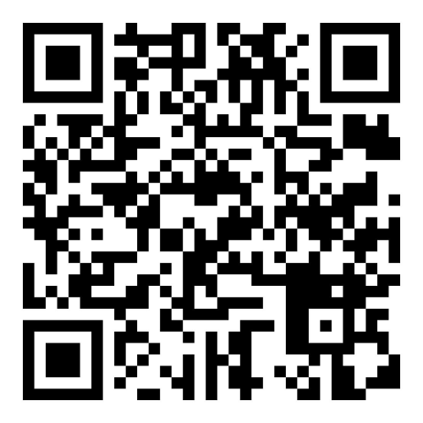
We also have a Closed Facebook Group where we post announcements, updates, and photos from events for parents/guardians to see. It is “Spokane Bethel Nazarene Youth Group”. You can also scan the QR code below with your phone to be directed to the page to request to join.

