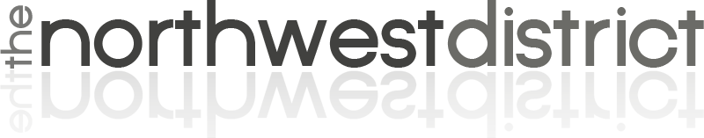

NORTHWEST DISTRICT SCHOLARSHIOP APPLICATION

Please return completed application before November 30, 2023 to info@northwestdistrict.org or mail to the
Northwest District Office, 919 Airport Rd., Sheridan, WY 82801

STUDENT INFORMATION
Last Name:
First Name:
Mailing Address: City: State: Zip Code:
Date of Birth: Age: Sex:

Membership Held in Which Church?
Church City and State:

Marital Status: Married Single
If Married: Name of Spouse: Occupation of Spouse:
Names/Ages of Children:

PARENT INFORMATION
Names of Parents:
Address (if different from above):
Occupation: Father Mother

STUDENT ACADEMIC HISTORY
Do you attend a Wesleyan College/University, or any other seminary approved by The Wesleyan Church? Yes No
Name of College/University:
Degree/Major you are Pursuing:
Years Attended:
Present Year in College: Full-Time Student Part-Time Student
Current GPA:
Do you plan to return to the Northwest District upon graduation? Yes No
Other school information you would like to tell us?

FINANCIAL INFORMATION
ESTIMATED EXPENSES FOR COMING YEAR:
Tuition, Books. Fees:
Room & Board:
Other Personal or Family Expense:
Explain:
TOTAL EXPENSES:

SOURCES OF INCOME:
Personal Earnings while in school:
Spouse’s Earnings:
Assistance from Parents:
Scholarships, Grants, SS, GI, etc:
Loans (Stafford, Other Government Loans, Any Other Sources):
TOTAL INCOME:

PERSONAL TESTIMONY
Please give a short personal testimony, a statement of your life goals in relation to the field of service where God is calling you, and a statement of your financial need.

SIGNATURE: DATE:

