Minutes Recorded by: Annamarie
Members Present: Pastor Scott Rimer, Pastor Teresa Woodworth, Kristin Rickard, Jim Mcpherson, Mike O Connor, Leigh Caldwell, Tom Freeman, Pam Gregorczyk, Dick Garriott, Lynda Locklear, Betsy Turner

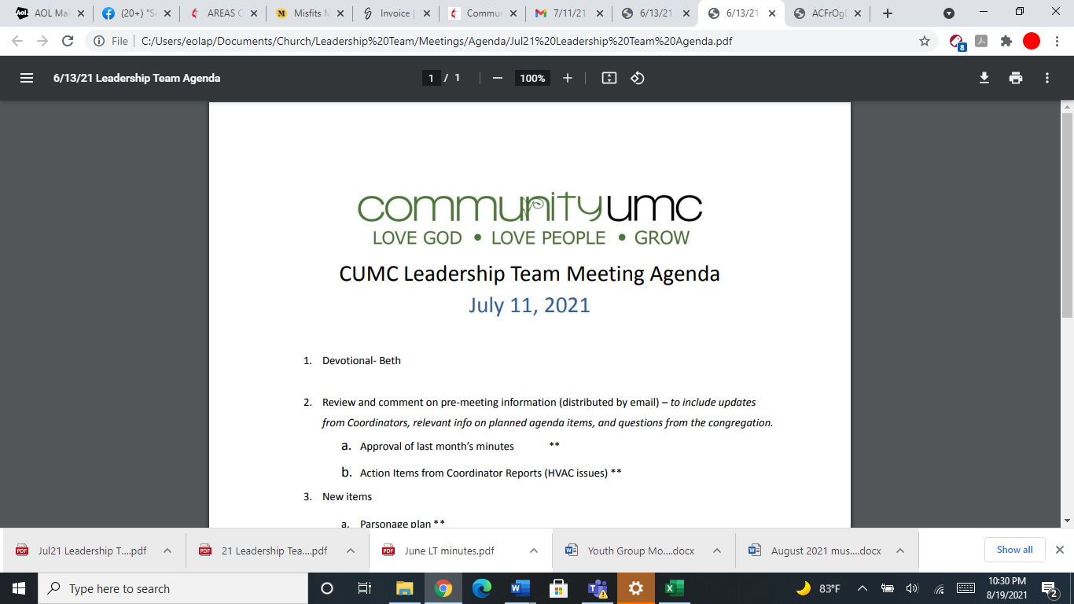
September 14, 2025

- Opening Prayer Leigh

- Spiritual Formation (Devotional) Mike

- Team Building Pam

- Senior Pastor Report Pastor Scott
Pastor Scott discussed his continuing education conference that he just attended. He reminded the team of the Charge Conference at Oaklette UMC on November 6th at 6:30pm. The nomination committee has met and by next meeting we should have all seats placed. Pastor Scott did ask the team to pray about filling the role for leadership chair.

- Goal Review Pastor Scott
Pastor Scott reviewed goals and updated the team that the communication and events goals have been met.

- Old Business
- Approval of previous meeting minutes Jim
Jim motions to approve the August meeting minutes and the leadership team approves.
- Encroachment on the field Jim
Dick discusses the house on Castle Rd where out field property is. 3 years ago a letter was written to the neighbor about encroachment on our property line. There has been more encroachment recently. Tabled.
- Volunteer Solicitation Jim
Larry, our facilities director, is asking to put in the newsletter, a small projects repair list for some maintenance repairs around the building, the leadership team approved to have this list posted to the newsletter.

- New Business
- Financial Report Pam
Pam discusses the financial report for August.Dallas discusses the payment plan for the apportionments, we will double up on them to $22,000 a month. Jim motions to approve the payment plan, the team approves.
- Funding Requests Jim
- Power Inverter ($132.00)- Approved
- Electrical work on sign ($1,554.00) Tabled.
- Replacement Desktop and monitor for Media Booth
($939.00) Approved with the understanding that this money will be taken from the money kept aside for oil.
(4) Request for Mics-$198- Approved.
(5) Kitchen hood inspection- will need more information- Dick will check on it.
- Review of Facilities Dick
Dick discusses the drain issue on Burlington Rd, the city will be taking care of fixing the issue. The refrigerator in the kitchen had the thermostat replaced and the vendor is looking for another part. Mark Turner has been working on the thermostats. Mothers Day Out will be replacing a door in the coming months and already paid for a drain replacement.
- Funeral Honorarium Form Jim
Jim motioned to approve increasing the custodian fee to $100 for funerals. The team approved.

- Financial Policy and Procedures Pam
Pam brought the financial policy and procedures to the team but the team asked for Dallas to look over and update. A counters instruction document was motioned by Jim for the team to approve. The team approved.
- Request for Use of Social Hall Jim
The Tidewater Quilters Guild is asking to bring a second chapter in on the first saturdays of each month. They are asking to pay $150 but the team discussed the fee will need to be $200. Jim motioned to approve the meetings and the fee for $200. The team approved. Annamarie will follow up with Debi Harding.
- Monthly Reports
Care/Hospitality Betsy
Family Ministries Beth
Hospitality Lynda
Evangelism Leigh
Missions Lynda
Megan Dunn made a donation to the church for the mission camp that was held here in June of 2025.
Contemporary Worship Betsy
Small Groups Leigh
Choir Tom

- Previous tasks/issues update Jim
Boy Scout presentation at the meeting today- a boy scout would like to do his Eagle scout project by making 3 wood picnic tables, he is doing all the fundraising and gathering of the volunteers to help him make the tables. Jim motions to approve the project, the project is approved by Leadership Team.

- Round Robin Jim

- Closing Prayer Lynda

- SPRC Matters Beth

Next Meeting: October 19, 2025

