Minutes Recorded by: Annamarie
Members Present:
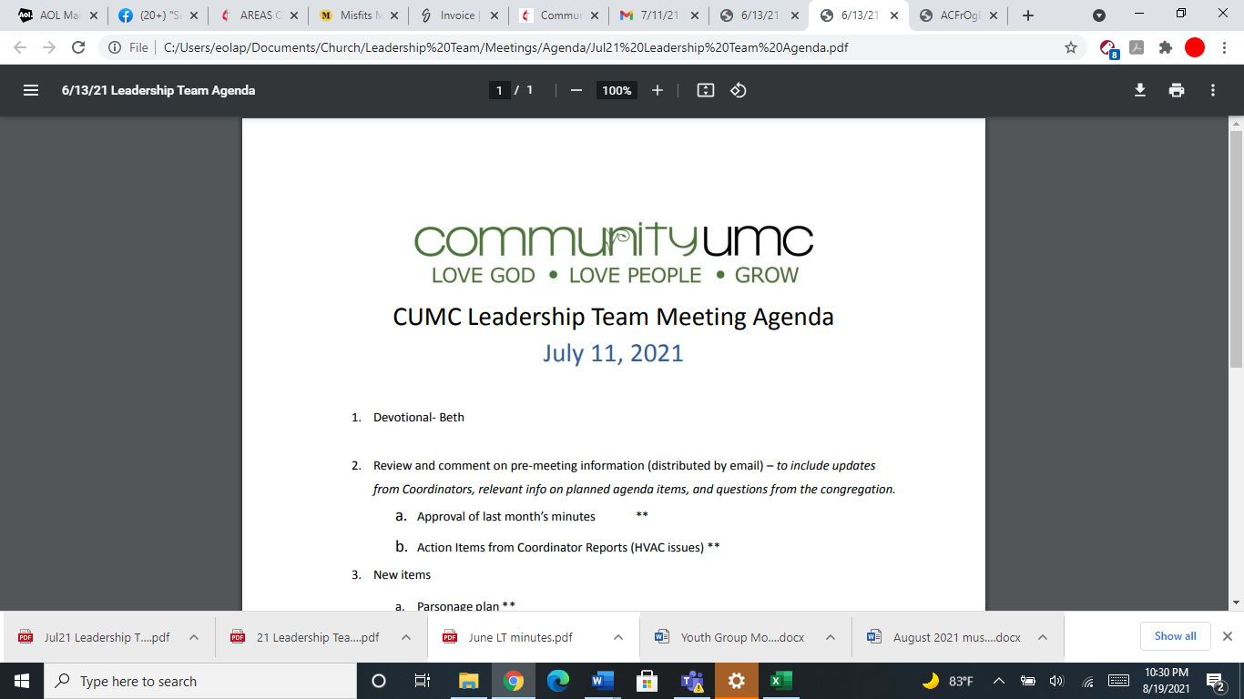
September 14, 2025

- Opening Prayer Leigh

- Spiritual Formation (Devotional) Mike

- Team Building Pam

- Senior Pastor Report Pastor Scott

- Goal Review Pastor Scott

- Old Business
- Approval of previous meeting minutes Jim
- Encroachment on the field Jim
- Volunteer Solicitation Jim

- New Business
- Financial Report Pam
- Funding Requests Jim
- Power Inverter ($132.00)
- Electrical work on sign ($1,554.00)
- Replacement Desktop and monitor for Media Booth
($939.00) Jim
- Review of Facilities Dick
- Facility Use Policy Jim
- Financial Policy and Procedures Pam
- Request for Use of Social Hall Jim
- Monthly Reports
Care/Hospitality Betsy
Family Ministries Beth
Hospitality Lynda
Evangelism Leigh
Missions Lynda
Contemporary Worship Betsy
Small Groups Leigh
Choir Tom

- Previous tasks/issues update Jim

- Round Robin Jim

- Closing Prayer Lynda

- SPRC Matters Beth

Next Meeting: October 19, 2025

