Minutes Recorded by: Annamarie
Members Present:Pastor Scott Rimer, Pastor Teresa Woodworth, Kristin Rickard,, Leigh Caldwell, Tom Freeman, Pam Gregorczyk, Dick Garriott, Lynda Locklear, Betsy Turner, Beth Grabowski

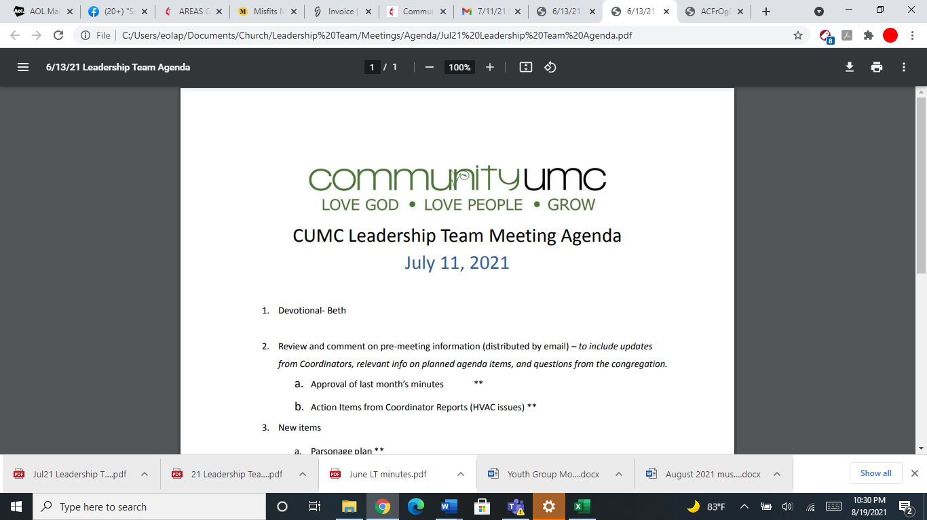
October 19, 2025

- Opening Prayer Dick

- Spiritual Formation (Devotional) Beth

- Team Building Leigh

- Senior Pastor Report Pastor Scott
Pastor Scott discusses the Charge Conference coming up November 6th, 6:30pm. Pastor Scott asks the Leadership team for a representative for Charge Conference for the acting secretary- Pam volunteered. Back to church Sunday was a great service and day. Advent study- December 3.10,17th from 6-7pm with Pastor Scott and Vicky. Nominations met- three new members, Terry Buzzard, Dallas Heilman, and Tina Arterburn. Jim will continue to be the chair.

- Goal Review Pastor Scott
No goal Reviews until Jan

- Old Business
- Approval of previous meeting minutes Pam
Pam motions to approve September meeting minutes- Leadership team approved

- New Business
The 2026 Commitment Card was updated and corrected.The correction is that only two funds will be on the card, the Operating budget and Faith in our Future funds only. The Capital Improvements fund has been removed. Pam motions to approve the commitment card- Leadership team approves.
- Financial Report Pam
Pam discusses the September 2025 funds. Apportionments are paid for September, Pam motions to table line of credit repayments until Apportionments are paid. Lynda would like to have something posted about what apportionments are. The motion was approved by the Leadership team.

- Funding Requests Pam
- Kitchen Fire Hood Clean/Inspect ($500)
Pam discusses that an anonymous donor is paying for inspection. No vote necessary.

- Replace Backdoor Call Box ($705) Dick discusses the backdoor callbox- Tom and Pastor Scott discuss the safety reasons about not fixing the callbox. Pam motions give Larry $50 for signs for coming to the front and the callboxes in the back be removed. The team approves the motion.
- Facility Review Dick
Dick discusses the marquee sign, when Larry went to the city to get the permit, the city wanted $1800 for the electrical and then to make the sign. Beth asks about the three quotes for the project. The leadership team would like to table this project. A designated donation was made for $2300.
Dick discusses the lights in the sanctuary.Taqounda will speak with Dallas about a recommendation about apportionments in order to get the lights fixed,
Dick discusses an anonymous donor about the steeple- Dick will find out what a study costs. Dick discusses the gravel parking by the memorial garden was paid for by an anonymous donor and Taqounda was not aware of the gravel being put in.
- Financial Policy and Procedures Pam
- Monthly Reports
Care/Hospitality Betsy
Funding Request- Need communion wafers- a request needs to be made with the expense on it.
Family Ministries Beth
Bibles for 3rd graders $115.00 funding request. Pam motions that $113 is available but Pastor Teresa will find donations first.
Hospitality Lynda
Evangelism Leigh
Missions Lynda
Contemporary Worship Betsy
Small Groups Leigh
Choir Tom

- Previous tasks/issues update Pam

- Round Robin Pam
Beth brings up the fabric over lights in a classroom in Mothers Day Out. She discussed it being a fire hazard. Pastor Teresa will talk with Mary Sue.
Beth discusses the back parking lot lines that need to be redone for parking spaces. The Leadership team tabled this project.
Women’s bathrooms by the chapel need to be cleaned. Pastor Scott will talk with Otis about his floor disk to clean that bathroom.
Tom asks about the water fountain in the back hallway near the Parlor and if a water bottle fountain can be put there instead of a traditional water fountain because we are in post covid. It was discussed that yes, if someone wants to pay for that project- a water bottle fountain can go there.
Anonymous donors- Leadership team discusses that all special projects with facilities will still need to go through the church office. An anonymous donor cannot pay a vendor directly. Donors will remain confidential.

- Closing Prayer Leigh

- SPRC Matters Beth

Next Meeting: November 9, 2025

