Minutes Recorded by: Annamarie
Members Present:
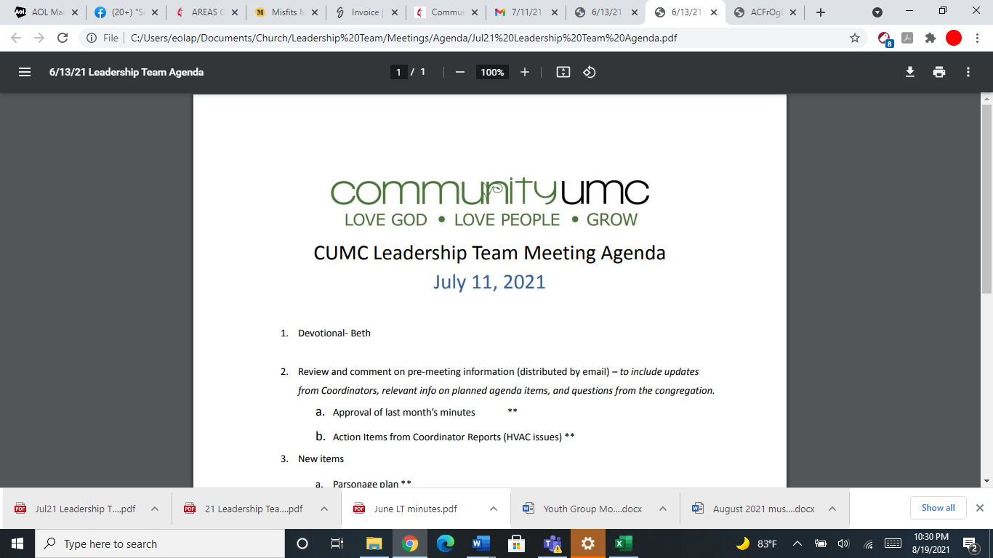
November 9, 2025

- Opening Prayer Mike

- Spiritual Formation (Devotional) Leigh

- Team Building Betsy

- Senior Pastor Report Pastor Scott

- Goal Review Pastor Scott

- Old Business
- Approval of previous meeting minutes Jim
- Financial Information Request Jim

- New Business
- Review of Finances Jim
- Funding Requests
- Computer Replacement Project (Monitors) - $540.00
- Sanctuary Light Bulb Replacement - $6,552.00
- Janitorial Supplies for Nov 25 – Feb 26 - $820.00
- Repair Light in Main Hallway - $165 - $255
- Fuel Oil – Expected mid-December - $5,000.00
- Review of Facilities Dick
- Monthly Reports
Care/Hospitality Betsy
Family Ministries Beth
Hospitality Lynda
Evangelism Leigh
Missions Lynda
Contemporary Worship Betsy
Small Groups Leigh
Choir Tom

- Previous tasks/issues update Jim

- Round Robin Jim

- SPRC Matters Beth
- One matter to discuss

- Closing Prayer Jim

Next Meeting: December 14, 2025

