Minutes Recorded by: Annamarie
Members Present:Pastor Scott Rimer, Pastor Teresa Woodworth, Pastor Jannette Clavez, Jim Mcpherson, Mike O Connor, Leigh Caldwell, Tom Freeman, Pam Gregorczyk, Dick Garriott, Lynda Locklear, Betsy Turner
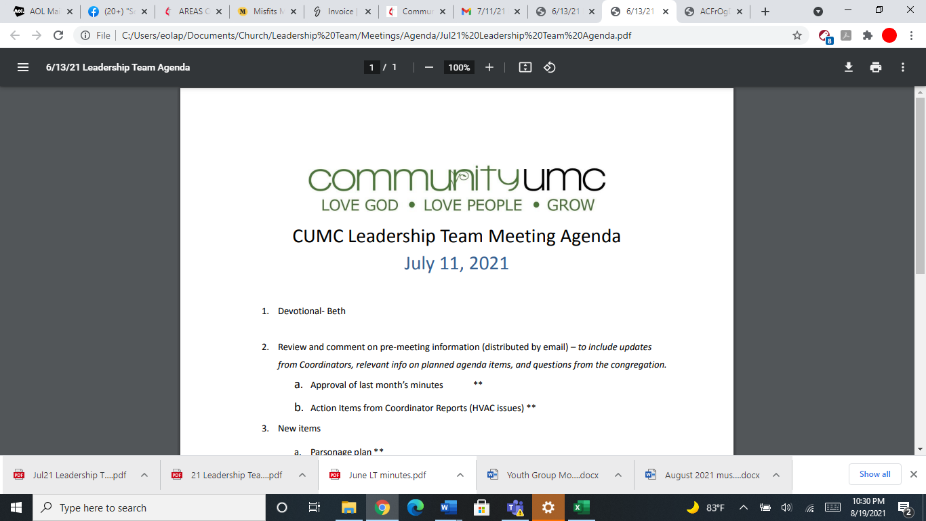
March 9, 2025

- Opening Prayer Betsy

- Spiritual Formation (Devotional) Mike

- Team Building Pam

- Senior Pastor Report Pastor Scott
Pastor Scott discusses delegates to the annual conference, Jim, Leigh, Tom. Ash Wednesday- good turnout for Ashes to Go- Lenten Study Thursdays- Adam Hamilton study, Winter shelter follow up meeting with Sallie Volk on Tuesday, three new members on March 16th, march 30th combined worship,

- Goal Review Pastor Scott
No updates

- Old Business
- Approval of previous meeting minutes Jim
Jim motions to approve February minutes, Leadership team approves the February minutes.

- New Business
- Financial Report Pam
Pam discusses the financial report for February- Tom asks about Faith in our future account- Dallas needs more time for budget- hopefully by April
- Funding Requests Jim
- Fuel Oil Pending as of 4 March - $4500.00- Leadership team approved
- Toilet Paper (min order) - $150.66- Jim Motions to approve- Leadership team Approved
- Staff Parking Only sign - $121.49- Jim motions to approve- Leadership team Approved
- Youth “Mock-In Lock” - $50- Jim motions to approve- Pastor Teresa discussed that the youth have the supplies so we do not need the $50.00
- Safety deposit box- 25.00 box from the bank- Jim motions to approve- Leadership Team Approved
- Review of Facilities Dick
Centimark will come this week to clean the roof which is under warranty, so it will not cost the church. Terms in the Centimark contract will be updated with our terms for sanctuary roof. Approval from city for repairs on water sewage
Faith in our Future- asks to use that money on the pending requests. Jannette will speak with the committee. $50,000 left that we need to raise to go to fixing the first part of HVAC.
- Monthly Reports
Care/Hospitality Betsy
Family Ministries Beth
Hospitality Lynda
Evangelism Leigh
Missions Lynda
Contemporary Worship Betsy
Small Groups Leigh
Choir Tom
- Town Hall Meeting (March 16, 2025) Jim
Reminder there will be zoom call this week over Monday for Leadership, google meet meeting setup- Annamarie will make meeting setup for Jim- 6:30pm- 7:30pm

- Previous tasks/issues update Jim

- Round Robin Jim
Annamarie will print out Meeting Minutes to put in the Sunday School folders.

- Closing Prayer Tom

- SPRC Matters Beth

Next Meeting: April 13, 2025

