Minutes Recorded by: Annamarie
Members Present: Pastor Scott Rimer, Pastor Teresa Woodworth, Pastor Jannette Clavez, Jim Mcpherson, Mike O Connor, Leigh Caldwell, Tom Freeman, Pam Gregorczyk, Dick Garriott, Lynda Locklear, Betsy Turner
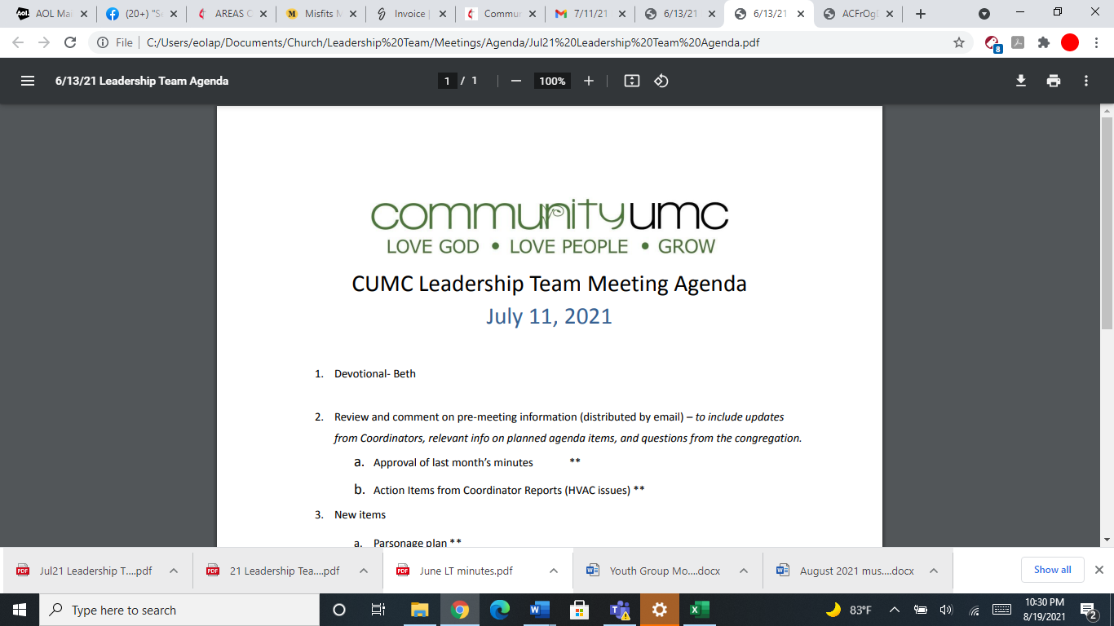
May 18, 2025

- Opening Prayer Leigh

- Spiritual Formation (Devotional) Pam

- Team Building Handout

- Senior Pastor Report Pastor Scott
Pastor Scott discussed transitioning Pastor Jannette role as she retires and putting another person in her place. Annual Conference is happening in June, the 3 pastors and 3 delegates. UMCOR kits dedicated on June 1st.

- Goal Review Pastor Scott
Pastor Scott asks if there is any updates to goal review, none mentioned.

- Old Business
- Approval of previous meeting minutes Pam
Pam motions to approve the April meeting minutes, the Leadership Team approves of April meeting minutes.

- New Business
- Financial Report Pam
Pam discusses the financial report for April. She discusses Faith in our Future expenses as well.
- Funding Requests Pam
- Youth Sunday School Curriculum ($160.00)- hold off for now.
- Youth Grad Day expenses ($200.00)-hold off for now- will reassess in JUNE 2025
- Take Out Church ($175.00)- hold off for now- reassess in JUNE 2025
- Replace Sanctuary Light Bulbs ($6552.67)- hold off for now
- PM for furnace/AC ($4633.50)- clarify with Dick with the PM. hold off for now.one time cost.
- Inspection of Fire Hood ($712.20)- Annual inspection- Pam discusses with the Leadership Team about inspection, and would like to get the City to inspect it. Last inspection was in November. Dick will be notified about questions that the Leadership team has. approval on hold.
- Nursery AC- ($3600) Pam discusses the contract with MDO for the AC. there will be a service charge along with the $3600. Defer payment until June. Pam motions to approve, leadership team approves.
- Review of Facilities Beth
- CUMC Sign Electrical Issue-clarification from Dick
- Replace broken downspouts- Leadership team would like to get estimate
- Mens Toliet downstairs- Pam moves to approve to ask Taqounda about funding $350 dollars for the plumber to come out.
- Kitchen convection oven repair- defer/tabled.
- Freezer repair- defer until June 2025
- Intercom System- Beth discusses the ideas for the intercom system from Max, Pastor Scott recommends paying $600 to fix it, table this for a later date.
- Water Fountain Repairs- Beth discusses the water fountain repairs- hold off for now.
- Monthly Reports
Care/Hospitality Betsy
Pastor Jannette is working with a group to show them what responsibilities Pastor Jannette has been doing.
Family Ministries Beth
Hospitality Lynda
Evangelism Leigh
Missions Lynda
Contemporary Worship Betsy
Small Groups Leigh
Choir Tom

- Previous tasks/issues update Pam
none.

- Round Robin Pam
Pastor Jannette discusses our checking account has been compromised. We are closing the account. 3rd account to be looked at for designated funds- pam motions to approve the 3rd account to be made- leadership team approves of motion.

Pastor Teresa- Mission Camp- contact Megan Dunn- push until later until more information is found out.

Beth- Tyler fundraising for music department. Concert in September. Beth motions to approve the fundraising concert. Leadership team approves.
Pam asks about a calendar for yearly financial asks- Annamarie will make and send to her.

- Closing Prayer Betsy

- SPRC Matters Beth

Next Meeting: June 8, 2025

