Minutes Recorded by: Annamarie
Members Present:
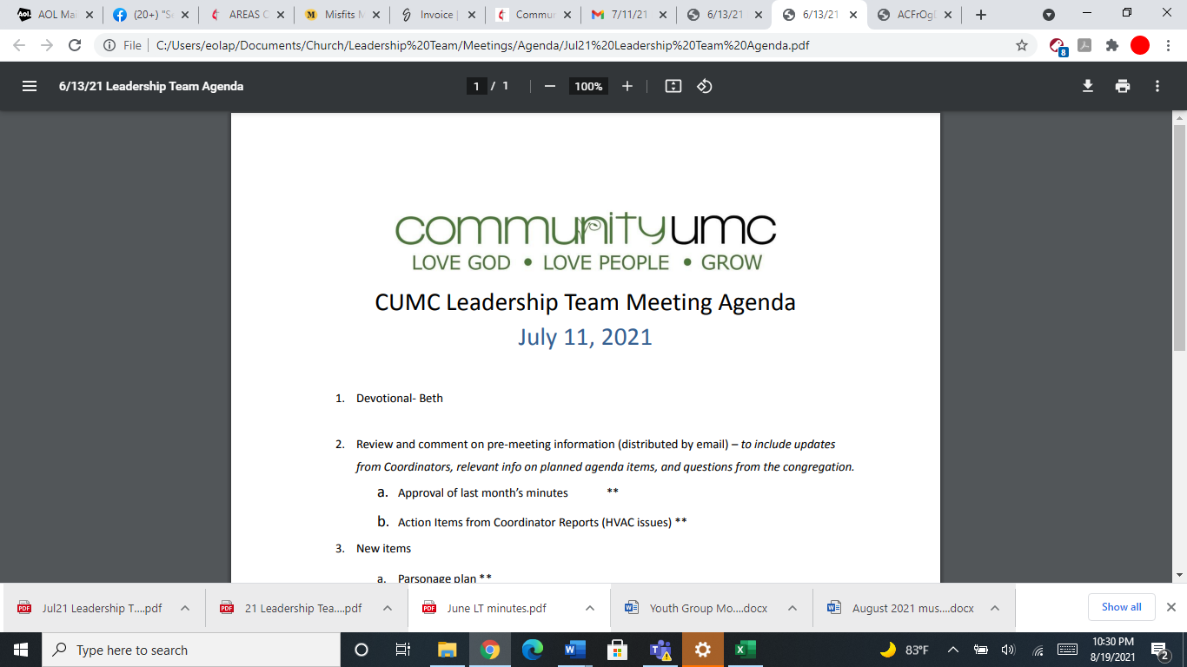
May 18, 2025

- Opening Prayer Leigh

- Spiritual Formation (Devotional) Pam

- Team Building Handout

- Senior Pastor Report Pastor Scott

- Goal Review Pastor Scott

- Old Business
- Approval of previous meeting minutes Pam

- New Business
- Financial Report Pam
- Funding Requests Pam
- Youth Sunday School Curriculum ($160.00)
- Youth Grad Day expenses ($200.00)
- Take Out Church ($175.00)
- Replace Sanctuary Light Bulbs ($6552.67)
- PM for furnace/AC ($4633.50)
- Inspection of Fire Hood ($712.20)
- Review of Facilities Beth
- CUMC Sign Electrical Issue
- Replace broken downspouts
- Kitchen convection oven repair
- Intercom System
- Water Fountain Repairs
- Monthly Reports
Care/Hospitality Betsy
Family Ministries Beth
Hospitality Lynda
Evangelism Leigh
Missions Lynda
Contemporary Worship Betsy
Small Groups Leigh
Choir Tom

- Previous tasks/issues update Pam

- Round Robin Pam

- Closing Prayer Betsy

- SPRC Matters Beth

Next Meeting: June 8, 2025

