Minutes Recorded by: Annamarie
Members Present:
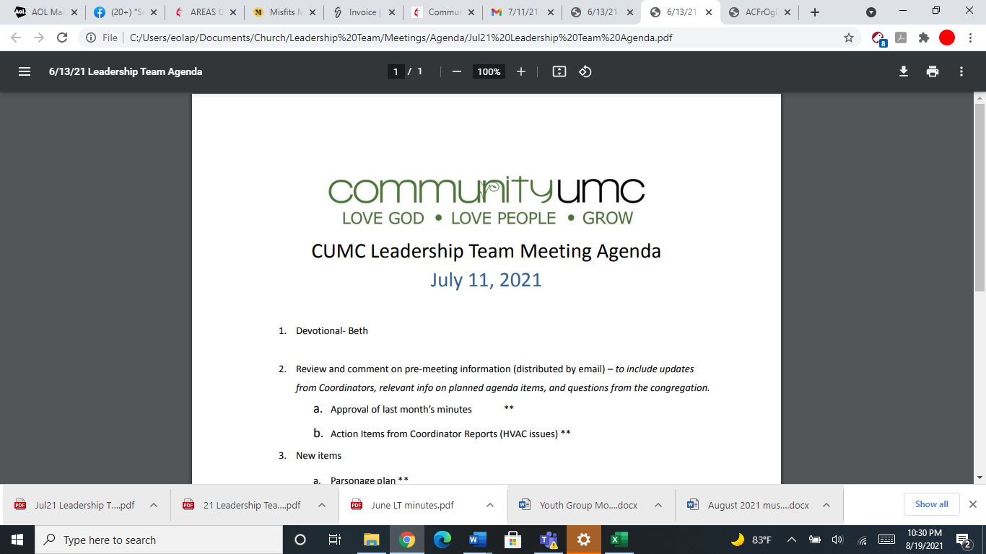
October 19, 2025

- Opening Prayer Dick

- Spiritual Formation (Devotional) Beth

- Team Building Leigh

- Senior Pastor Report Pastor Scott

- Goal Review Pastor Scott

- Old Business
- Approval of previous meeting minutes Pam

- New Business
- Financial Report Pam
- Funding Requests Pam
- Kitchen Fire Hood Clean/Inspect ($500) Pam
- Replace Backdoor Call Box ($705)
- Facility Review Dick
- Financial Policy and Procedures Pam
- Monthly Reports
Care/Hospitality Betsy
Family Ministries Beth
Hospitality Lynda
Evangelism Leigh
Missions Lynda
Contemporary Worship Betsy
Small Groups Leigh
Choir Tom

- Previous tasks/issues update Pam

- Round Robin Pam

- Closing Prayer Leigh

- SPRC Matters Beth

Next Meeting: November 9, 2025

