Minutes Recorded by: Annamarie
Members Present: Pastor Scott Rimer, Pastor Teresa Woodworth, Pastor Jannette Clavez, Jim Mcpherson, Mike O Connor, Leigh Caldwell, Tom Freeman, Pam Gregorczyk, Dick Garriott, Lynda Locklear, Betsy Turner
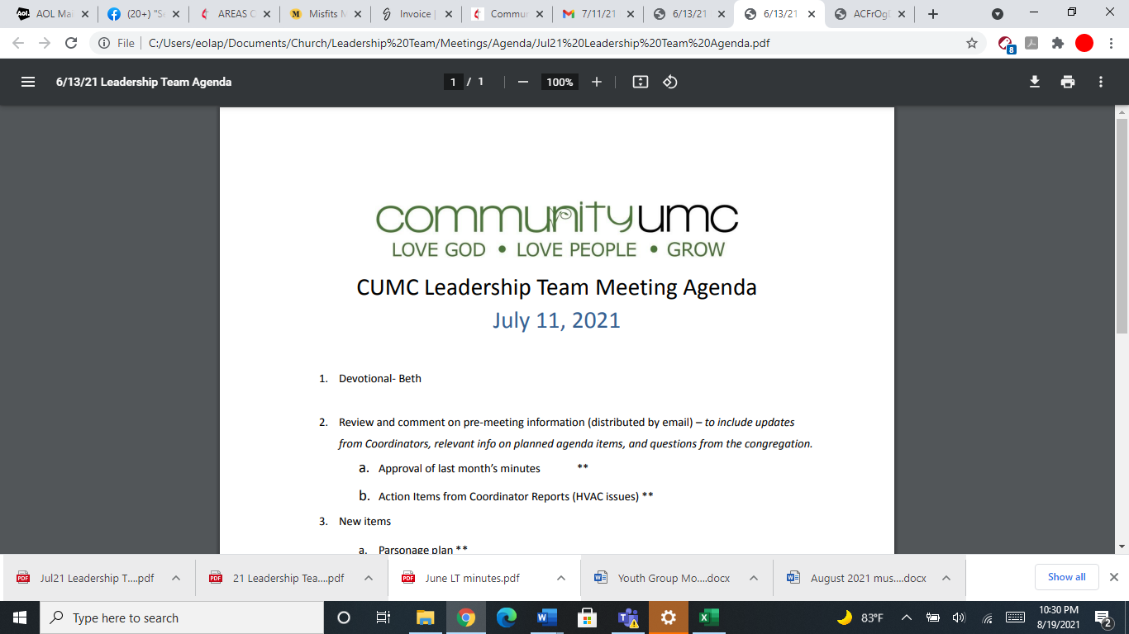
June 8, 2025

- Opening Prayer Mike

- Spiritual Formation (Devotional) Leigh

- Team Building Tom

- Senior Pastor Report Pastor Scott
Coming up on 6/29 Service for Pastor Jannette, Kristin will be involved leading worship to get to know the congregation. Annual conference coming up this week.

- Goal Review Pastor Scott

- Old Business
- Approval of previous meeting minutes Jim
Jim motions to approve May minutes. The Leadership team approves the May minutes.
- Loving Neighbors Mission Camp Approval Jim
Jim motions to approve the camp being here June 22-27th. The Leadership Team approves the camp to be held at the church.

- New Business
- Financial Report Pam (Jim)
Dallas reviews the financial reporting for May.
- Funding Requests Jim
- Microsoft Subscription ($660.00)-CUMC will pay a monthly amount of $55. Jim motions to approve the monthly $55 and the Leadership team approves.
- Youth Grad Day expenses ($100.00)- Deferred.
- JCOC $550 for August meals- Sunday schools will raise the funds for JCOC. Taqounda will be the point of contact for the funds for JCOC meals.
- Review of Facilities Dick
- Modification to Parsonage Lease- Jim motions to approve the lease modification for a son in law and daughter and cat to move in with the couple there now. The Leadership team approves.
- FIOF Campaign Committee Interim Report Jim
Dallas discussed and gave a summary of Faith in our Future. Pastor Scott would like to push back this month's apportionments. Dick mentions that the AC in the Social Hall is broken and needs repaired. Jim proposes that we take Faith in Our Future to fix the 2 systems in Social Hall. This will move a phase up from the current phase. The leadership team approves. The capital improvement fund will now be going into the Faith in our Future account.
- Monthly Reports
Care/Hospitality Betsy
Family Ministries Beth
Hospitality Lynda
Evangelism Leigh
Missions Lynda
Contemporary Worship Betsy
Small Groups Leigh
Choir Tom

- Previous tasks/issues update Jim
Small Funerals- We need to make a process for small funerals in the chapel because of the moving of furniture and other scheduled events. and funeral fees will need to be on the agenda for the next meeting.

- Round Robin Jim

- Closing Prayer Lynda

- SPRC Matters Beth

Next Meeting: August 10th, 2025

