Minutes Recorded by: Annamarie
Members Present:
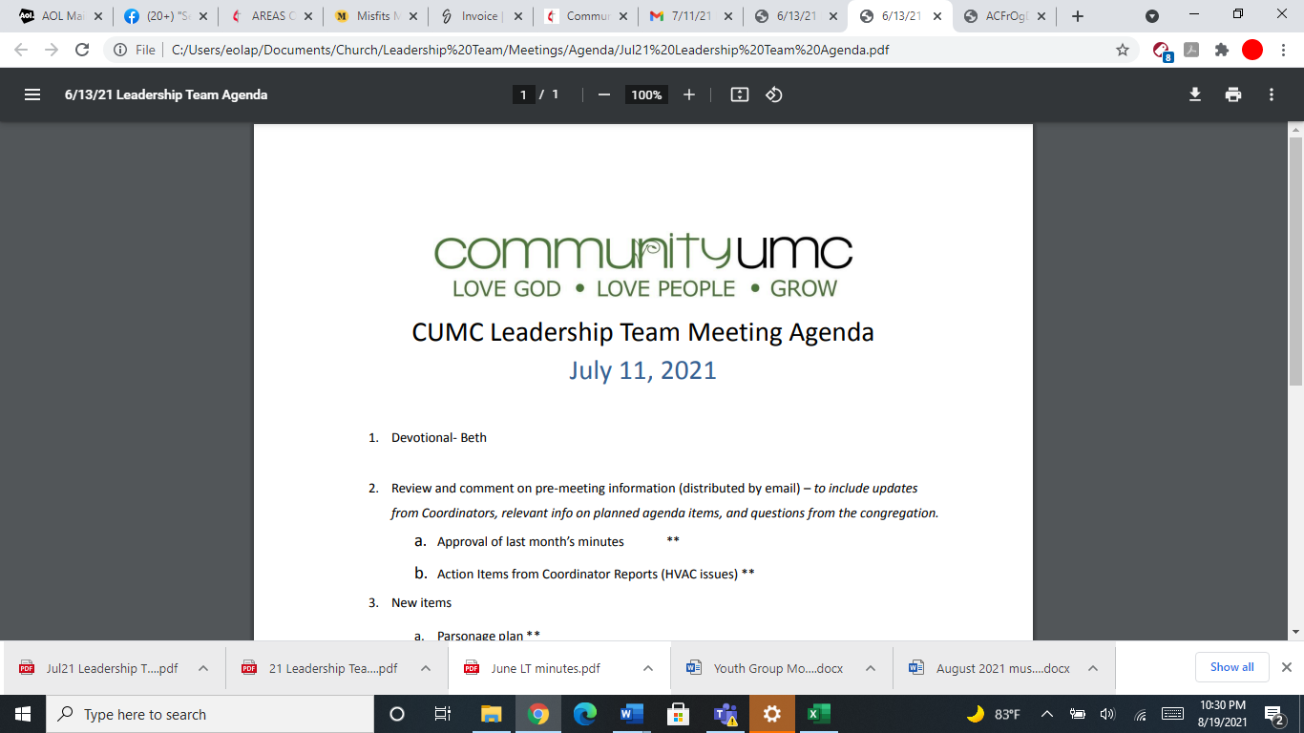
June 8, 2025

- Opening Prayer Mike

- Spiritual Formation (Devotional) Leigh

- Team Building Tom

- Senior Pastor Report Pastor Scott

- Goal Review Pastor Scott

- Old Business
- Approval of previous meeting minutes Jim
- Loving Neighbors Mission Camp Approval Jim

- New Business
- Financial Report Pam (Jim)
- Funding Requests Jim
- Microsoft Subscription ($660.00)
- Youth Grad Day expenses ($100.00)
- Review of Facilities Dick
- Modification to Parsonage Lease
- FIOF Campaign Committee Interim Report Jim
- Monthly Reports
Care/Hospitality Betsy
Family Ministries Beth
Hospitality Lynda
Evangelism Leigh
Missions Lynda
Contemporary Worship Betsy
Small Groups Leigh
Choir Tom

- Previous tasks/issues update Jim

- Round Robin Jim

- Closing Prayer Lynda

- SPRC Matters Beth

Next Meeting: July 13, 2025

