Minutes Recorded by: Annamarie
Members Present:
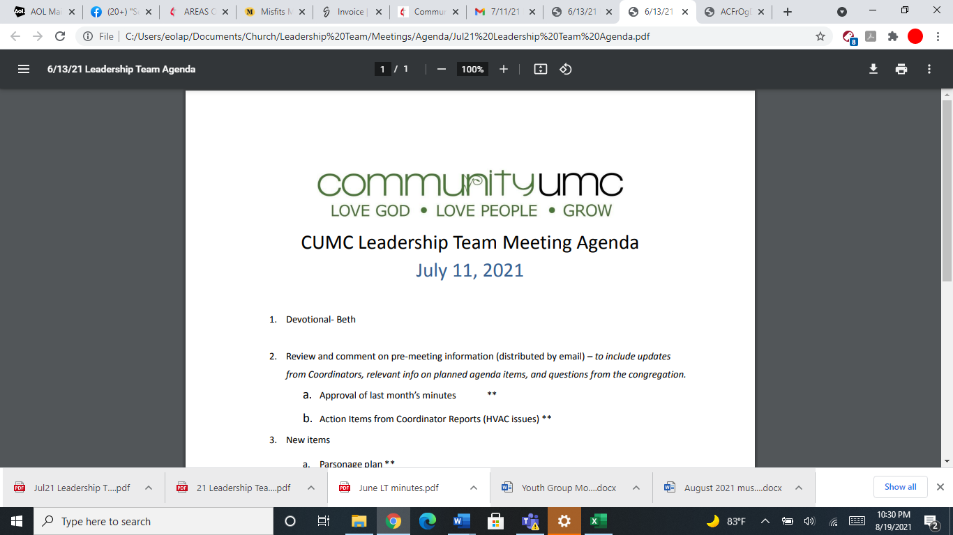
August 10, 2025

- Opening Prayer Pam

- Spiritual Formation (Devotional) Leigh

- Team Building Jim

- Senior Pastor Report Pastor Scott

- Goal Review Pastor Scott

- Old Business
- Approval of previous meeting minutes Jim

- New Business
- Financial Report Pam
- Apportionment
- Funding Requests Jim
- Parsonage attic fan ($1,078)
- Review of Facilities Dick
- Anticipated Funding Requests
- Review of Facility Use Policy Jim
- Fund Raising Discussion Dick
- Monthly Reports
Care/Hospitality Betsy
Family Ministries Beth
Hospitality Lynda
Evangelism Leigh
Missions Lynda
Contemporary Worship Betsy
Small Groups Leigh
Choir Tom

- Previous tasks/issues update Jim

- Round Robin Jim

- Closing Prayer Betsy

- SPRC Matters Beth

Next Meeting: September 14, 2025

