Minutes Recorded by: Pam Gregorczyk
Members Present: Pastor Scott Rimer, Pastor Teresa Woodworth, Pastor Jannette Clavez, Jim Mcpherson, Mike O Connor, Leigh Caldwell, Tom Freeman, Pam Gregorczyk, Dick Garriott, Lynda Locklear, Betsy Turner

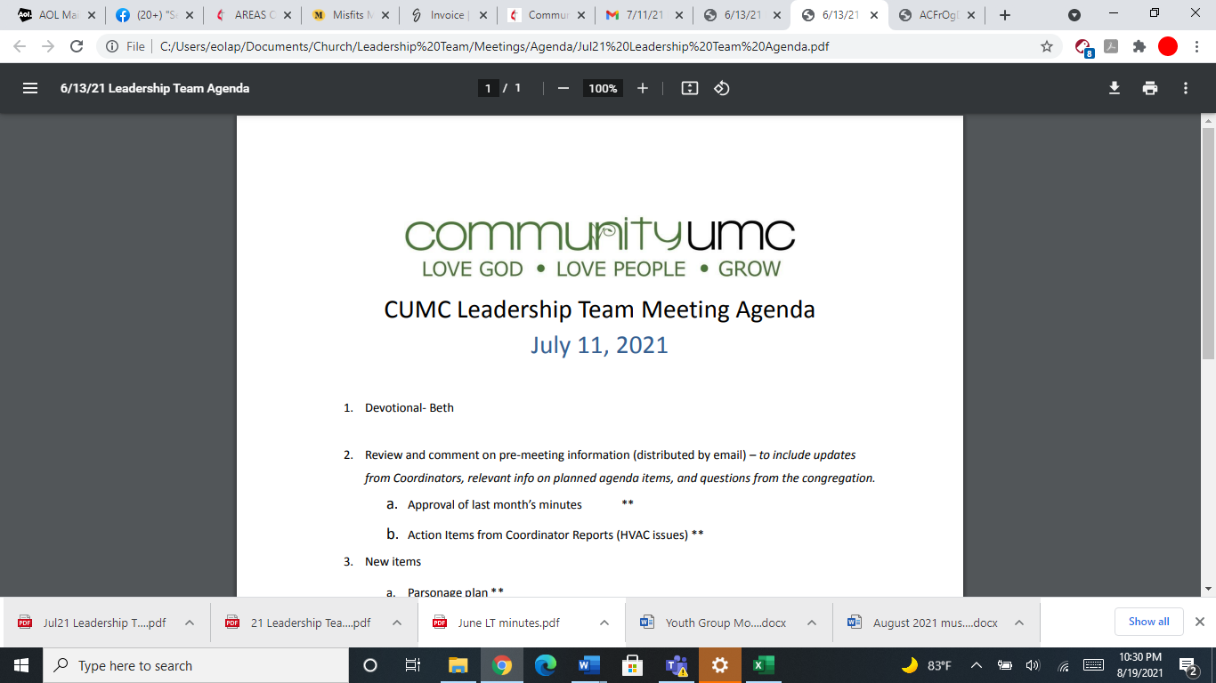
April 13, 2025

- Opening Prayer Jim

- Spiritual Formation (Devotional) Lynda

- Team Building Jim

- Senior Pastor Report Pastor Scott
Lenten Study attendance had good consistent numbers . Pastor Scott asked UMM to host Rise Against Hunger on Sunday, November 2nd, 2025.

- Goal Review Pastor Scott
Communication- cards were handed out to Mothers Day Out Preschool for Holy Week, parents night out and VBS. Rise Against Hunger will be advertised.

- Old Business
- Approval of previous meeting minutes Jim
Jim motioned to approve the previous meeting minutes, Leadership Team approved of previous meeting minutes.

- New Business
- Financial Report Pam
- 2025 Budget- The budget for 2025 tries to capture everything accurately but 2026 should be more accurate. The budget is still very tight. We will be focusing on paying off the line of credit.
- Review of Facilities Dick
$776 for building supplies with stripping and waxing- every 6 months. Jim motions to approve $776 dollars and the Leadership team approves. The payment will occur in May. $100 for parking lot repairs of potholes- anonymous donor paid for this. The church sign replacement- Dick will go to the city this month for approval. Taquonda will try and locate money for this. New sign purchase is deferred until money is located. Air Conditioning- to complete AC check, last AC check cost $2200 to do it. Dick is looking in to a new price and then Leadership Team will vote on the cost. Tower Door intercom needs to be replaced and it will cost $676 dollars. A suggestion was made that perhaps a “Ring” doorbell be the replacement and put another one on the back door as well. Dick and Larry will discuss. Shingles over the Social Hall- repair cost was $400 not $800.
- Funding Requests Jim
- $6500.00 (HVAC Engineering Report - From FoF)- to obtain HVAC Engineering report for MDO and youth wing- Jim motions to approve this expense from Faith in our Future fund- The leadership team approves.
- $38.10 (Reimburse Pastor Jannette for palm purchase) Jim motions to approve this reimbursement and leadership team approves.
- Cabinets in Coffee Bar (Amount of Request pending) Jim motions to approve, there is no cost. Leadership team approves.
- $450.00 (JCOC participants meal in April)- Jim motions to approve, leadership team approves.
- Monthly Reports
Care/Hospitality Betsy
Family Ministries Beth
Hospitality Lynda
Evangelism Leigh
Missions Lynda
Contemporary Worship Betsy
Small Groups Leigh
Choir Tom

- Previous tasks/issues update Jim

- Round Robin Jim
Can lights in the sanctuary are not working, be aware replacement will be needed. 2 costs- 1st is to determine what needs to be done to repair them, 2nd is to do the actual work to repair and what the cost is compared to what we have now and LED lights.
Faith in our Future- are there any plans to extend this fund beyond the three years? Pastor Jannette will ask the Faith in our Future Committee.

- Closing Prayer Pam

- SPRC Matters Beth

Next Meeting: May 18, 2025

