Minutes Recorded by: Annamarie
Members Present:
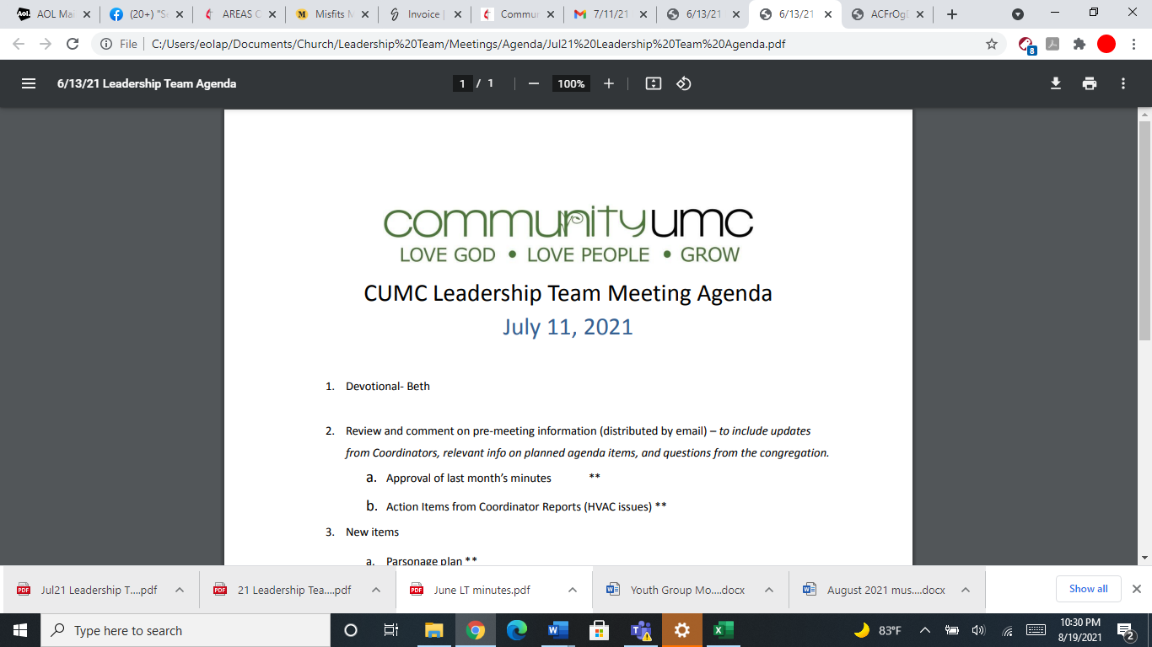
April 13, 2025

- Opening Prayer Jim

- Spiritual Formation (Devotional) Lynda

- Team Building Jim

- Senior Pastor Report Pastor Scott

- Goal Review Pastor Scott

- Old Business
- Approval of previous meeting minutes Jim

- New Business
- Financial Report Pam
- 2025 Budget
- Review of Facilities Dick
- Funding Requests Jim
- $6500.00 (HVAC Engineering Report - From FoF)
- $38.10 (Reimburse Pastor Jannette for palm purchase)
- Cabinets in Coffee Bar (Amount of Request pending)
- $450.00 (JCOC participants meal in April)
- Monthly Reports
Care/Hospitality Betsy
Family Ministries Beth
Hospitality Lynda
Evangelism Leigh
Missions Lynda
Contemporary Worship Betsy
Small Groups Leigh
Choir Tom

- Previous tasks/issues update Jim

- Round Robin Jim

- Closing Prayer Pam

- SPRC Matters Beth

Next Meeting: May 18, 2025

