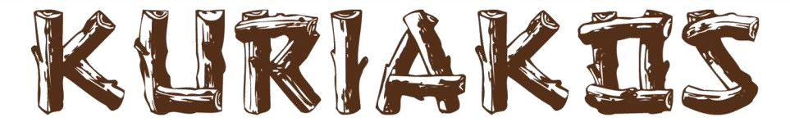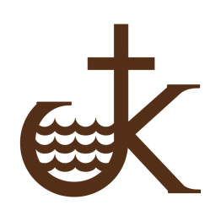

Sylvan Lake Lutheran Bible Camp Association

To the members and supporters of Kuriakos:

At the 2024 AGM, the Sylvan Lake Lutheran Bible Camp Association (Kuriakos) membership approved an update to our bylaws. When those bylaws were submitted to Alberta Registries, as required under the Alberta Societies Act, they were returned because it is no longer acceptable to have a Statement of Faith incorporated into bylaws. The Board considered this change to our bylaws as a major change, and chose to take the time to review the bylaws in total in order to bring them up to date and carefully consider how the bylaws can also support our future in the most effective way.

A Bylaws Working Group was formed in December 2025 with the following mandate:

Mandate
The Bylaws Review Working Group is an Ad-Hoc working group of the Kuriakos Governance Committee. The Working Group will ensure that the purpose of Kuriakos is achieved through the updating of the Bylaws in accordance with the Alberta Societies Act and the values of Kuriakos.

To achieve this mandate, the following Working Group members were recruited:

Dave Christiansen
Judy Hansen
Debbie Kemp
Heidi Miller Zerr
Kristian Wold
Laureen Wray

Our original plan was to have the draft of new bylaws ready for approval at the 2026 AGM. However, the Working Group discussions surfaced some important changes that we felt would benefit from input at the AGM. That input has been incorporated into these draft bylaws which the Board is recommending to the membership at a Special General Meeting (online) on September 26, 2026.

The Working Group was guided by the following assumptions in drafting the new Bylaws:
- Our future must be grounded in our Lutheran heritage and faith.
- Maintaining and nurturing relationships with congregations is important to our mission.
- Protecting the land and the Kuriakos commitment to being a place set apart to be together is key to our future.
- Ensuring a strong membership in support of Kuriakos mission is required for our success.

Overview
The Alberta Societies Act governs our actions as a nonprofit association in Alberta, and our bylaws and our activities must align with the Act. The following chart outlines how our bylaws relate to the Act, and guide the decisions we make at Kuriakos.

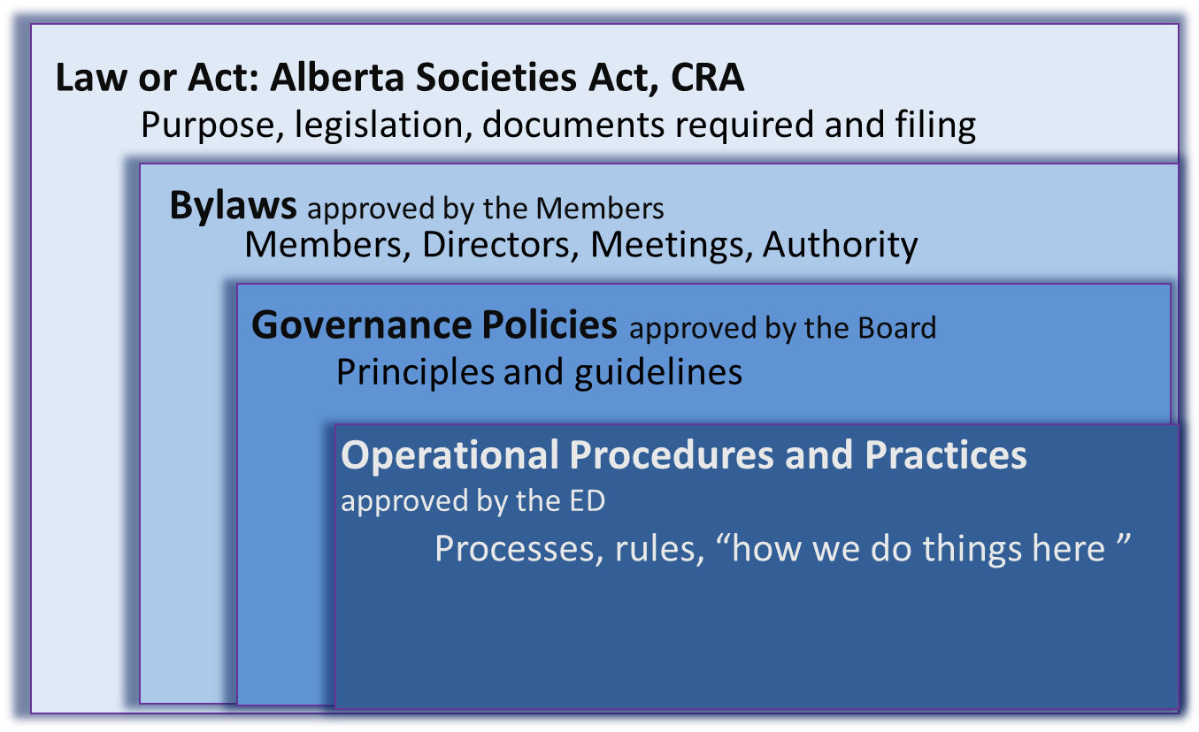

We look forward to your ongoing support of Sylvan Lake Lutheran Bible Camp Association.

Sincerely,
Members of the Bylaws Working Group

