

SUNDAY WORSHIP SERVICE
September 27, 2026 at 11:00 am
If you would like to join us virtually the link is down below:
https://www.youtube.com/channel/UC6UHqS_OTHDrNw8hP1OAGnQ
Service will be led by Rev. Petra Thombs

SUNDAY WORSHIP SERVICE
See other recent Worship Services on UUCCN's Facebook page.

MINISTER'S MESSAGE
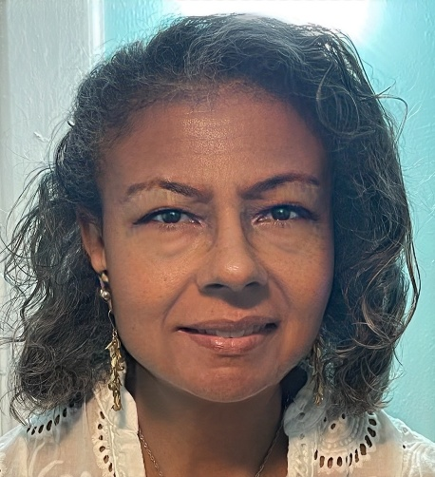
Beloveds,
As fall begins, the temperatures cool down and we wrap ourselves in warmer layers. This week began with Yom Kipper, a day of reflection for wrong doing, seeking forgiveness, atonement and making amends, for observant Jews. This is part of the High Holy Days. We recognize that we all need time to reflect on our actions, recognizing that we are not perfect as we strive to be connected to one another.
This Sunday we will celebrate the Wisdom of Wise Women on Sunday, and we invite you to wear white if possible. If you have a short reflection to share, we welcome you adding your voice to this service. Please bring a photograph of yourself, a wise woman in your life, a poem or letter from them. Should you have experienced a loss, we will offer prayers for your loved one. Our theme this month is beginnings and it is important to recognize that life in our world begins with women. For women and those who love them, let us celebrate the gifts and wisdom of women of a certain age.
Also on Sunday afternoon, the Long Island Immigrant Justice Alliance will hold an event in Hempstead at 3:00 at the Key Food Shopping Center, 386 Fulton Avenue in Hempstead, New York. We are lifting up the memory of Santos Benajas Reyes, who died hours after being taken to the detention center in Nassau County. I will be present for this event and hope that you will be able to join me.
This organization has brought certain information to light. I learned that ICE is seeking funds to pay for taser gloves, to use on detainees. This equipment is said to be used in the prison system, something I have not been aware of and I am sure most people do not know. The use of tasers in law enforcement, especially because those detained who are only looking for work and are not criminals, only escalates tensions
and delivers harm.
The situation caused for me to reflect and now I am sharing my thoughts with you.
Shock and Awe,
They hit the floor.
Down they go to breathe no more.
We are at war away and at home,
Weapons deployed- high flying drones.
Something new, we plan to use,
Taser gloves, meant to abuse.
The sacred touch, no longer healing,
There’s no love here, that we’re dealing.
Twenty million expected cost,
Reign shock and awe upon those Lost.
Resist and organize as we pray,
Prevent this travesty and decay.
The war on terror, fought within,
Is waged on neighbors, kit and kin.
That is the nature of the State,
Claim peace, as bombs proliferate.
This raging war-aimed at innocents,
Fascism declared, sets precedence.
Rev. Petra Thombs, Unitarian Universalist Congregation of Central Nassau in Garden City
( Pronounced Pay-tra Toms)
These two services are happening on Sunday. I look forward to seeing you all at UUCCN for The Wisdom of Wise Women. I hope you can also join me in support of our immigrant community. I’m always grateful for all that you do for our community.
The Long Island Advocates for Police Accountability continue to meet weekly on Monday evenings at 7:30. Here is the link:
LIAPA UPDATE
https://us02web.zoom.us/j/85205749096?pwd=VWL9IKFO0ayearK5keKEPxm3waZ3eb.1
Blessings to you all,
Rev. Petra
MINISTER'S OFFICE HOURS:
SPECIAL EVENT!
My office hours will be on Friday, October 2nd from 2:00pm - 4:00pm.
Be sure to come to our annual Pumpkin Patch! The first delivery of pumpkins will be on Saturday, September 19th, 2026. Tell your family and friends to come by.
SEE PDF Regarding Letter

Our UUCCN Board Members welcome you as we begin a new congregational year.
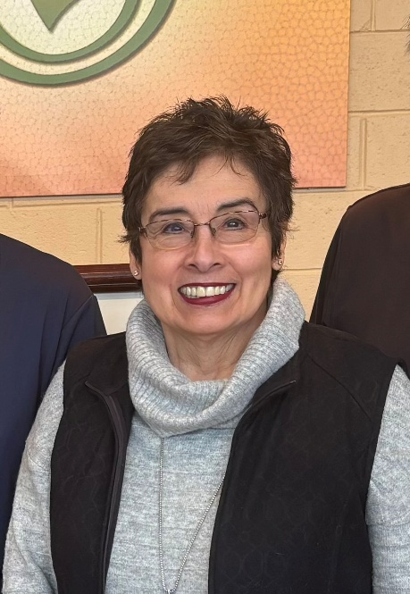
Anita Coddington- Board Member, House and Grounds, Rentals
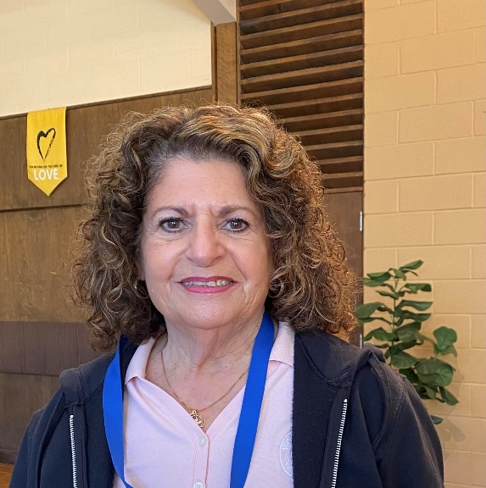
Gerri Forrai- Board Member, Stewardship Committee
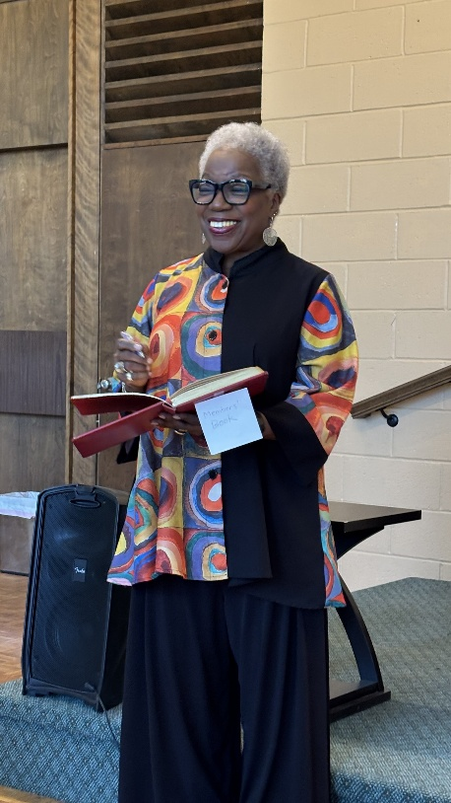
Dr. Janice Marie Johnson- Board Member, Caring Committee and Outreach Committee
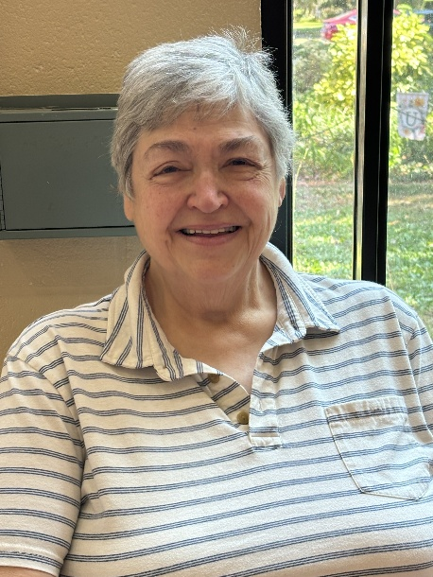
Georgie Collins- Board Member
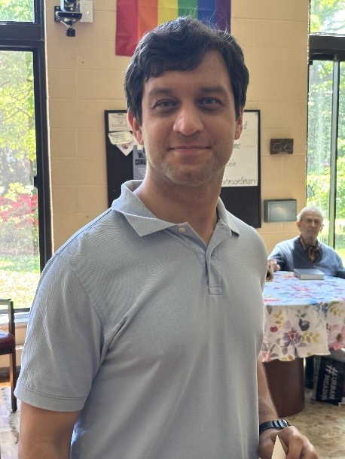
Adam Marczyk Board Member, Secretary,

UUCCN ANNUAL EVENTS - SAVE THE DATE
Book Club on zoom at 8pm: September 24th- Here Where We Live Is Our Country: The Story of the Jewish Bund by Molly Crabapple

Pumpkin Patch 2026
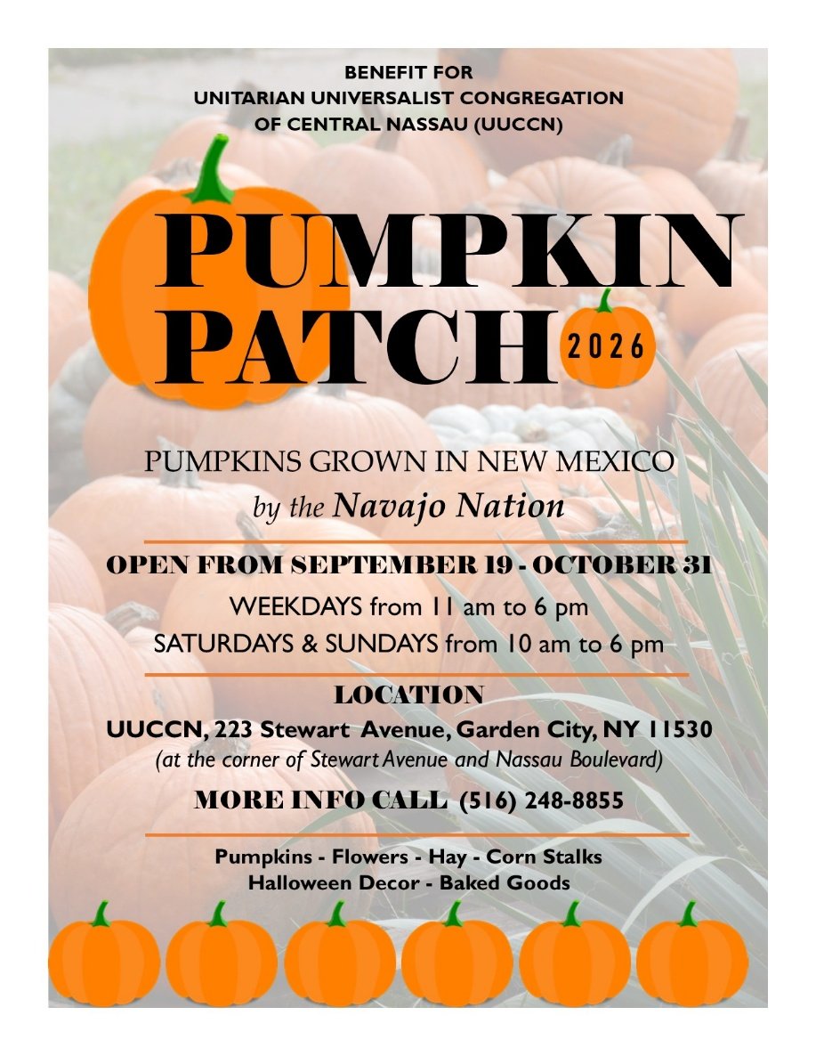

Share The Plate for September
Our Share the plate for September is a not-for-profit, volunteer-based organization, The INN provides a broad variety of essential services to assist those challenged by hunger, homelessness and profound poverty. We partner with those in need in a dignified and respectful manner to help them achieve self-sufficiency.
Please mail a check made out to UUCCN with “Share the Plate”
written on the memo line or go online to: www.uuccn.org/donate.

Special Alert- Scammers
Dear Community,
Please be aware that scammers are sending out invitations and or requests for funds. If you receive something like this please delete it. If you are unsure, check with the person directly to confirm that it came from them. We need to take care of each other. Be safe out there!

The Wisdom of Women Celebration


Immigration Update
Dear UUCCN,
We will be sharing pertinent information regarding immigration on a regular basis. Much is taking place that we as a congregation working for justice, should know about.
Last February, our congregation sponsored a Share the Plate program for a Catholic Church in Haiti that was providing support to the population due to the effects of Hurricane Melissa. The arrangement was made to send the funds to the church but their website and any internet access was compromised.
I have been working with my colleague, Deacon Berthin Eduoard to find a suitable replacement. Given the recent actions of this government’s administration to end the Temporary Protected Status of Haitian people, we will be sending the Share the Plate donations to Haitian Bridge Alliance, tps. They provide community services and legal resources to support the Haitian community. Presently there are 350,000 Haitian people who have lost protections under recent legislation.
The situation is dire; on the first of this month, a twenty year old honor student, Pierre Damas Bel , newly enrolled in Wright State University, Ohio, took his own life when he was forced to wear an ankle monitor. He was no longer allowed to play soccer, which he had excelled in. He had contacted ICE to have the monitor removed, to no avail.
Overtime he became despondent. His college scholarships and freedoms were stripped away. He called his father to say that he was not feeling right. He expressed his despair. His father encouraged him to return home so that they could talk. He never made it home. He parked his car on the side of the road and walked into traffic.
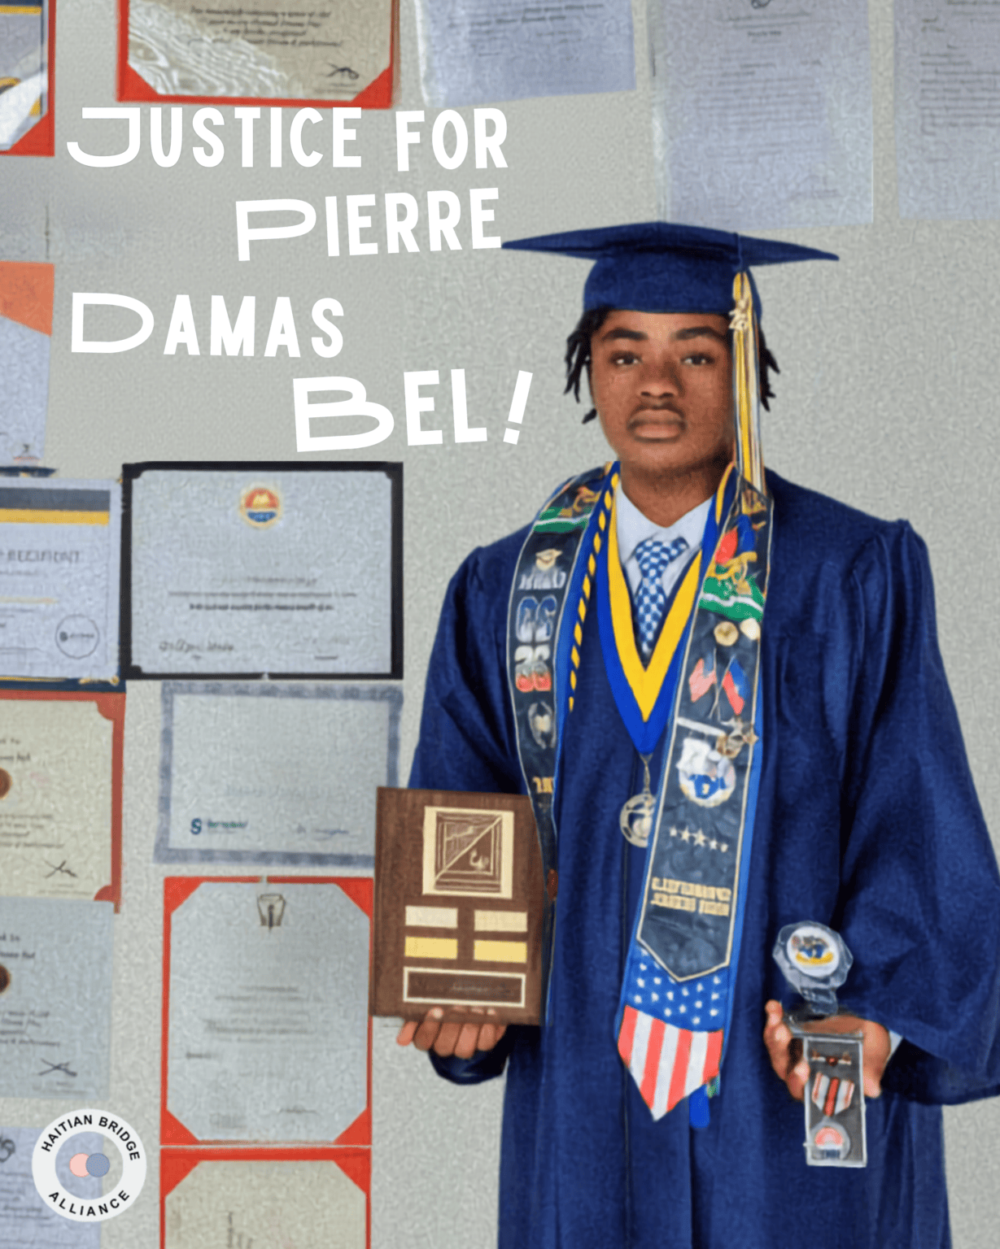
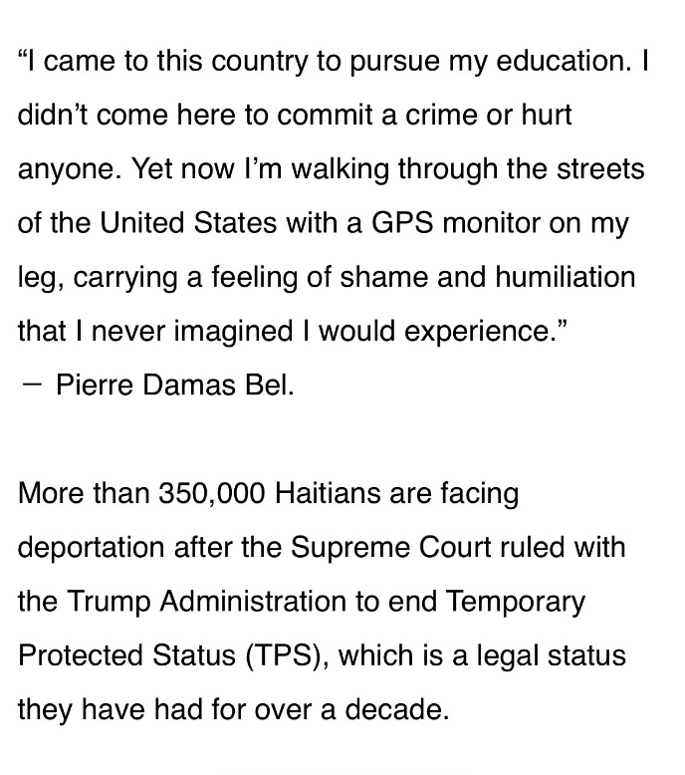

Family: Ankle monitor distressed Haitian man killed by tanker truck in Springfield (Please read the article)
Family wants proof Haitian man’s death was suicide https://haitiantimes.com/2026/09/01/haitian-pierre-damas-bel-death-ohio-immigration/

Helpful Strategies for Dealing with Members of Hate Groups
Dear UUCCN,
I found this information from my friend and colleague, Rev. Kate Lore. Please take the time to read it and reflect on it as it is helpful for addressing the frustration many are experiencing.
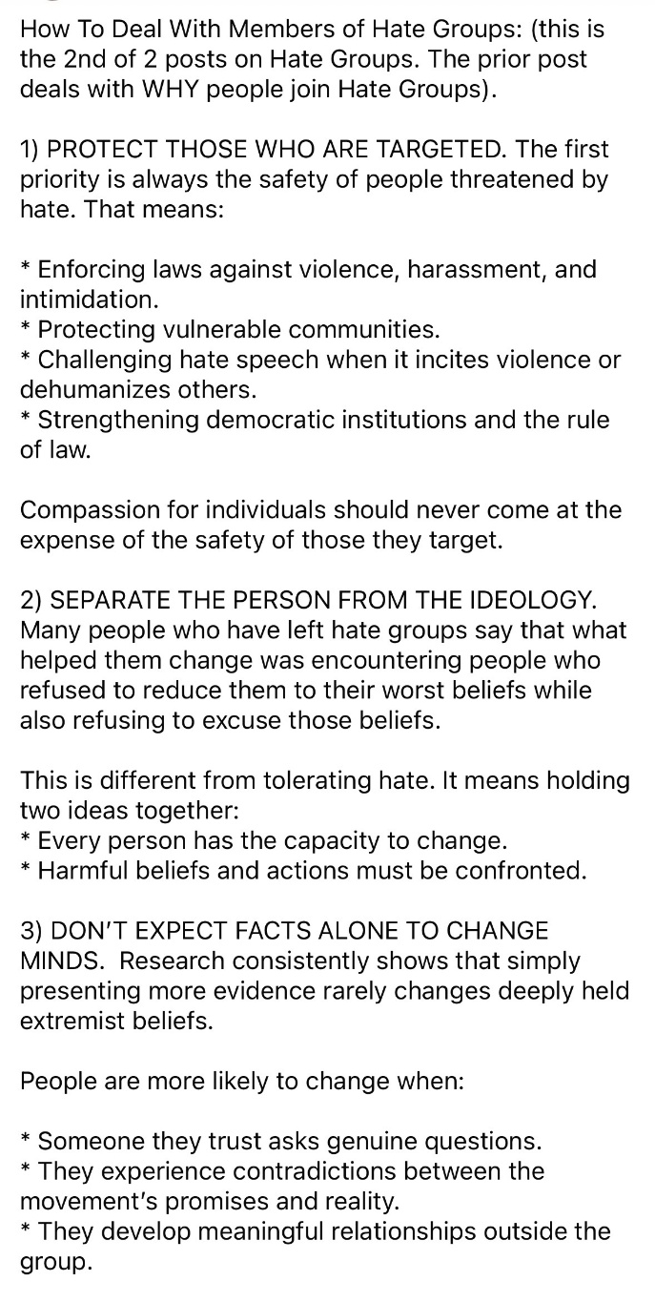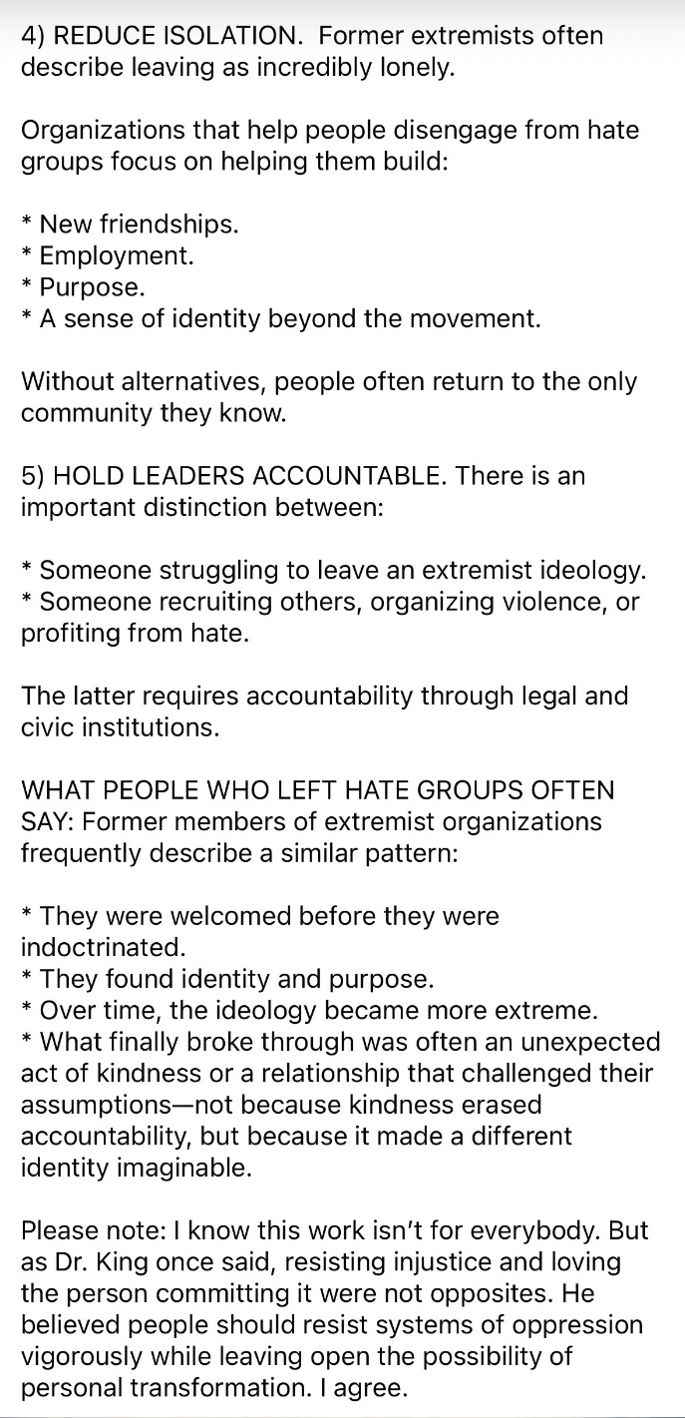

When Black Women Gather CAPITAL B: Federal court rules there is no constitutional right to safe drinking water
Federal court rules there is no constitutional right to safe drinking water
A federal appeals court has used a decades-long water crisis in one of the Blackest cities in America to rule that the U.S. Constitution does not guarantee Americans the right to clean and safe drinking water.
Read in Capital B: https://apple.news/AMXxa5732Rb-prcgLs-dS9A

Religious Education
RE Session Summary – September 20, 2026
Our lesson, “Beginning in Sacred Space: The Rituals That Start Us Off Right,” explored what makes a space or experience feel sacred and how rituals can transform the people participating in them.
We had one older student and one toddler present. Although the toddler was too young to participate in most of the structured activities, I provided plastic blocks for her to build and play with. This gave her an age-appropriate opportunity to be creative, remain engaged, and enjoy being part of the RE space.
We began by answering a question the older student had raised during our previous session: Why is every planet named after a Roman god except Earth? We learned that Mercury, Venus, Mars, Jupiter, and Saturn were visible to ancient observers without telescopes and were eventually associated with Roman deities. Earth, however, already had a name before people understood that it was also a planet. Its English name comes from Old English and Germanic words meaning “ground” or “soil.” We also learned that Uranus is named for a Greek, not Roman, god. This opening gave us a chance to affirm the importance of curiosity and encourage students to keep bringing their questions to RE.
After our Chalice Lighting, we completed the “What Changed?” curiosity challenge. I took ordinary objects from my RE office and arranged them more intentionally. We considered whether the objects or room had actually become sacred or whether what changed was the attention and meaning we brought to them.
During the movement activity, “Sacred, Special, or Ordinary?”, the student classified different places, objects, and experiences and explained the reasoning behind several choices. Their responses included:
- A church sanctuary — special
- A bedroom — special
- A family dinner table — ordinary
- A memorial garden — special
- A school classroom — ordinary
- A favorite tree — special
- A candle — ordinary, although the student thoughtfully asked, “Which kind of candle?”
- A photograph of someone you love — special
- A sports field before an important game — special
- A place where people protest for justice — somewhere between special and sacred
- A place where someone feels safe enough to tell the truth — sacred
I found the student’s explanations especially encouraging. Their questions and distinctions showed they weren't simply trying to identify a “correct” answer. They were thinking carefully about context, meaning, safety, and the experiences people bring into a space.
We then learned about the history of the flaming chalice and considered how the chalice can remind us of love, hope, courage, justice, community, and our responsibility to put those values into action.
The student participated especially enthusiastically in the Ritual Laboratory, during which they designed a new ritual intended to transform part of our ordinary classroom into sacred space. We performed the ritual together and then reflected on whether anything had changed. The student observed that the room and its four walls had not changed, but that perhaps the people inside the room had changed.
I found that insight remarkably thoughtful. It captured one of the central ideas of the lesson: rituals may not physically alter a space, but they can transform our attention, intentions, relationships, and the way we enter a shared experience.
We concluded with a closing reflection and our Chalice Extinguishing. Overall, this was a deeply meaningful session for me. The student’s curiosity, reasoning, and willingness to engage reminded me of how much our students can contribute when they are given room to think beyond predetermined answers. The experience made me even more excited about our future RE sessions this year and the kinds of conversations we may have together.
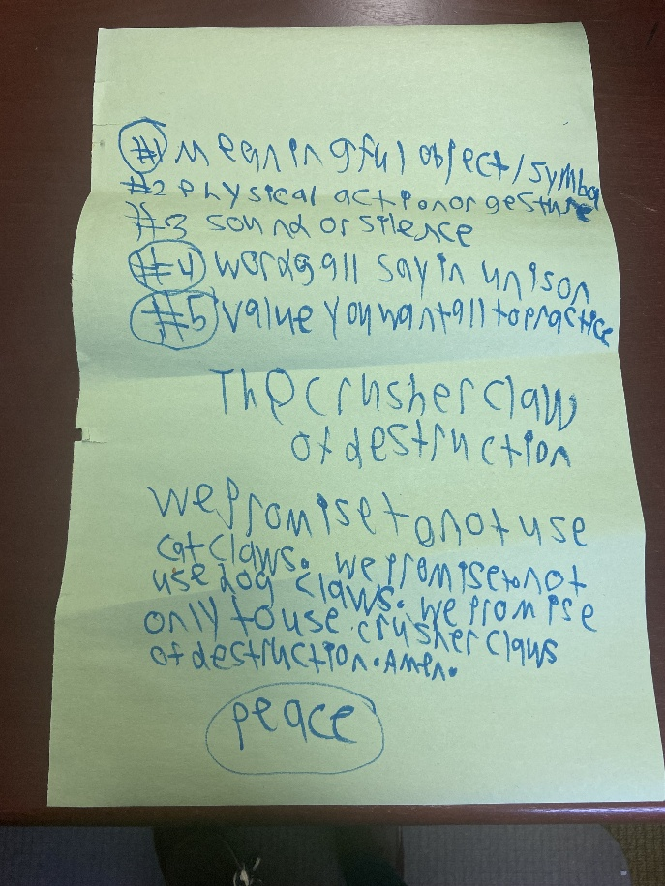
Warmly,
Ashley

BOOK CLUB
Here Where We Live Is Our Country: The Story of the Jewish Bund by Molly Crabapple

September 24th, 2026 at 8PM
ZOOM LINK:
https://us02web.zoom.us/j/86826549564?pwd=MDNIRUVSNnUrR29SN0F3NXhYb2JLdz09

LIIJA FINAL 9.27.26 Hempstead Action
Click here to view the flyer

IIJA
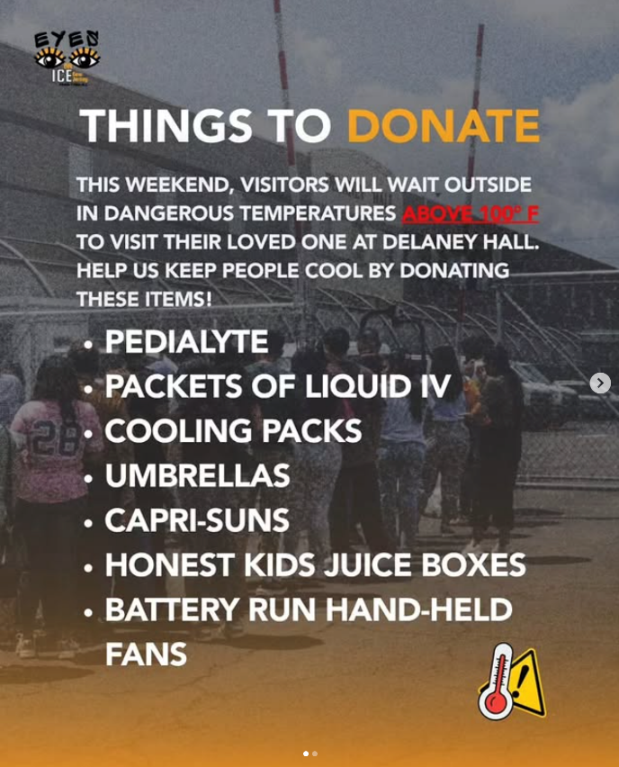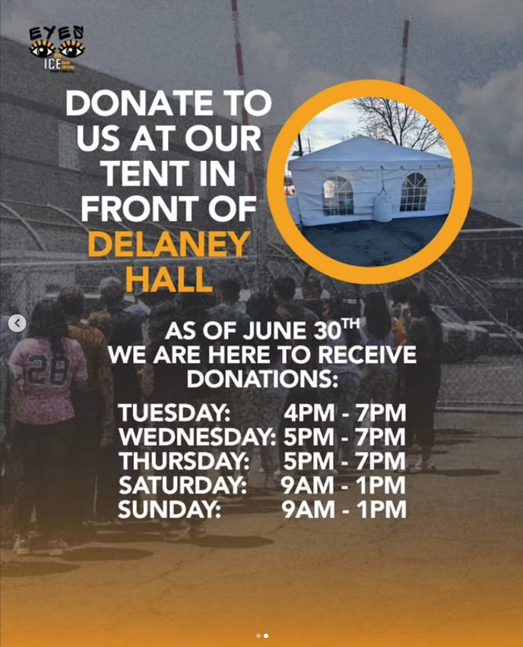

Vote
Our Fifth Unitarian Universalist principle says:
The right of conscience and the use of democratic principles within our congregations and society at large. We encourage everyone to vote in every election and support others who may need help getting to the polls.

LISTEN: New Performance by Shaina Taub for Immigrant NY - NYCLU
https://www.nyclu.org/resources/campaigns-actions/campaigns/huddled-masses

Does Anyone Have a Piano Lamp?
Michael Sansonia has requested a little bit more light over the piano. A piano lamp would be great!
Please contact Jessica or a Board Member with your donation.

STEWARDSHIP
Please send in your pledge form for the new congregational year.
We are all Stewards of UUCCN. Your pledges and gifts sustain our congregation! We look forward to hearing
from you. Contact: Gerri Forrai at gerriforrai@gmail.com (516) 567-1066
Anita Coddington at anitagesky@aol.com (516) 581-2603
Once again, it is time for the Stewardship Committee to ask you to join us in supporting our congregation in the coming year. By renewing our financial commitment, we support our mission of making a difference here and in the world. This congregation belongs to each of us. It is our spiritual home and our beloved community.
Your pledge provides the salaries for our minister, religious education teacher, our musical director as well as the administrative assistant. It pays for the utilities, insurance, maintenance and the heating of our building, as well as any capital campaign improvements.
Please review your pledge form, fill it out promptly and return it. You can mail it, bring it in on Sunday, drop it in the office, or pledge on our website (uuccn.org). Thank you for your support and participation in UUCCN. We couldn't do it without the help of every member and friend.

Donate / Pledge Payment

ARTICLE II AND OUR UU PRINCIPLES
Our congregation has responded to updating our affirmation with this responsive reading shared during our services:
- Love is at the heart of our values.
- We promise to live our values everyday with love at the center of all things.
- Equity is the value of our inclusive community.
- We believe in the inherent worthiness of all.
- Interdependence teaches us, we are all connected.
- We will only be made whole when we live as co-inhabitants of the world.
- Justice is essential for peace and building a Beloved Community.
- We will work to dismantle racism and other oppressions in ourselves and in our institutions.
- Generosity expresses compassion, gratitude, and hope.
- We will offer our faith, ourselves, and our resources.
- Pluralism encourages respect for diverse beliefs.
- And allows us to be curious, as we learn from one another.
- Transformation allows us to adapt to an ever-changing world.
- We are evolving and growing; we are never perfect
Please read updated information regarding Article II.

UU HOUSING
Have you thought about moving? Why not think about living in the vibrant community of Port Washington on Long Island! How about considering living at Hadley House, a 40 unit apartment building for Independent Seniors for UU members and their families? If you have any questions about the availability of units or how to apply they can be answered by the Social Worker in the building, Susan Bagnini, 516-944-8457. A descriptive brochure is available on request.

RENTERS NEEDED
UUCCN's excellent location makes it a great site for renters. We are looking for new organizations that would be a good partner for UUCCN. Please share this with any interested groups and contact Maria Sutton in the UUCCN office for more information at uuccn@aol.com or call (516) 248-8855.

CARING COMMITTEE
Janet McShea, Phyllis Ross, and Gerri Forrai are serving on UUCCN's new Caring Committee. They will be reaching out to members as we try to uplift and support one another. Let one of them know if you want to talk or need a hand.

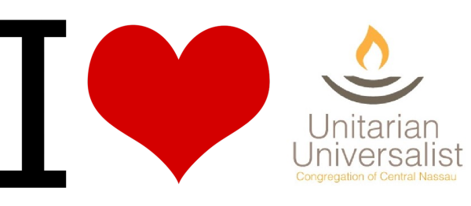

RESOURCES AND NEWS FROM
THE GREATER COMMUNITY

UUA - CENTRAL EAST REGION
CER News for September
Welcome & Orientation Packet
UUA HEALTH INSURANCE PLAN
UUA Newsletter
RE Save the Date - Trainings & New Curricula
The Longest day (and why it matters)
In Recognition that All Roads Lead to Delaney Hall

NOW WHAT: The Gathering for Congregational Leaders
Join the "Side With Love" monthly event to strengthen your spirit, make sense of the threats to democracy, and take meaningful action alongside others.
INFORMATION

UU MINISTRY FOR EARTH (UUMFE)
The changemakers in our interdependent web of life
September News
The theme behind our Earth Day Worship
Support our work!
Side with love
Community Read Starts This Month!
The light is receding (and the work is urgent)
One Week Out!

NO MORE DEATHS:
UPDATES FROM NORTHERN MEXICO PROJECTS
INFORMATION

FERRY BEACH DISCOVERY
Ferry Beach Retreat & Conference Information

JOIN THE UUCCN Private Facebook Group

